**UNIT 5: ANIMAL RIGHTS**

[**https://www.endangered.org/assets/uploads/2019/05/ESC-Infographics-large-PDF-for-poster-printing.pdf**](https://www.endangered.org/assets/uploads/2019/05/ESC-Infographics-large-PDF-for-poster-printing.pdf)

[**https://www.ieltsjacky.com/ielts-opinion-essays.html**](https://www.ieltsjacky.com/ielts-opinion-essays.html)

**WRITING TASK: After having a class discussion about wildlife species which are in danger of extinction, you decided to write an essay for the school magazine to support your opinion about how we can protect endangered animals.**

**Write an essay of 120-150 words**

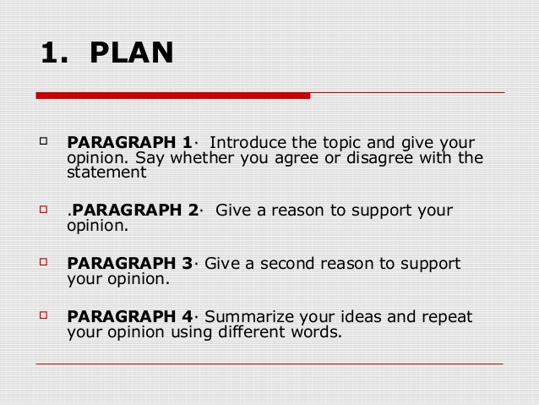

**RELATED VOCABULARY/USEFUL PHRASES**

**opinions**

**are under serious threat of becoming extinct**

**what extinction of these species could mean to our planet**

**species are threatened by extinction**

**we can stop extinction**

**Many of the endangered species are essential for other species survival**

**wild animals need to be protected against extinction**

**they are an important part of the ecosystem**

**When a species becomes endangered, it is a sign that the ecosystem is slowly falling apart.**

**Humans depend on healthy ecosystems**

**Possible solutions/suggestions (ways to protect)**

**Teach your friends and family about the wonderful wildlife**

**Visit a national wildlife refuge, park or other open space**

**the best way to protect endangered species is to protect the places where they live**

**Protect wildlife habitat**

**Never purchase/buy products made from threatened or endangered species**

**Inform local authorities/ school community/ local community**

**Sensitize the public/raise public awareness/Educate others/volunteer/recycle**