**UNIT 6: HOW TO BE A GOOD AND GLOBAL CITIZEN**

****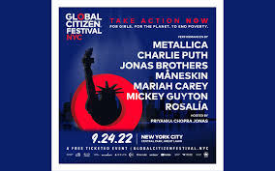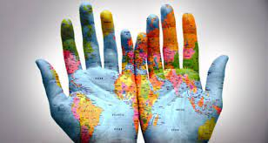

**global citizenship**

[**https://youtu.be/_yio6kQrlYQ?t=12**](https://youtu.be/_yio6kQrlYQ?t=12) **1.44**

What makes a Global Citizen?

[**https://youtu.be/1E-YEj-6ZWU?t=154**](https://youtu.be/1E-YEj-6ZWU?t=154) **4.37**

World Citizen | Leadership Development Qualities

[**https://www.un.org/en/academic-impact/global-citizenship 0.51**](https://www.un.org/en/academic-impact/global-citizenship%20%200.51)

We are an action platform dedicated to achieving the end of extreme poverty, powered by a community of millions Global citizens.

[**https://youtu.be/Q1GzedjrpA8 2.35**](https://youtu.be/Q1GzedjrpA8%202.35)

Answering the question what is Global Citizen and how can we build a movement.

[**https://www.youtube.com/watch?v=VH2F--QQNWA**](https://www.youtube.com/watch?v=VH2F--QQNWA) **4.56**

**Global Citizen: Βιώνοντας μία εθελοντική εμπειρία στο εξωτερικό!**