**Refugees**

The world is witnessing the highest levels of displacement on record. An unprecedented 70.8 million people around the world have been forced from home by conflict and persecution at the end of 2018. Among them are nearly 30 million refugees, over half of whom are under the age of 18. There are also millions of stateless people, who have been denied a nationality and access to basic rights such as education, healthcare, employment and freedom of movement.

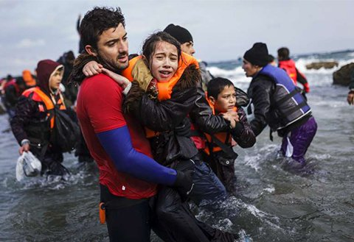

© UNHCR/A. Zavallis

A volunteer life-guard helps a young girl out of the sea after the boat she used along with her family and other Afghan refugees to cross part of the Aegean from the coast of Turkey to Lesbos towards the end of 2015 crashed on a rock off the island’s coast.