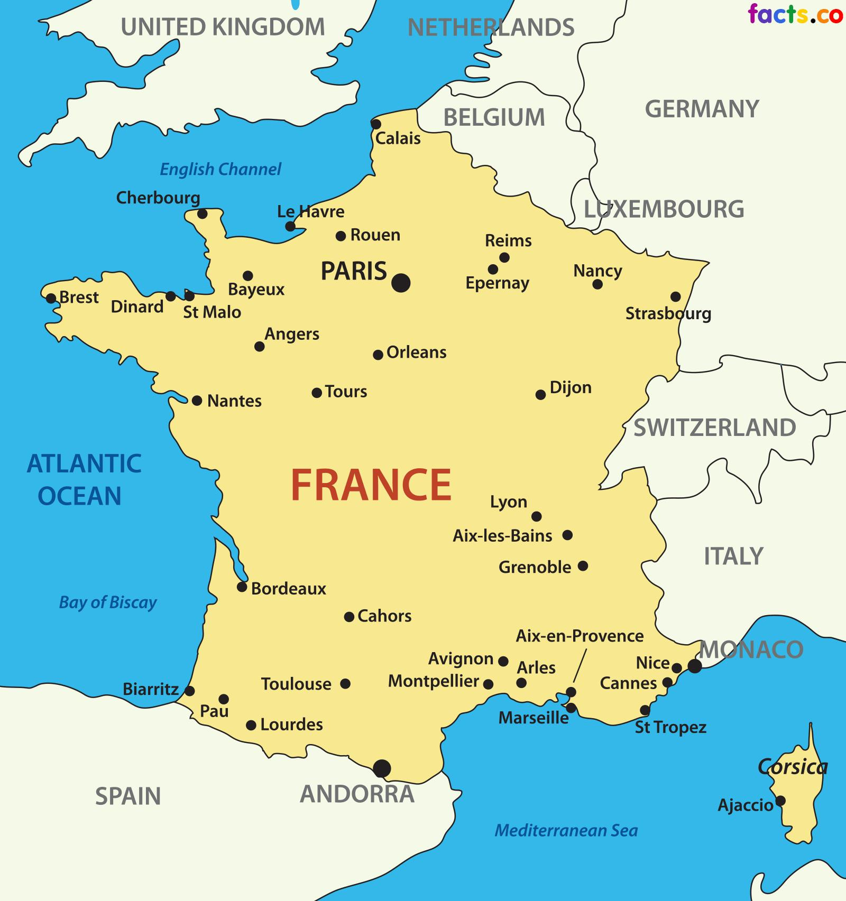

**Terrorism in France** refers to the terrorist attacks that have targeted the country and its population during the 20th and 21st centuries. Terrorism, in this case is much related to the country's history, international affairs and political approach. Legislation has been set up by lawmakers to fight terrorism in France.

[CBC News](https://en.wikipedia.org/wiki/CBC_News" \o "CBC News) reported in December 2018 that the number of people killed in terrorist attacks in France since 2015 was 249, with the number of wounded at 928. Within the European Union, France is the most affected country with recent data showcasing a total of 82 Islamist attacks and 332 deaths from 1979 to 2021

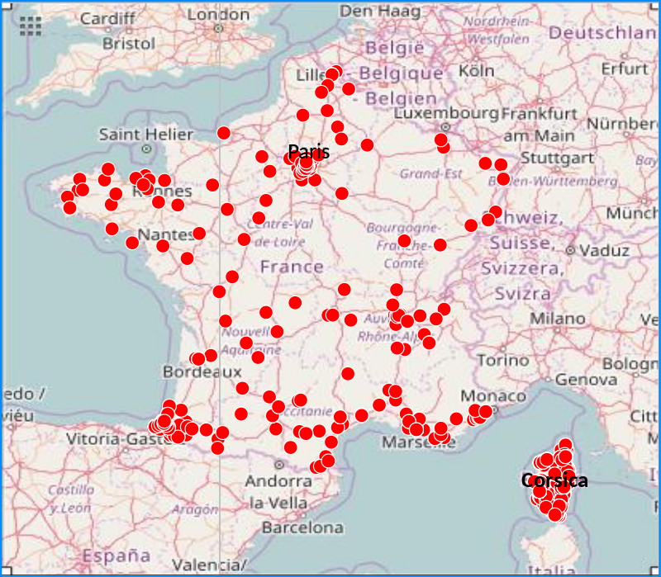

|  |  |  |  |  |  |  |  |
| --- | --- | --- | --- | --- | --- | --- | --- |
| *3 November 2015* | **[Paris](https://en.wikipedia.org/wiki/Paris" \o "Paris), [Saint-Denis](https://en.wikipedia.org/wiki/Saint-Denis,_Seine-Saint-Denis" \o "Saint-Denis, Seine-Saint-Denis)** | 130 (+7) | 368 | AK-47 assault rifles, hand grenades, various explosives, suicide vests | **Islamic State of Iraq and the Levant** | On the evening of 13 November 2015, a series of coordinated [terrorist attacks](https://en.wikipedia.org/wiki/Terrorism" \o "Terrorism) comprising [mass shootings](https://en.wikipedia.org/wiki/Mass_shooting" \o "Mass shooting) and [suicide bombings](https://en.wikipedia.org/wiki/Suicide_bombings" \o "Suicide bombings) occurred in [Paris](https://en.wikipedia.org/wiki/Paris" \o "Paris) and [Saint-Denis](https://en.wikipedia.org/wiki/Saint-Denis,_Seine-Saint-Denis" \o "Saint-Denis, Seine-Saint-Denis), France. Beginning at 21:16 [CET](https://en.wikipedia.org/wiki/Central_European_Time" \o "Central European Time), three separate explosions and six mass shootings occurred, including bombings near the [Stade de France](https://en.wikipedia.org/wiki/Stade_de_France" \o "Stade de France) in the northern suburb of [Saint-Denis](https://en.wikipedia.org/wiki/Saint-Denis,_Seine-Saint-Denis" \o "Saint-Denis, Seine-Saint-Denis). The deadliest attack was at the [Bataclan theatre](https://en.wikipedia.org/wiki/Bataclan_(theatre)" \o "Bataclan (theatre)) where attackers took [hostages](https://en.wikipedia.org/wiki/Hostage" \o "Hostage) and engaged in a standoff with police until it was ended at 00:58 CET 14 November 2015. 130 civilians were killed in the attacks. |  |