**UNHCR**

**An agency to help Refugees**

People fleeing persecution and conflict have been granted asylum in foreign lands for thousands of years. The UN agency that helps refugees is [UNHCR](http://www.unhcr.org/) (also known as the UN Refugee Agency), which emerged in the wake of World War II to help Europeans displaced by that conflict.

UNHCR was established on December 14, 1950. In the 1960s, the decolonization of Africa produced the first of that continent's numerous refugee crises needing UNHCR intervention. Over the following two decades, UNHCR had to help with displacement crises in Asia and Latin America. By the end of the century there were fresh refugee problems in Africa and, turning full circle, new waves of refugees in Europe from the series of wars in the Balkans.

In a world where nearly 1 person is forcibly displaced every 2 seconds as a result of conflict or persecution, the work of UNHCR is more important than ever before.

[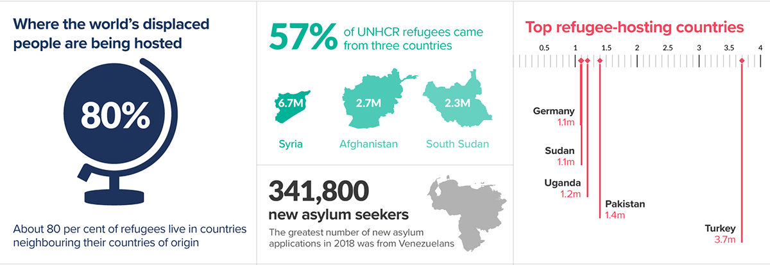](https://www.unhcr.org/figures-at-a-glance.html)