**Πηγή:** **https://brilliant.org**

**Think twice**

[**Classical Mechanics**](https://brilliant.org/mechanics/)Level 2

If in a system, all the internal forces are conservative, then the mechanical energy of that system remains constant only when there are no external forces acting on it. Is this statement always true?

*(The total mechanical energy of a system, is the sum of its kinetic energy and potential energy.)*

**The Newtonian Ant-Man problem!**

[**Classical Mechanics**](https://brilliant.org/mechanics/)Level 2

Suppose somebody achieves the ability to become incredibly dense, or at least more than usual, by using the great space between the atoms of his body. Now this person, (regardless of whether it's possible or not let's assume it is just for the sake of the problem) is hitted by a train both in his dense and normal variations, in the dense one he has the volume of an ant and in the other one of a middle-age man. When does he gain a greater acceleration DUE TO THE TRAIN, who applies the same force in both cases? Assume they're rigid bodies meaning there's no force lost to the body being deformed, and ignore air resistance as you focus only on the force the train applies.

Top of Form

Neither, he has the same acceleration in both

In the one he's smaller he'll have a greater acceleration

In the one he's bigger he'll have a greater acceleration

Bottom of Form

**A not-so-easy dynamics problem**

[**Classical Mechanics**](https://brilliant.org/mechanics/)Level 2

In the system below, the coefficient of friction between all surfaces is the same and equal to 1. When you apply force FFF on the green body, the three bodies move with different accelerations with respect to the ground.

What is the acceleration of the blue body?

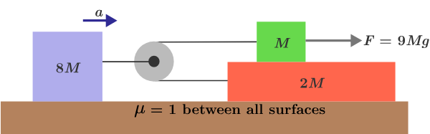

**To Space And Beyond! (The Earth)**

[**Classical Mechanics**](https://brilliant.org/mechanics/)Level 3

The spacecraft *The Newtonian* is heading out from the Earth without propulsion at an initial velocity vvv. Which of the following could be a plausible crew report?

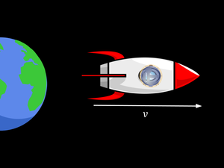

Top of Form

"As we headed further away from the Earth, the force pushing us into our seats diminished." "As we headed further away from the Earth, the force pushing us into our seats was always non-zero and constant." "As we headed further away from the Earth, the force pushing us into our seats was always zero."

**Mechanics - 3**

[**Classical Mechanics**](https://brilliant.org/mechanics/)Level 3

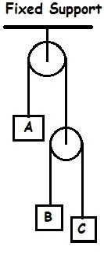

Given that:

* the velocity of AAA with respect to CCC, vAC=300 m/s↑v_{AC} = \text{300 m/s}\uparrowvAC​=300 m/s↑ (note the direction of the velocity)
* the velocity of BBB with respect to AAA, vBA=200 m/s↓v_{BA} = \text{200 m/s}\downarrowvBA​=200 m/s↓.

Find the absolute velocity of AAA, vAv_AvA​.

**Assumptions:**

* The strings are massless and inextensible.
* The pulleys are massless and there is no friction in the pulley and between the string and pulley.

**How much does the CM go up?**

[**Classical Mechanics**](https://brilliant.org/mechanics/)Level 3

Consider a homogeneous cylinder of radius r=1r=1r=1 and height h=2h=2h=2. Cut out a hemisphere of radius 1 from the bottom and place it on top. 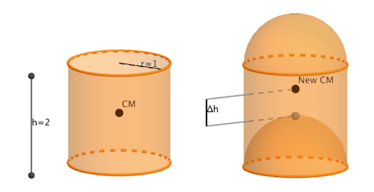

The new body's center of mass will lie at a distance Δh=ab\Delta h=\frac{a}{b}Δh=ba​ where aaa and bbb are coprime positive integers. Find a+ba+ba+b.

What type of function (ignoring constants and lower degree terms) describes the position (in terms of time t t t) of a car whose gas pedal is pushed down with a constant acceleration?

**Accelerating twice**

[**Classical Mechanics**](https://brilliant.org/mechanics/)Level 3

What type of function (ignoring constants and lower degree terms) describes the position (in terms of time t t t) of a car whose gas pedal is pushed down with a constant acceleration?

**Details and Assunptions**

* The acceleration of the car is proportional to the position of the gas pedal.

**Sidereal Times**

[**Classical Mechanics**](https://brilliant.org/mechanics/)Level 2



George and Harold are traveling to the equator for the weekend. They measure the length of the shadow cast by George during the day. They start a stopwatch when George's shadow is the shortest on Saturday, and they stop it when George's shadow is the shortest on Sunday.

Let the time duration recorded by the stopwatch be t,t,t, and let TTT be the time it takes for Earth to make one complete rotation about its axis.

How does ttt compare with T?T?T?

**Note:** Use the fact that Earth rotates about its axis and revolves around the Sun in the same sense. In the animation, both are counterclockwise.

**Getting to 17**

[**Probability**](https://brilliant.org/discrete-mathematics/)Level 1

Starting from the number 1, your goal is to get to the number 17 using only these actions:

* add 1, or
* multiply by 3.

What is the minimum number of actions it takes to get to 17?

Top of Form

5 6 7 8 9

**Classic Dot Puzzle Inspiration**

[**Probability**](https://brilliant.org/discrete-mathematics/)Level 1

What is the minimum number of straight segments needed in a **single closed loop**, in order to pass through a 3×33\times 33×3 square grid of points such that

* each point is intersected exactly once, and
* none of the lines have any grid point as their endpoint(s)?

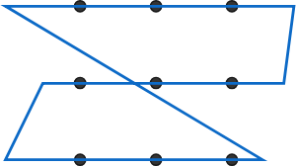This closed loop meets the requirements, but can we do with fewer segments?

Top of Form

3 4 5 6

**The houses of Nicholas**

[**Probability**](https://brilliant.org/discrete-mathematics/)Level 1

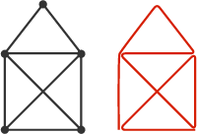

In Germany, the problem to the right is known as "Das Haus vom Nikolaus." The left diagram is a "house" that can be drawn with a single stroke of a pen (never drawing the same segment twice). A possible solution is on its right.

Which of the diagrams below can be drawn with a single stroke of a pen?

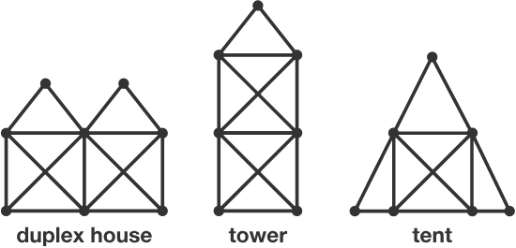

Top of Form

Duplex house Tower Tent None of the above

**Does it Have it?**

[**Probability**](https://brilliant.org/discrete-mathematics/)Level 2

(x−1)(x2−2)(x3−3)⋯(x20−20) \big(x - 1\big)\big(x^2 - 2\big)\big(x^3 - 3\big)\cdots \big(x^{20} - 20\big)(x−1)(x2−2)(x3−3)⋯(x20−20)

What is the coefficient of x203x^{203}x203 in the expansion of this expression?

Bottom of Form

Bottom of Form

Top of Form

Bottom of Form

Bottom of Form