**Πηγή:** **https://brilliant.org**

**Somebody's Wrong**

[**Classical Mechanics**](https://brilliant.org/mechanics/)Level 1

Two students, Jon and Javin, are trying to find the spring constant kkk of an ideal, massless spring.

Both of their setups are the same:

1. Hang the spring in a vertical position and measure the length of the unextended spring L1L_1L1​.
2. Hang a known mass of mass mmm at the bottom of the spring, and measure the length of the extended spring L2L_2L2​
3. Find the length of extension: x=L2−L1x = L_2 - L_1x=L2​−L1​.

However, Jon and Javin have different ways of finding kkk.

Jon proposes:

Suppose the mass is hung on the spring and supported such that the spring remains unextended. This mass has more gravitational potential energy compared to when the mass is unsupported and the spring extends to length L2L_2L2​. In fact, it has mgxmgxmgx more gravitational potential energy, where ggg is the gravitational field strength. This additional gravitational potential energy must be converted to potential energy of the spring as the spring extends to length L2L_2L2​, which is 12kx2\displaystyle \frac{1}{2} kx^221​kx2 by Hooke's Law. Hence by Conservation of Energy, mgx=12kx2\displaystyle mgx = \frac{1}{2}kx^2mgx=21​kx2, so k=2mgx\displaystyle k=\frac{2mg}{x}k=x2mg​.

Javin proposes:

The gravitational force on the mass is mgmgmg, where ggg is the gravitational field strength, while the force on the mass by the spring is kxkxkx by Hooke's Law. Since the mass is in equilibrium, by Newton's First Law, the forces on the mass must balance: kx=mgkx = mgkx=mg. Hence k=mgx\displaystyle k = \frac{mg}{x}k=xmg​.

Jon's and Javin's expressions for kkk differ. Who has the correct reasoning?

**Gravity Train**

[**Classical Mechanics**](https://brilliant.org/mechanics/)Level 2

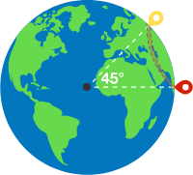

Two cities are situated at an angular distance of 45∘45^\circ45∘ with respect to Earth's center.

You are asked to design a tunnel through Earth’s crust connecting the two cities such that it minimizes the time TTT to commute between the cities when the train moves only under the influence of gravity.

What is this minimum T?T?T?

**Details and Assumptions:**

* Assume Earth to be a sphere of uniform mass density.
* RRR is the radius of Earth.
* ggg is acceleration due to gravity.
* Ignore friction.

**Elastic Block**

[**Classical Mechanics**](https://brilliant.org/mechanics/)Level 2

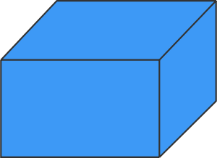

Karen has an elastic block of dimensions 3×4×5.3 \times 4 \times 5.3×4×5. She can press two opposite faces of the block and compress it by a distance of x.x.x.

Along which faces does Karen require the least force to compress the block?

Assume that the block is isotropic.

**Mechanics - 3**

[**Classical Mechanics**](https://brilliant.org/mechanics/)Level 3

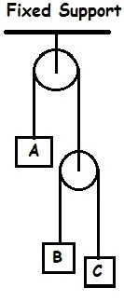

Given that:

* the velocity of AAA with respect to CCC, vAC=300 m/s↑v_{AC} = \text{300 m/s}\uparrowvAC​=300 m/s↑ (note the direction of the velocity)
* the velocity of BBB with respect to AAA, vBA=200 m/s↓v_{BA} = \text{200 m/s}\downarrowvBA​=200 m/s↓.

Find the absolute velocity of AAA, vAv_AvA​.

**Assumptions:**

* The strings are massless and inextensible.
* The pulleys are massless and there is no friction in the pulley and between the string and pulley.

**How much does the CM go up?**

[**Classical Mechanics**](https://brilliant.org/mechanics/)Level 3

Consider a homogeneous cylinder of radius r=1r=1r=1 and height h=2h=2h=2. Cut out a hemisphere of radius 1 from the bottom and place it on top. 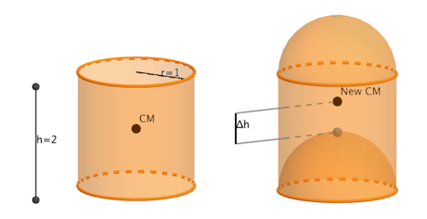

The new body's center of mass will lie at a distance Δh=ab\Delta h=\frac{a}{b}Δh=ba​ where aaa and bbb are coprime positive integers. Find a+ba+ba+b.

**Accelerating twice**

[**Classical Mechanics**](https://brilliant.org/mechanics/)Level 3

What type of function (ignoring constants and lower degree terms) describes the position (in terms of time t t t) of a car whose gas pedal is pushed down with a constant acceleration?

**Details and Assunptions**

* The acceleration of the car is proportional to the position of the gas pedal.

**Sidereal Times**

[**Classical Mechanics**](https://brilliant.org/mechanics/)Level 2



George and Harold are traveling to the equator for the weekend. They measure the length of the shadow cast by George during the day. They start a stopwatch when George's shadow is the shortest on Saturday, and they stop it when George's shadow is the shortest on Sunday.

Let the time duration recorded by the stopwatch be t,t,t, and let TTT be the time it takes for Earth to make one complete rotation about its axis.

How does ttt compare with T?T?T?

**Note:** Use the fact that Earth rotates about its axis and revolves around the Sun in the same sense. In the animation, both are counterclockwise.

**Getting to 17**

[**Probability**](https://brilliant.org/discrete-mathematics/)Level 1

Starting from the number 1, your goal is to get to the number 17 using only these actions:

* add 1, or
* multiply by 3.

What is the minimum number of actions it takes to get to 17?

Top of Form

5 6 7 8 9

Bottom of Form

**Classic Dot Puzzle Inspiration**

[**Probability**](https://brilliant.org/discrete-mathematics/)Level 1

What is the minimum number of straight segments needed in a **single closed loop**, in order to pass through a 3×33\times 33×3 square grid of points such that

* each point is intersected exactly once, and
* none of the lines have any grid point as their endpoint(s)?

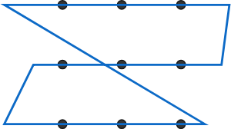This closed loop meets the requirements, but can we do with fewer segments?

Top of Form

3 4 5 6

Bottom of Form

Top of Form

Bottom of Form

**The houses of Nicholas**

[**Probability**](https://brilliant.org/discrete-mathematics/)Level 1

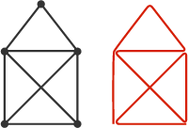

In Germany, the problem to the right is known as "Das Haus vom Nikolaus." The left diagram is a "house" that can be drawn with a single stroke of a pen (never drawing the same segment twice). A possible solution is on its right.

Which of the diagrams below can be drawn with a single stroke of a pen?

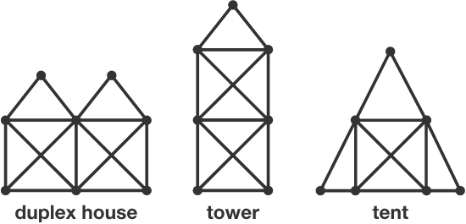

Top of Form

Duplex house Tower Tent None of the above

Bottom of Form

**Does it Have it?**

[**Probability**](https://brilliant.org/discrete-mathematics/)Level 2

(x−1)(x2−2)(x3−3)⋯(x20−20) \big(x - 1\big)\big(x^2 - 2\big)\big(x^3 - 3\big)\cdots \big(x^{20} - 20\big)(x−1)(x2−2)(x3−3)⋯(x20−20)

What is the coefficient of x203 in the expansion of this expression?