Watch the following short video

"Tribute to Unsung heroes of Coronavirus Pandemic"

https://youtu.be/NqiKdkhqRIE

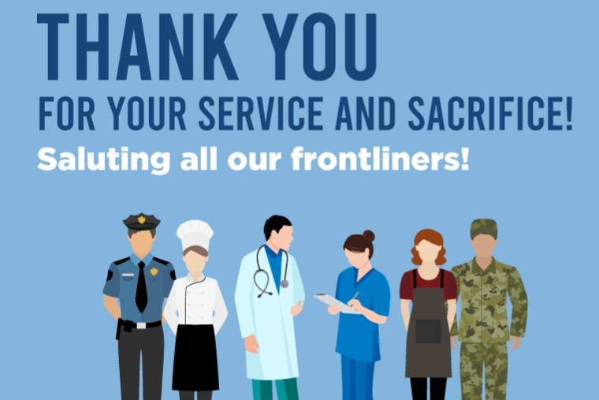
and then
Read the following text

"The undervalued heroes of the coronavirus crisis need our thanks – and our support"
Retrieved from: The Guardian by Owen Jones
https://www.theguardian.com/commentisfree/2020/mar/21/undervalued-heroes-coronavirus-crisis-cleaners-supermarket-workers

‘Thank yous are important, but they are not sufficient.’
Thank yous are too often implied. They get casually dumped in a box labelled “take it as read”, presumed too self-evident to be publicly stated. Sometimes they’re expressed through a knowing nod or a smile, or – before our current plight, of course – a gently squeezed hand clasp. In normal times that’s not really good enough, and in a time of mounting catastrophe, it definitely isn’t.
So, this is a thank you, more profusely meant than any other. Thank you to the supermarket workers, as panicked people throng your stores, leaving your shelves in need of relentless replenishment, your checkouts requiring constant attention and disinfection. You’ve been compelled to offer reassurance to a public who – even in times of calm – can be prone to taking their private frustrations out on you, believing that the power dynamic shields them from retribution.
In some US states, you have now been rightly reclassified as emergency workers, and yet most of you toil for long hours on wages too low to sustain a comfortable life.
Thank you to the paramedics, midwives, nurses and doctors, overwhelmed and under-resourced even before a public health emergency detonated in your hospitals and ambulances. You are lacking in equipment and staff, and – with insufficient masks, protective gear or testing – are risking your health to save lives. More frightened ill people will enter your care as conditions deteriorate in the coming weeks, and yet your efforts will prolong lives and relieve suffering. Thank you, too, to the hospital administrators, managers, secretaries, rota coordinators and other pillars of a desperately strained NHS, without whom it would collapse.
Thank you to the cleaners, among the nation’s most undervalued and underpaid workers. As it is, you save thousands of lives each year – in hospitals and in office blocks – by extinguishing the invisible tormentors of our immune systems. Many middle-class professionals are able to retreat to the relative safety of working from their homes, but no floor can be cleaned remotely: you have now become frontline soldiers in a war against a remorseless killer.
Thank you to those who produce and deliver food and the goods necessary for a healthy existence; to those who keep our transport system operating, preventing the collapse of a nation’s infrastructure. Thank you to the teachers who, by continuing to educate the children, allow doctors and nurses to focus on saving lives and the country to function.
Thank yous are important, but they are not sufficient.
If this gratitude is to be given meaning, it should lead to an overdue reassessment of who we value most in society and how we treat them.
It should not have taken a pandemic to expose how poorly paid, insecure and badly treated so many workers that society cannot function without, truly are...

Question:

Name all the professions (in a word or a phrase ) mentioned in the short video and in the text. (more than 20)

…............................................................................................................................................................

…............................................................................................................................................................

…............................................................................................................................................................

…............................................................................................................................................................

…............................................................................................................................................................

…............................................................................................................................................................

