Coronavirus: The unusual ways countries are managing lockdowns
Retrieved from: BBC NEWS ( https://www.bbc.com/news/world-52109792 )
Countries across the globe are taking unprecedented measures to prevent the coronavirus spreading, ranging from the extreme to the relaxed to the creative.
We've taken a look at some of the more unusual steps countries have taken to combat Covid-19.

1) Panama
The Central American country, which has had close to 1,000 confirmed cases, has announced strict quarantine measures separating people by gender in an effort to stop the spread of the coronavirus.
From Wednesday, men and women will be able to leave their homes for only two hours at a time, and on different days.
No-one will be allowed to go out on Sundays.
"This absolute quarantine is for nothing more than to save your life," security minister Juan Pino said at a press conference.

2) Colombia
In some Colombian towns, people are allowed outside based on the last number of their national ID number.
For example, people in Barrancabermeja with an ID number ending in 0, 7 or 4 are allowed to leave the house on Monday, while those with an ID number ending 1, 8 or 5 can go outside on Tuesday.
Nearby Bolivia is proposing a similar approach.

3) Serbia
At one point, Serbia's government introduced a "dog-walking hour" from 20:00 to 21:00 for those in lockdown. But that has now been scrapped, to howls of protest from dog-owners.
One vet said that skipping the evening walk could worsen the condition for the dogs with urinary problems and "aggravate basic hygienic conditions in people's homes".

4) Belarus
Social distancing may be the current rule in many countries but not in Belarus
Belarusian President Alexander Lukashenko has been raising plenty of eyebrows with his attitude towards the coronavirus outbreak.
He laughed off the suggestion that his country should try to stem the spread of the coronavirus, because he couldn't see the virus "flying around".
Speaking to a TV reporter at an indoor ice hockey match, he also claimed that crowds at the match were fine because the coldness of the stadium would prevent the virus from spreading.
There is no evidence that this could be the case and the coronavirus cannot be seen with the naked eye.
Unlike most of Europe, Belarus has not placed any restrictions on sports events.
"There are no viruses here," Mr Lukashenko said. "You haven't seen them flying around, have you? I don't see them either! This is a fridge. Sport, particularly the ice, this fridge here, that's the best antiviral cure!"
He has also cited drinking vodka and regular trips to the sauna as ways to ward off the virus - which is completely at odds with professional advice.

5) Sweden
Unlike its neighbours, Sweden has taken a relaxed attitude.when it comes to lockdown measures, despite close to 4,500 confirmed cases there. The government hopes people will behave sensibly, and trusts them to do the right thing.
Gatherings of more than 50 people were banned on Sunday but schools for children under the age of 16 remain open.
Pubs and restaurants can still offer table service and many people are still socialising as normal.
The strategy is dividing opinion both at home and abroad, but only time will tell whether the Swedes' laid-back approach will backfire.

6) Malaysia
Advice offered in Malaysia has proven to be no less controversial.
The government was forced to apologise after its women's ministry posted cartoons online telling wives to dress up, wear makeup and avoid nagging their husbands during the country's partial lockdown.
Social media users were quick to criticise the posters, which were later taken down.

7) Turkmenistan
Turkmenistan, meanwhile, has reportedly gone for a completely different approach to the dealing with the pandemic… and banned the word "coronavirus".
According to the independent news website, the Turkmenistan Chronicle - which is banned in the Central Asian nation - the government has removed the word from its health information brochures. Journalists working for Radio Azatlyk have said that people talking about the virus or wearing masks in public could face arrest.
The authorities say no cases of coronavirus have been recorded in Turkmenistan, which borders one of the world's hardest-hit nations, Iran.

8) Austria
While the World Health Organization says that healthy people do not need to wear face masks unless caring for someone who is ill, Austria has made it obligatory to use them in supermarkets.
The new rules were introduced by Chancellor Sebastian Kurz and come into effect on Wednesday, with millions of masks provided.
Although masks are a common sight in many parts of Asia, Austria is only the fourth European country to enforce the use of masks in public - following in the footsteps of the Czech Republic, Slovakia and Bosnia and Herzegovina.

9) Greece
Retrieved from: Greece-is.com (https://www.greece-is.com/news)
Only those going to or from their workplace, shopping for food or medicine, visiting a doctor or pharmacy, taking brief exercise or walking their pet will be allowed to leave their homes. People returning to their permanent places of residence will also be exempt, as will those who are unable to do banking transactions online or have serious family obligations.
In a press conference later on Sunday, government officials clarified that, under the new restrictions, citizens planning to leave the house must inform authorities of the reason for their movements. They have the options: either filling in a special form on the government website, sending an SMS free of charge, or explaining their reason in a signed personal declaration.
Police will be out in force to ensure that the restrictions are being observed and to issue fines of 150 euros for each offense. All citizens must carry police identity cards or passports.

    - Write the name/names of the country next to each statement.

- There are almost 1000 confirmed cases.
- Schools for children under the age of sixteen are open
- Women are advised to look after themselves while in lockdown
- People could walk their dogs for only one hour every evening.
- Ice and alcohol are considered to ward off the virus
- People may be arrested if caught talking about the virus.
- People must wear masks when they are in supermarkets.
- People are allowed to go out only if they have informed the authorities.
- There are NO measures taken to avoid the spread of the virus.
- People are allowed to go out based on the last number on their ID.
- There are no confirmed cases of coronavirus.
- All people who leave their homes should carry a form of identity.
- The use of masks is obligatory. ( 4 countries)
- Pubs and reastaurants are still working.
- People who leave their homes can only stay out for 2 hours.

  - Answer the question:

According to your opinion, which country has taken:
a) the best measures ...............
b) the worst measures ..............

Watch the BBC video and answer the following questions:

Isolation tips from a nuclear submarine captain
https://www.bbc.com/reel/playlist/world-in-lockdown?vpid=p0884k8x
BBC News
01 April 2020|Coronavirus

Video journalist: Ben Moore

Ryan Ramsey knows what it's like to self-isolate.
He was the captain of the nuclear submarine HMS Turbulent between 2008 and 2011 and once spent 286 days at sea without seeing the sky.

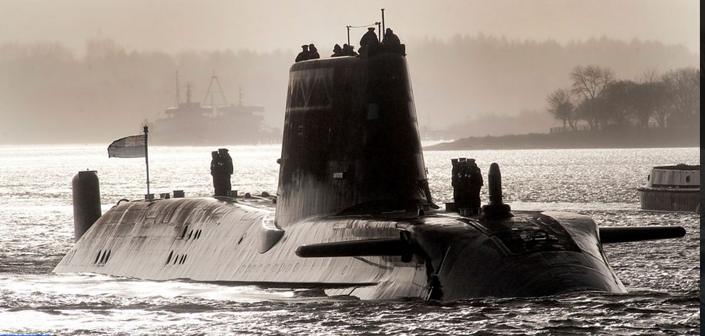
Question
What are the five things that captain Ryan Ramsey considers to be the most important in order to cope with isolation.
1)..................
2)..................
3)..................
4).................
5).................

Do you do any of these things?

….............................................................................................................................................
….............................................................................................................................................

Watch the BBC video and answer the questions

Why do we touch our faces and how to stop it.
https://www.bbc.com/news/av/uk-51879695/coronavirus-why-we-touch-our-faces-and-how-to-stop-it
BBC News, 15 March 2020
Several medical officials across the world have warned people to avoid touching their face as a key way to prevent the spread of coronavirus. Often when issuing the warning, they've gone on to - you guessed it - put their hands on their face.
But why do we touch our faces in the first place? And is it that easy to just stop doing it all of a sudden?
We spoke to psychologist Natasha Tiwari.
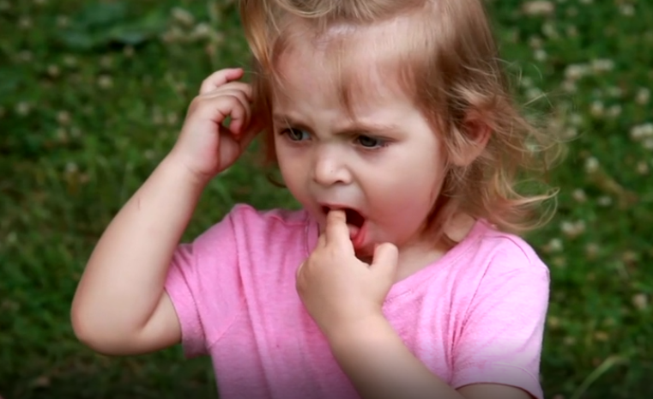

1) Why do people touch their faces (give at least 2 reasons)
a. …......................................................................................
b. …......................................................................................

2) How can we stop touching our face (give at least 3 ideas)
a. …....................................................................................
b. …....................................................................................
c. …....................................................................................

Watch the BBC video and answer the questions

Coronavirus: Health myths to ignore

https://www.bbc.com/reel/playlist/coronavirus-covid19?vpid=p0876nsd
BBC News ,24 March 2020

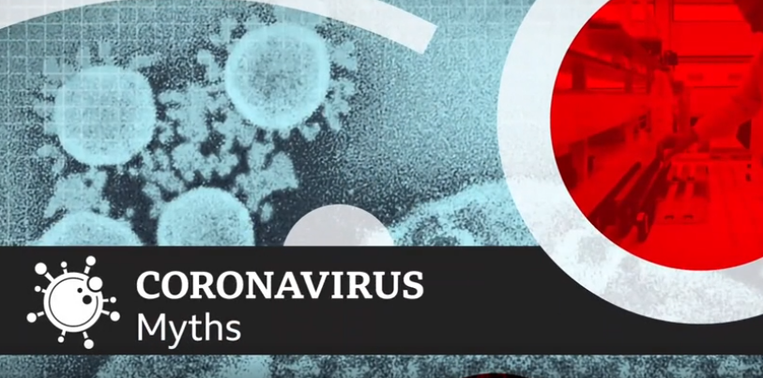

1) What are the 4 myths that the reporter mentions in his story?
a. ....................
b. ...................
c. ....................
d. ....................

2) Would you ever try myth number 4 ?
…......................................................

