PAST TENSES
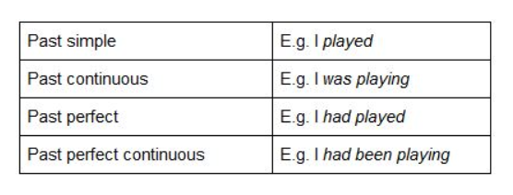
PAST SIMPLE
I went / I played
The main use of the past simple is for finished actions in the past. For example:
- I was born in San Francisco.
- I cleaned my room.
- I forgot my key.

PAST CONTINUOUS
I was going / I was playing
We use this tense when we are talking about actions in progress in the past. Another common use of the past continuous is to show that a longer action was interrupted (usually by a shorter action in the past simple). We often use the time expression when. For example:
- I was swimming in the sea when I saw a shark.
- Henry was sitting at home when the phone rang.
- She was playing golf when it began to rain.

SIMPLE PAST PERFECT
I had gone / I had played
We use it when one action happens before another past action. For example:
A. The film had started when we arrived. (the film started before we arrived)
B. The film started when we arrived (we arrived at the same time the film started)
We use time expressions such as before, by the time and when.

PAST PERFECT CONTINUOUS
I had been going / I had been playing
We use it to show that an action which started in the past continued up to another point in the past. For example:
- She had been living in Italy for three years when she lost her job.
- I had been waiting for ten minutes before the bus came.
- By the time Steve arrived I had been working for nearly eight hours!

