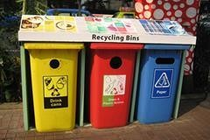
Use the words in capitals to form a word that fits into the space next to it!

GOING GREEN

There is an (ARGUE) that (RECYCLE) may have some unforeseen negative effects. Of course, it would be a major (ACHIEVE) if we were able to increase
(AWARE) to the threat of the environment caused by (POLLUTE) and the (BURN) of fossil fuels. However, if the public’s only (INVOLVE) in ecological issues is taking their newspapers and bottles to a recycling point, we may only be creating the (APPEAR) of (IMPROVE).

If they have to drive any (DISTANT) to the recycling point, for example, it might mean the (CONSUME) of more energy than is saved. In addition, if people feel that they are making their (CONTRIBUTE) to the environment, they might not put so much
(PRESS) on large (ORGANISE) to encourage the
(DEVELOP) of safer, less damaging forms of (PRODUCE).

