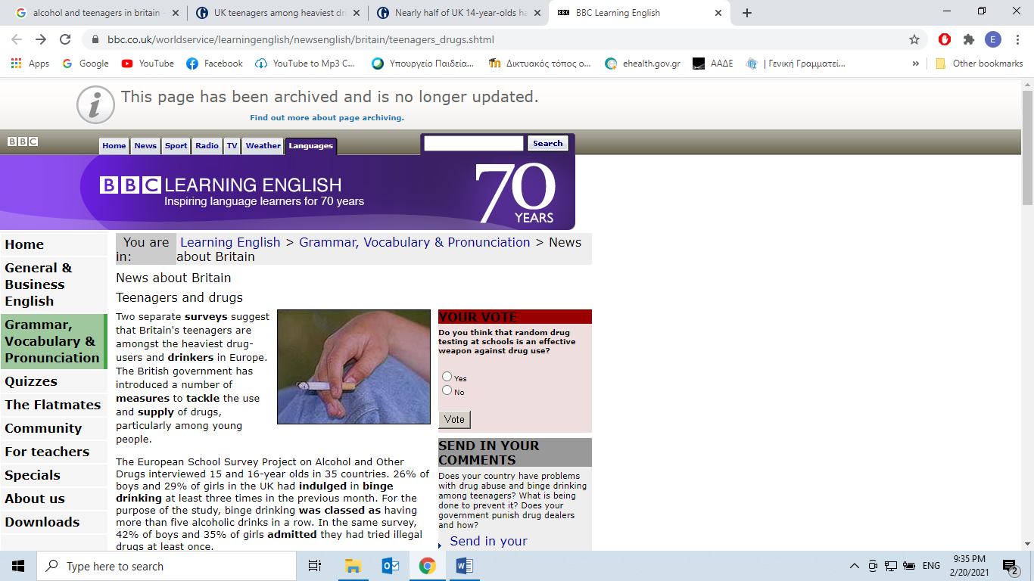

**A. Read the text and decide if each statement (1-10) is True (A) or False (B).**

|  |  |  |
| --- | --- | --- |
| News about Britain    Teenagers and drugs | | |
| |  |  | | --- | --- | | https://www.bbc.co.uk/staticarchive/faaacf6350afde3ead1e7b25148beeb02d5dbbae.gif | Teenagers and drugs | |  |   Two separate **surveys** suggest that Britain's teenagers are amongst the heaviest drug-users and **drinkers** in Europe. The British government has introduced a number of **measures** to **tackle** the use and **supply** of drugs, particularly among young people.  The European School Survey Project on Alcohol and Other Drugs interviewed 15 and 16-year olds in 35 countries. 26% of boys and 29% of girls in the UK had **indulged** in **binge drinking** at least three times in the previous month. For the purpose of the study, binge drinking **was classed as** having more than five alcoholic drinks in a row. In the same survey, 42% of boys and 35% of girls **admitted** they had tried illegal drugs at least once.  According to another survey, by the European Monitoring Centre for Drugs and Drug **Addiction**, two in five 15-year-olds in the UK have tried cannabis. This number is higher than anywhere else in Europe. The UK has also the **joint** highest number of young cocaine users, **alongside** Spain.  The British government has recently **unveiled** new plans to fight the problem of **drug abuse** in the United Kingdom, also among teenagers. According to the new proposals, young offenders will have to attend drug treatment as part of **community service**. British police will be able to give people blood tests for drugs when they arrest them, not just when they **charge them with** an offence. **Dealers** working near a school or using children to help sell drugs will face tougher penalties.  But schools also try to fight the problem of drug use themselves. At the beginning of 2005 a British **state school** has introduced for the first time **random** drug testing. Students from a school in Kent will have **mouth swabs** taken to **detect** drug use. Each week 20 names will be selected by computer and the swabs sent off to a drug testing laboratory. Results will be available three days later. The school's head teacher says that no child will be tested against his or her wishes. Children who test positive will not be **expelled** from the school, but those who sell drugs will.   |  |  |  |  | | --- | --- | --- | --- | | **STATEMENTS** | | **A** | **B** | | **TRUE** | **FALSE** | | **1.** | The article is based on the results of one single research. |  |  | | **2.** | More teenage boys than girls are into binge drinking. |  |  | | **3.** | Binge drinking has been a regular pastime among teenagers at least three times last month. |  |  | | **4.** | More teenage boys than girls had tried illegal drugs. |  |  | | **5.** | The U.K. has more cannabis and cocaine users than anywhere else in Europe. |  |  | | **6.** | The British government are still processing measures to deal with drug abuse which will be announced soon. |  |  | | **7.** | Young offenders will have to offer unpaid work for the community as an alternative to prison. |  |  | | **8.** | Offenders and dealers will be treated equally. |  |  | | **9.** | Only when people are accused of a crime, will be given a blood test for drugs. |  |  | | **10.** | British schools have already joined forces to fight drug abuse. |  |  |   **B. Match each of the phrases below (11-20) with a word from the box that has a similar meaning (A-J). Use each word only once.**   |  |  |  |  |  |  |  |  |  |  | | --- | --- | --- | --- | --- | --- | --- | --- | --- | --- | | **A.** | joint | **B.** | indulged | **C.** | binge drinking | **D.** | tackle | **E.** | community service | | **F.** | unveiled | **G.** | mouth swabs | **H.** | charge them with | **I.** | expelled | **J.** | drug abuse |  |  |  | | --- | --- | | **11.** | made known publicly; revealed | | **12.** | unpaid work for the community, often as an alternative to prison | | **13.** | forced to leave | | **14.** | shared, common | | **15.** | uncontrolled drinking over a period of time | | **16.** | accuse them of | | **17.** | try to deal with ( a problem) | | **18.** | tests taken with a small piece of cotton which is put into a person’s mouth in order to take a sample of their saliva | | **19.** | improper or excessive use of narcotics | | **20.** | you take pleasure in something |   Retrieved from:   https://www.bbc.co.uk/worldservice/learningenglish/newsenglish/britain/teenagers_drugs.shtml |  | |  |  | | --- | --- | |  | | |  | | | https://www.bbc.co.uk/worldservice/images/furniture/clear.gif | https://www.bbc.co.uk/worldservice/images/furniture/clear.gif | |

**C. Fill in the blanks (21-30) with one word from the table (A-J). Use each word only once.**

|  |  |  |  |  |  |  |  |  |  |
| --- | --- | --- | --- | --- | --- | --- | --- | --- | --- |
| **A.** | symptoms | **B.** | dependent | **C.** | deteriorate | **D.** | common | **E.** | attempts |
| **F.** | progressive | **G.** | withdrawal | **H.** | than | **I.** | function | **J.** | personality |

Alcohol abuse is the second most 21 ...……… form of substance abuse in the United States, after tobacco addiction. Some people are more severely affected 22 …………… others.

When an individual's drinking causes distress or harm, that's called an alcohol use disorder. An estimated 10% of adult men and 5% of adult women have an alcohol use disorder.

Early 23…………. of an alcohol abuse disorder include drinking more than planned, continuing to drink alcohol despite the concerns of others, and frequent 24…………… to cut down or quit drinking.

When a person becomes 25……………on alcohol, and can't get a drink, he or she develops 26…………… symptoms such as headache, nausea and vomiting, anxiety, and fatigue.

Finally, 27…………….. changes occur. Someone suffering from alcohol abuse can become more aggressive and his or her ability to 28……………… (hold a job or maintain relationships with friends and family) can seriously 29……………….. Heavy drinkers may experience tremors, panic attacks, confusion, hallucinations, and seizures.

A person who needs help for alcohol addiction may be the last to realize he or she has a problem.

Almost all treatment programs view alcohol dependence as a chronic, 30………………. disease, and most programs insist on complete abstinence from alcohol and other drugs.

Retrieved from:

[***https://www.health.harvard.edu/addiction/alcohol-abuse***](https://www.health.harvard.edu/addiction/alcohol-abuse)