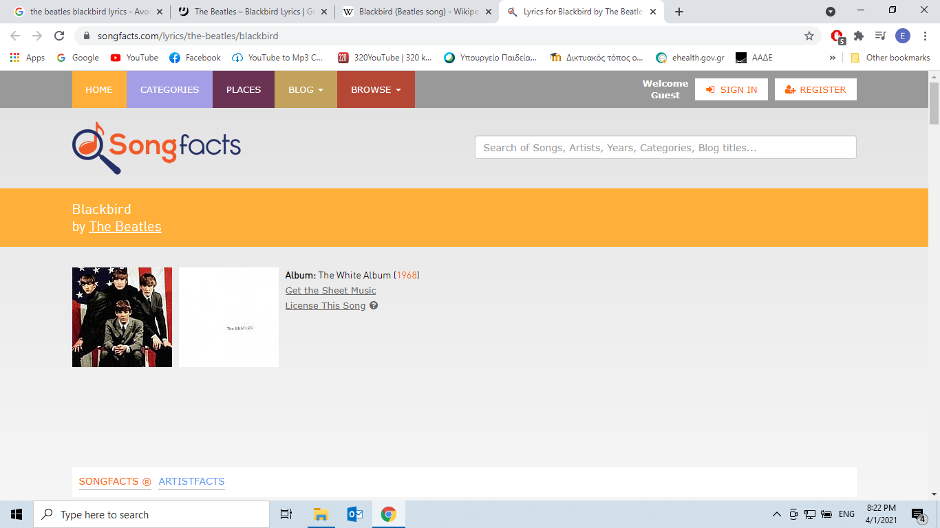

**Retrieved from:**

[***https://www.songfacts.com/facts/the-beatles/blackbird***](https://www.songfacts.com/facts/the-beatles/blackbird)

* Blackbird singing in the dead of night  
  Take these broken wings and learn to fly  
  All your life  
  You were only waiting for this moment to arise  
    
  Blackbird singing in the dead of night  
  Take these sunken eyes and learn to see  
  All your life  
  You were only waiting for this moment to be free  
    
  Blackbird fly, blackbird fly  
  Into the light of a dark black night  
    
  Blackbird fly, blackbird fly  
  Into the light of a dark black night  
    
  Blackbird singing in the dead of night  
  Take these broken wings and learn to fly  
  All your life  
  You were only waiting for this moment to arise  
  You were only waiting for this moment to arise  
  You were only waiting for this moment to arise
* **Writer/s: John Lennon, Paul McCartney  
  Publisher: Sony/ATV Music Publishing LLC, Tratore  
  Lyrics licensed and provided by [LyricFind](https://www.lyricfind.com/" \t "_blank)**

Paul McCartney wrote this about the civil rights struggle for African Americans after reading about race riots in the US. He penned it in his kitchen in Scotland not long after an incident in Little Rock when the federal courts forced the racial desegregation of the Arkansas capital's school system.  
  
"I was sitting around with my acoustic guitar and I'd heard about the civil rights troubles that were happening in the '60s in Alabama, Mississippi, Little Rock in particular," he told *GQ*. "I just thought it would be really good if I could write something that if it ever reached any of the people going through those problems, it might give them a little bit of hope. So, I wrote 'Blackbird.'"

**Retrieved from:**

[***https://en.wikipedia.org/wiki/Blackbird***](https://en.wikipedia.org/wiki/Blackbird) ***(Beatles song)***

The lyrics have invited similarly varied interpretations – as a nature song, a message in support of the [Black Power movement](https://en.wikipedia.org/wiki/Black_Power_movement), or a love song. Writing in the 1990s, [Ian MacDonald](https://en.wikipedia.org/wiki/Ian_MacDonald) dismissed the idea that "Blackbird" was intended as "a metaphor for the black civil rights struggle".[[1]](https://en.wikipedia.org/wiki/Blackbird_(Beatles_song)#cite_note-FOOTNOTEMacDonald1998256fn-1) Noting instead the composition's romantic qualities, MacDonald said that the early-morning bird song "translates … into a succinct metaphor for awakening on a deeper level". However, during an informal rehearsal at EMI Studios on 22 November 1968, before he and Donovan took part in a [Mary Hopkin](https://en.wikipedia.org/wiki/Mary_Hopkin) recording session, McCartney played "Blackbird", telling Donovan that he wrote it after having "read something in the paper about the riots" and that he meant the black "bird" to symbolise a black woman.