**https://www.britannica.com/event/Renaissance**

**Renaissance**, (French: “Rebirth”) period in European civilization immediately following the Middle Ages and conventionally held to have been characterized by a surge of interest in [Classical scholarship](https://www.britannica.com/topic/classical-scholarship) and values. The Renaissance also witnessed the discovery and exploration of new continents, the substitution of the [Copernican](https://www.britannica.com/science/Copernican-system) for the [Ptolemaic](https://www.britannica.com/science/Ptolemaic-system) system of [astronomy](https://www.britannica.com/science/astronomy), the decline of the [feudal system](https://www.britannica.com/topic/feudalism) and the growth of commerce, and the invention or application of such potentially powerful [innovations](https://www.merriam-webster.com/dictionary/innovations) as paper, [printing](https://www.britannica.com/topic/printing-publishing), the mariner’s compass, and gunpowder. To the scholars and thinkers of the day, however, it was primarily a time of the revival of Classical learning and wisdom after a long period of cultural decline and stagnation.

**Artistic Developments And The Emergence Of**[**Florence**](https://www.britannica.com/place/Florence)

It was in [art](https://www.britannica.com/art/visual-arts) that the spirit of the [Renaissance](https://www.britannica.com/art/Renaissance-art) achieved its sharpest formulation. Art came to be seen as a branch of knowledge, valuable in its own right and capable of providing man with images of God and his creations as well as with insights into man’s position in the universe. In the hands of men such as [Leonardo da Vinci](https://www.britannica.com/biography/Leonardo-da-Vinci) it was even a [science](https://www.britannica.com/science/science), a means for exploring nature and a record of discoveries. Art was to be based on the observation of the visible world and practiced according to mathematical principles of balance, harmony, and [perspective](https://www.britannica.com/art/perspective-art), which were developed at this time. In the works of painters such as [Masaccio](https://www.britannica.com/biography/Masaccio), the brothers [Pietro](https://www.britannica.com/biography/Pietro-Lorenzetti) and [Ambrogio Lorenzetti](https://www.britannica.com/biography/Ambrogio-Lorenzetti), [Fra Angelico](https://www.britannica.com/biography/Fra-Angelico), [Sandro Botticelli](https://www.britannica.com/biography/Sandro-Botticelli), [Perugino](https://www.britannica.com/biography/Perugino), [Piero della Francesca](https://www.britannica.com/biography/Piero-della-Francesca), [Raphael](https://www.britannica.com/biography/Raphael-Italian-painter-and-architect), and [Titian](https://www.britannica.com/biography/Titian); sculptors such as [Giovanni Pisano](https://www.britannica.com/biography/Giovanni-Pisano), [Donatello](https://www.britannica.com/biography/Donatello), [Andrea del Verrocchio](https://www.britannica.com/biography/Andrea-del-Verrocchio), [Lorenzo Ghiberti](https://www.britannica.com/biography/Lorenzo-Ghiberti), and [Michelangelo](https://www.britannica.com/biography/Michelangelo); and architects such as [Leon Battista Alberti](https://www.britannica.com/biography/Leon-Battista-Alberti), [Filippo Brunelleschi](https://www.britannica.com/biography/Filippo-Brunelleschi), [Andrea Palladio](https://www.britannica.com/biography/Andrea-Palladio), [Michelozzo](https://www.britannica.com/biography/Michelozzo), and [Filarete](https://www.britannica.com/biography/Filarete), the dignity of man found expression in the arts.

[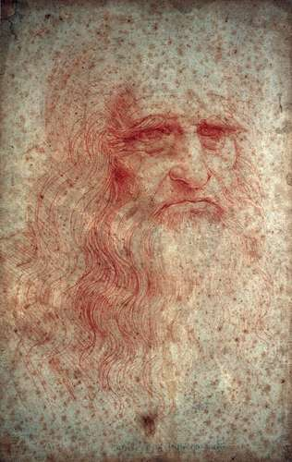](https://cdn.britannica.com/75/115475-050-9F9B00CE/Self-portrait-drawing-Leonardo-da-Vinci-Royal-Library.jpg)

[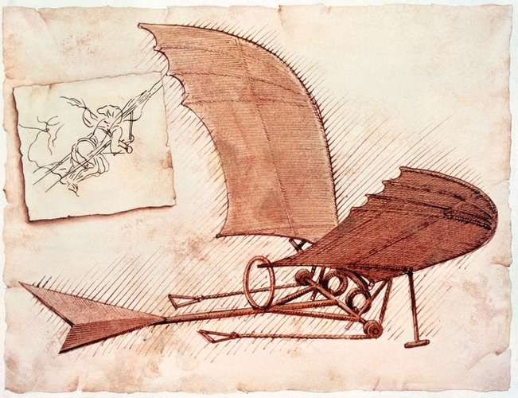](https://cdn.britannica.com/40/96240-050-142CC589/flying-machine-Leonardo-da-Vinci-plans-ornithopter.jpg)

[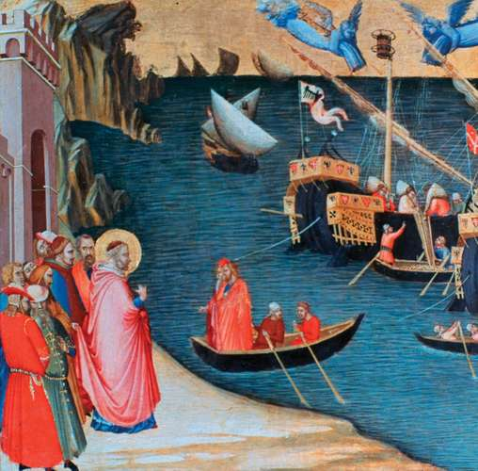](https://cdn.britannica.com/16/121116-050-8F6F07F1/Saving-Myra-from-Famine-detail-panel-tempera.jpg)

[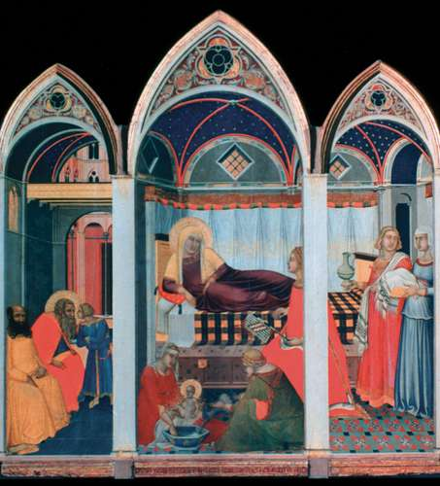](https://cdn.britannica.com/54/132254-050-EE0282C1/Birth-of-the-Virgin-Pietro-Lorenzetti-Siena.jpg)

[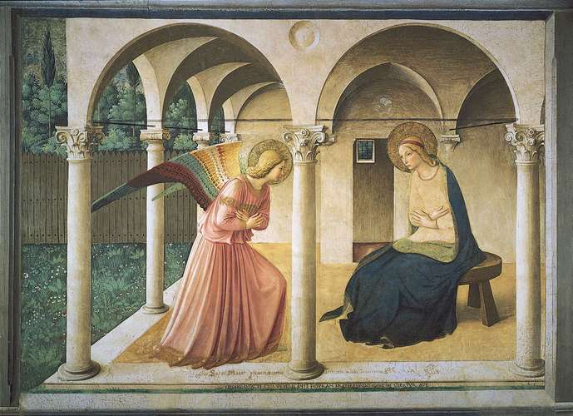](https://cdn.britannica.com/94/5594-050-1C1166D6/Annunciation-Fra-Angelico-Florence-Museum-of-San.jpg)

[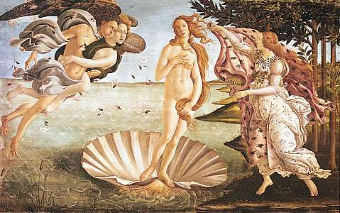](https://cdn.britannica.com/92/6792-004-C757C6D7/The-Birth-of-Venus-canvas-Sandro-Botticelli.jpg)

[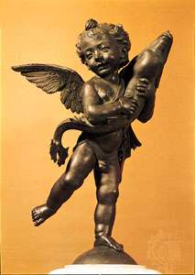](https://cdn.britannica.com/19/4919-004-9B492403/Putto-Dolphin-bronze-sculpture-Andrea-del-Verrocchio.jpg)

[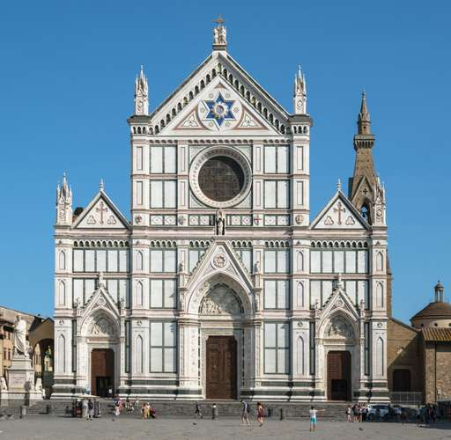](https://cdn.britannica.com/25/13725-050-6432C39D/Santa-Maria-Novella-Florence-Leon-Battista-Alberti.jpg)

[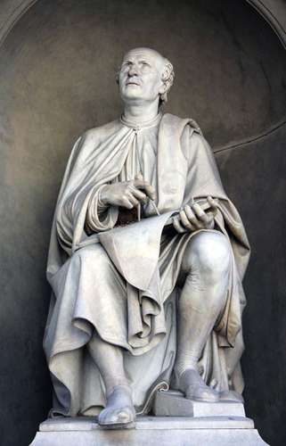](https://cdn.britannica.com/76/145976-050-EF221E05/Filippo-Brunelleschi-statue-Luigi-Pampaloni-Florence-Duomo-1830.jpg)

[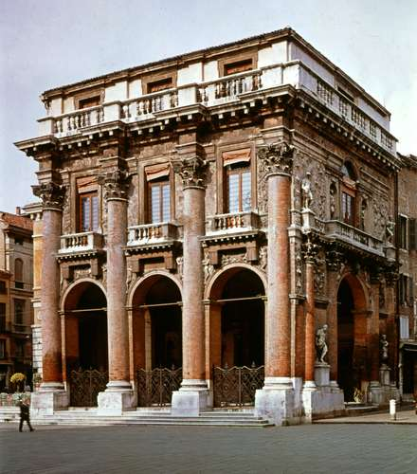](https://cdn.britannica.com/22/8822-050-514D00A8/Loggia-del-Capitanio-Andrea-Palladio-Italy-Vicenza.jpg)

**Leonardo da Vinci**Self-portrait of Leonardo da Vinci in red chalk, *c.* 1512–15.*Photos.com/Jupiterimages*

**Leonardo da Vinci: ornithopter**Leonardo da Vinci's plans for an ornithopter, a flying machine kept aloft by the beating of its wings, *c.* 1490.*SuperStock*

**Lorenzetti, Ambrogio: *Saving Myra from Famine****Saving Myra from Famine*, detail of a panel from *Four Stories from the Life of St. Nicholas*, tempera on wood by Ambrogio Lorenzetti, *c.* 1330–32; in the Uffizi Gallery, Florence.*© Photos.com/Jupiterimages*

**Pietro Lorenzetti: *Birth of the Virgin****Birth of the Virgin*, triptych by Pietro Lorenzetti, 1342; in the Museo dell'Opera del Duomo, Siena, Italy.*Photos.com/Jupiterimages*

**Fra Angelico: *The Annunciation****The Annunciation*, fresco by Fra Angelico, 1438–45; in the Museum of San Marco, Florence.*SCALA/Art Resource, New York*

**Sandro Botticelli: *The Birth of Venus****The Birth of Venus*, tempera on canvas by Sandro Botticelli, c. 1485; in the Uffizi Gallery, Florence. 172.5 × 278.5 cm.*Gallleria Degli Uffizi, Florence, Italy/SuperStock*

**Pisano, Giovanni: pulpit**Marble pulpit by Giovanni Pisano, 1297–1301; in the church of San Andrea, Pistoia, Italy.*© Piero M. Bianchi—Moment/Getty Images*

**Verrocchio, Andrea del: *Putto with Dolphin****Putto with Dolphin*, bronze sculpture by Andrea del Verrocchio, before 1476; in the Palazzo Vecchio, Florence.*Art Resource, New York*

**Ghiberti, Lorenzo**Self-portrait by Lorenzo Ghiberti, detail from *Gates of Paradise*, 1425–52; on the east side of the Baptistery of San Giovanni, Florence.*Brogi—Alinari/Art Resource, New York*

**Filippo Brunelleschi**Filippo Brunelleschi, statue by Luigi Pampaloni, 1830; near the Duomo, Florence.*© Mc Xas/Fotolia*

**Palladio, Andrea: Loggia del Capitanio**Loggia del Capitanio, a gallery designed by Andrea Palladio, in Vicenza, Italy.*SCALA/Art Resource, New York*