**WRITTEN BY**

[**Mario Salmi**](https://www.britannica.com/contributor/Mario-Salmi/2574)

Professor of the History of Medieval and Modern Art, University of Rome. Author of *Il Beato Angelico*and many monographs on Italian Renaissance artists.

**Fra Angelico**

QUICK FACTS

**Alternative Titles:** Beato Angelico, Fra Giovanni da Fiesole, Guido di Pietro

**To students:**

(*Make sure you follow the underlined links in blue for vocabulary and explanatory notes*)

**Fra Angelico**, (Italian: “Angelic Brother”) original name **Guido di Pietro**, also called **Fra Giovanni da Fiesole** and **Beato Angelico**, (born *c.* 1400, Vicchio, republic of Florence [Italy]—died February 18, 1455, Rome), Italian painter, one of the greatest 15th-century painters, whose works within the framework of the early [Renaissance](https://www.britannica.com/event/Renaissance) style [embody](https://dictionary.cambridge.org/dictionary/english/embody) a *serene (peaceful)* religious attitude and reflect a strong Classical influence. A great number of works executed during his career are [altarpieces](https://www.britannica.com/topic/altarpiece) and [frescoes](https://www.britannica.com/art/fresco-painting) created for the church and the priory of San Marco in Florence while he was in residence there.

* [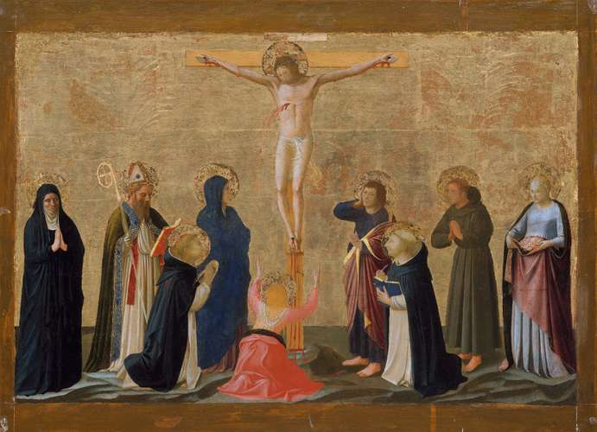](https://cdn.britannica.com/23/198623-050-AEEA3776/Crucifixion-tempera-painting-Fra-Angelico-New-York.jpg)

**Fra Angelico: *The Crucifixion***

*The Crucifixion*, tempera painting by Fra Angelico, possibly *c.* 1440; in the Metropolitan Museum of Art, New York City.

*The Metropolitan Museum of Art, New York, Bequest of Benjamin Altman, 1913 (14.40.628), www. metmuseum.org*

Taken from:

<https://www.britannica.com/biography/Fra-Angelico>

*Citation*

CONTRIBUTOR:

[Mario Salmi](https://www.britannica.com/contributor/Mario-Salmi/2574)

TITLE

Fra Angelico

PUBLISHER

Encyclopædia Britannica

DATE PUBLISHED

February 14, 2020

URL

<https://www.britannica.com/biography/Fra-Angelico>

ACCESS DATE

November 16, 2020

<https://www.britannica.com/biography/Fra-Angelico/Years-at-the-priory-of-San-Marco>

**Years At The Priory Of San Marco**

Angelico remained in the Fiesole *priory (small monastery)* until 1439, when he entered the [priory of San Marco](https://www.britannica.com/place/priory-of-San-Marco) in Florence. There he worked mostly on frescoes. San Marco had been transferred from the Sylvestrine monks to the Dominicans in 1436, and the rebuilding of the church and its spacious priory began about 1438, from designs by the Florentine architect and sculptor [Michelozzo](https://www.britannica.com/biography/Michelozzo). The construction was generously subsidized by the [Medici family](https://www.britannica.com/topic/Medici-family). Angelico was commissioned about 1438 by Cosimo de’ Medici the Elder to execute the [altarpiece](https://www.britannica.com/topic/altarpiece), for which he again painted a *sacra conversazione*. When the church was [consecrated](https://www.merriam-webster.com/dictionary/consecrated) at [Epiphany](https://www.britannica.com/topic/Epiphany) in 1443, the altarpiece must have dominated the place of worship. Angelico portrayed the Virgin and child raised high on a throne, with saints on either side receding into space; among them are the two patron saints of the Medici, [Cosmas and Damian](https://www.britannica.com/biography/Saint-Cosmas). This work, one of the most compelling Fra Angelico created, ends in a dense grove of cypresses, palms, and pines against a deep but toneless sky. His figures seem cleansed of any human passion and appear to have supreme serenity of spirit. A [predella](https://www.merriam-webster.com/dictionary/predella), showing eight little [legends](https://www.merriam-webster.com/dictionary/legends) of the two Medicean saints separated by a [Pietà](https://www.britannica.com/topic/Pieta-iconography) (Virgin Mary holding the body of Christ), completed the work. These paintings are now scattered among various museums.

On the walls of the priory of San Marco in Florence are the paintings that mark the high point of Angelico’s career. In the chapter hall, he executed a large [*Crucifixion*](https://www.britannica.com/topic/Crucifixion-Christianity) that seems akin to the “Moralities” of the 14th century, which urged detachment from worldly vanities and salvation through Christ alone. In addition to the three crucified figures against the sky, Angelico painted groups of ritual figures, rhythmically arranged, with a chorus of [martyrs](https://www.merriam-webster.com/dictionary/martyrs), founders of religious orders, hermits, and defenders of the Dominican order (whose genealogical tree is depicted beneath this striking scene), as well as the two Medicean saints. Thus, in the *comprehensiveness (understanding)* of this work, Fra Angelico developed a concept that was barely suggested in his earlier altarpieces.

Fra Angelico portrayed the [exaltation](https://dictionary.cambridge.org/dictionary/english/exaltation) of [the Redeemer](https://dictionary.cambridge.org/dictionary/english/redeemer) in many other paintings in the priory’s first cloister and in its cells. In one corridor he executed an Annunciation that broadened the pattern of his earlier one in Cortona. In the cells, he proclaimed devotion to Christ crucified in at least 20 examples, all related to monastic life. The pictorial work in these narrow spaces is intricate, probably the work of numerous hands directed by the master, including [Benozzo Gozzoli](https://www.britannica.com/biography/Benozzo-Gozzoli), the greatest of Fra Angelico’s [disciples](https://www.merriam-webster.com/dictionary/disciples), and Zanobi Strozzi, another pupil better known as a miniaturist, as well as his earliest collaborator, Battista Sanguigni. The hand of Fra Angelico himself is identifiable in the first 10 cells on the eastern side. Three subjects *merit(deserve)* particular attention: a [Resurrection](https://www.britannica.com/topic/resurrection-religion), a coronation of the Virgin, and, especially, a gentle Annunciation, presented on a bare white gallery, with [St. Peter Martyr](https://www.britannica.com/biography/Saint-Peter-Martyr) in prayer, *timidly(shyly)* facing the group, his coloured habit contrasting with the delicate two tones of pink in the garments of the Virgin and the Angel. The cells, originally hidden from public view because of monastic vows of [reclusion](https://www.thefreedictionary.com/reclusion), reveal the secret joy of the painter-*friar (monk)* in creating figures of purity to move his fellow friars to meditation and prayer. The images in these paintings are the lyrical expressions of a painter who was also their prior.

[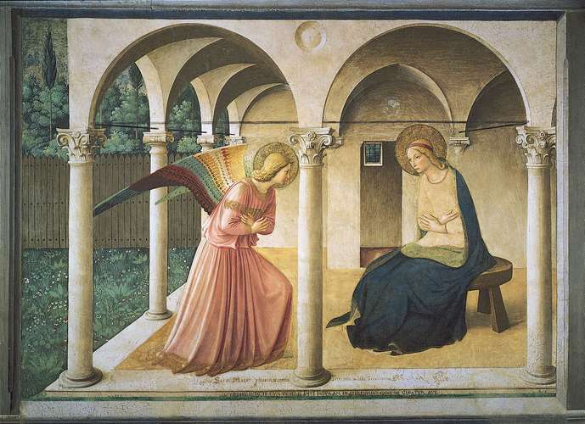](https://cdn.britannica.com/94/5594-050-1C1166D6/Annunciation-Fra-Angelico-Florence-Museum-of-San.jpg)

**Fra Angelico: *The Annunciation***

*The Annunciation*, fresco by Fra Angelico, 1438–45; in the Museum of San Marco, Florence.

*SCALA/Art Resource, New York*

**Roman Period**

At the end of 1446, Fra Angelico was called to Rome by [Pope Eugene IV](https://www.britannica.com/biography/Eugenius-IV), and he remained there until about 1450.

In Rome the frescoes that Angelico executed in a chapel of [St. Peter’s](https://www.britannica.com/topic/Saint-Peters-Basilica) (*c.* 1446–47), in the chapel of the Sacrament in the Vatican (not before 1447), and in the studio of [Pope Nicholas V](https://www.britannica.com/biography/Nicholas-V-pope) (1449) have all been destroyed.

About 1450 Fra Angelico returned to Florence, where, still a friar, he became *prior (in charge)* of the priory of San Domenico in Fiesole (1450–*c.* June 1452). His most notable work of this time was the cycle of 35 paintings of scenes from the life of Christ and other subjects for the doors of a silver chest in the sanctuary of the church of [Santissima Annunziata](https://www.britannica.com/place/Santissima-Annunziata) in Florence.

In 1453 or 1454, Fra Angelico again went to Rome, where he died in the Dominican priory in which he had stayed during his first visit to that city. He was buried in the nearby church of Santa Maria sopra Minerva, where his tomb remains an object of veneration.

**Legacy**

In addition to the influence he had on his followers, Fra Angelico [exerted](https://www.collinsdictionary.com/dictionary/english/exert) a significant influence in Florence, especially between 1440 and 1450, even on such an accomplished master as [Fra Filippo Lippi](https://www.britannica.com/biography/Fra-Filippo-Lippi). As a friar, Fra Angelico was *lauded (praised)* in writings of the 15th century and later, some of which [bestowed](https://dictionary.cambridge.org/dictionary/english/bestow) a legendary halo on him. As a painter, he was acclaimed as early as 1438 by the contemporary painter [Domenico Veneziano](https://www.britannica.com/biography/Domenico-Veneziano). Vasari, in his section on Angelico in [*Lives of the Most Eminent Italian Painters, Sculptors, & Architects*](https://www.britannica.com/topic/Lives-of-the-Most-Eminent-Painters-Sculptors-and-Architects), was largely inaccurate in his biographical data but correctly situated Fra Angelico in the framework of the Renaissance.

**Further suggestion**

You can also visit the site of the MET Museum N.Y. on his work:

<https://www.metmuseum.org/toah/hd/fang/hd_fang.htm>

Briefly answer the questions:

1. Which work marks the high point in Angelico’s career?

…………………………………………………………………………………………………………………………………………………………………………………………………………………………

2. Mention his fields of work and places he visited during his lifetime.

……………………………………………………………………………………………………………………………………………………………………………………………………………………………………………………………………………………………………………………………………………………………………………………………………………………………………………………

3. Describe his style and themes of his work.

…………………………………………………………………………………………………………………………………………………………………………………………………………………………………………………………………………………………………………………………………………………………………………………………………………………………………………………….