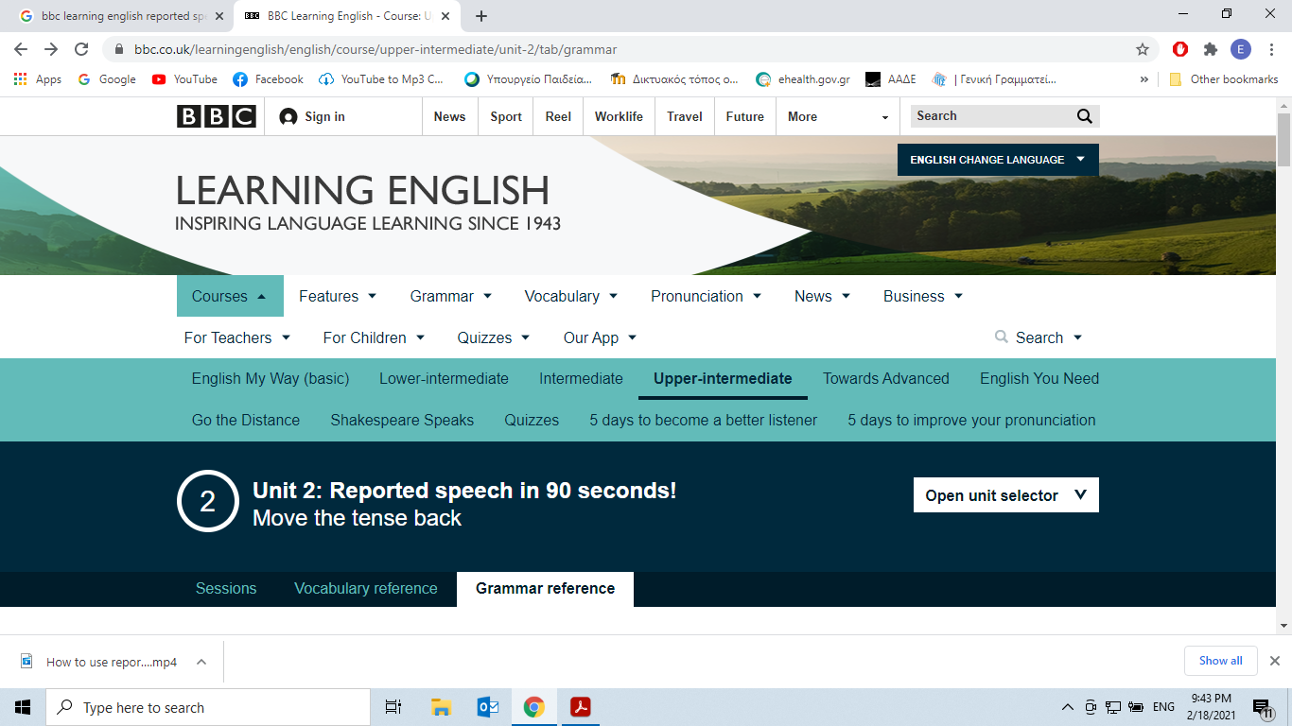

**Grammar Reference**

**Reported Speech**

**Meaning and use**

If someone says something that you want to tell another person, you can report it using **direct speech** or **reported speech**.

In direct speech we use speech (or quotation) marks to show the exact words the person said.

**"**I’m hungry.**"**

**"**I love chicken sandwiches.**"**

We can also use a reporting verb to show who was speaking.

He **says:** "I’m hungry."

She **tells** me: "I love chicken sandwiches."

**Say** and **tell** are both reporting verbs. We use **tell**when we say who we are speaking to.

**CORRECT:** *She****tells me****she loves chicken sandwiches.* (The speaker is talking to ‘me’.)

**CORRECT:** *She****says****she loves chicken sandwiches.*(We don’t know who the speaker is talking to.)

**WRONG:** *She****says me****she loves chicken sandwiches.*(We don’t use ‘me’ with the reporting verb ‘say’.)

**CORRECT:** *She said TO me she loves chicken.*

If the reporting verb is in the present tense, then the reported statement stays in the present tense:

**Direct speech**

***"****He****’s****hungry****"****, he****says****.*

*She****tells****me, "I****love****chicken sandwiches."*

**Reported speech**

*He****says****he****is****hungry.*

*She****tells****me she****loves****chicken sandwiches.*

If the reporting verb is in the past tense, we usually change the present form to a past form in reported speech.

**Direct speech**

***"****He****’s****hungry****"****, he****said****.*

*She****told****me, "I****love****chicken sandwiches."*

**Reported speech**

*He****said****he****was****hungry.*

*She****told****me she****loved****chicken sandwiches.*

We change the pronoun when the speaker or listener changes.

A boy tells his mother: *"I****’m****hungry.*”

Later, the boy’s mother tells the father: *He said****he****was hungry.*

We can use **that,** but we can also miss it out and the meaning is the same.

*He said****that****he was hungry. > He said he was hungry.*

*She told me****that****she loved chicken sandwiches. > She told me she loved chicken sandwiches.*

**Form**

In reported speech, we usually move the direct speech verb one step back in the past.

**1)   Present simple -> past simple**

*"I****know****you." -> She said she****knew****him.*

**2)   Present continuous -> past continuous**

*"I****am having****coffee" -> He said he****was having****coffee.*

**3)   Present perfect -> past perfect**

*"I****have finished****my homework" -> He said he****had finished****his homework.*

**4)   Present perfect continuous -> past perfect continuous**

*"I****have been studying****Chinese" -> She said she****had been studying****Chinese.*

**5)   Is going to - > was going to**

*"I****am going to****go home" -> She said she****was going to****go home.*

**6)   Future simple - > would**

*"I****will go****to the bank later" -> He said he****would go****to the bank later.*

**Notes**

1) A reported statement in the**past simple**often stays the same:

*"I****drove****to work" -> She said she****drove****to work.*

2) And you can't go further back in time than the **past perfect**, so it stays the same too:

*"I****had driven****to work" -> She said she****had driven****to work.*

3) **Modal verbs**: some change in reported speech:

*“I****can/can't****speak Turkish” -> She said she****could/couldn't****speak Turkish.*

*“I****must/mustn't****wash my hair” -> She said she****had to/didn't have to****wash her hair.*

4) Some modal verbs don't change:

*“I****could****take the bus” -> He said he****could****take the bus.*

*“I****should****go to bed” -> She said she****should****go to bed.*

*“I****might****watch TV”   -> He said he****might****watch TV.*

5) We don’t change the verb in reported speech if the situation hasn’t changed, for example if it’s a fact or is generally true:

*"I****love****you" -> She told me she****loves****me.*

6) But we can use the past tense to show you're not certain the other person loves her/him – for example, the other person wasn’t telling the truth

*"I love you" -> She said she****loved****me.*

**Questions**

A **direct question** is:

*Where are you from?*

A **reported question** is:

*He asked where I was from.*

To form a reported question, you need to follow these steps:

1) Use a reporting verb:

*He****asked****where I was from.*

2) Repeat the question word:

*He asked****where****I was from.*

3) Change the pronouns:

*He asked where****I****was from.*

4) Move the tense back:

*He asked where I****was****from.*

5) Use statement word order:

*He asked where****I was from****.*

**Note: Yes/no questions**

For**yes/no questions**, we use**if**or**whether**.

*Example: Is it two o'clock?*

* *She asked if it was two o'clock*
* *She asked whether it was two o'clock*

**Form summary**

**Positive**

"I **love** you." > He said he **loved** her.

"I**’ve been working**hard." > She told me that she**’d been working**hard.

"I’**ll see**you later." > He said he **would see** me later.

**Negative**

"I **didn’t have** time to go shopping." > He said he **hadn’t had** time to go shopping. “I **can’t talk** to you." > She told me that she **couldn’t talk** to me.

"I **wouldn’t want** to live in the country." > He said he **wouldn’t want** to live in the country.

**Question**

"Where **can** I buy a hamburger?" > She asked **where** she **could** buy a hamburger.

"Who **must** I see at the bank?" > He asked **who** he **had to** see at the bank.

"**Are** you **going** to Leila’s party?" > She asked**if** I **was going** to Leila’s party.

**Short answers**

“Yes, I am. / No, I’m not.”> **I said I was. / I said I wasn’t.**

**Take note: facts and general truths**We don’t change the verb in reported speech if the situation hasn’t changed, for example if it’s a fact or is generally true. Compare:

*She****told****me she****loves****me.*(The speaker uses the present tense to show (s)he believes the other person still loves her/him now.)

*She****told****me she****loved****me.*(The speaker uses the past tense to show (s)he isn’t certain the other person loves her/him – for example, the other person wasn’t telling the truth.)

**Take note: the past perfect**

The past perfect doesn’t change in reported speech because there isn’t a verb form further 'back in time'.

*"I****had never eaten****sushi before I went to Japan." > 'She told me that she****had never eaten sushi****before she went to Japan.*

**Take note: reporting verbs**

We can use different verbs to report our thoughts, opinions or intentions.

"I know which way to go." -> He **thought** he knew which way to go.

"I stole the books." -> He **admitted** that he had stolen the books.

"Why doesn’t she like me?" -> He **wondered** why she didn’t like him.

**Spoken English**

Some contracted forms in reported speech can be difficult to hear, for example the past perfect and conditional. *He asked who****’d eaten****the cake. I told him he****’d have****to take the train.*In the first example, the words ‘who’and ‘had’ become **who’d**. In the second example, ‘he’and ‘would’ become **he’d**. In both examples, two different words are shortened to just a **/d/** sound. So, listen carefully for past tense contractions – make sure you get them right.

**Session 1**

**Insist**, **demand** and **advise** are all **reporting verbs**.

1**Activity 2**

Time to practise

**I can't deny it...**

In 6 Minute Vocabulary we learned these useful **reporting verbs**: **deny**,**admit**,**apologise**,**insist**,**suggest**, **advise**,**demand**and**offer**.

We use them to talk about what someone has said. They're used more often in writing than speaking, and are especially common in journalism.

For example, a recent news story about the British economy said:

*As the chancellor presented the first Conservative Budget in 20 years, he****insisted****that Britain had "turned a corner".*

In other words, the chancellor **said firmly** that Britain had "turned a corner" (come out of a difficult situation). We often use **insist** when we know that not everyone agrees with what we are saying.



**Activity 3**

What comes after the verb?

**The grammar of reporting verbs**

Knowing how to use **reporting verbs** correctly in a sentence is important. In our examples so far, you may have noticed that some verbs are followed by **'that' +** **clause**, some are followed by **verb-ing** (a gerund), and some are followed by a **preposition**.

We're now going to look at what comes after **reporting verbs**. Some verbs appear more than once because they can be used in different ways.

**1) Reporting verb + 'that' + clause:**admit, deny, insist, suggest.

* *He****admitted that he was mean****.*
* *The****suspect denied that he was at the scene of the crime****.*
* *We****insist that you join us for dinner****.*
* *I****suggest that you arrive early****.*

**Note:**People often leave out the **that** in spoken English. The meaning is the same:

* *I suggest you arrive early.*
* *We insist you join us for dinner.*

**2) Reporting verb + verb-ing:**deny, suggest

* *Lucia****denied meeting****the businessman last week.*
* *Mark****suggested buying****stocks in the IT firm.*

**3) Reporting verb + preposition + verb-ing:**apologise, insist

* *She****apologised for forgetting****my birthday.*
* *We****insisted on sharing****the cost of the meal*

**Note:**You can also apologise **to**someone**(apologise + to + object)**

* *Baz****apologised to Lucia****for forgetting her birthday.*

**4) Reporting verb + 'to' + infinitive:**demand, offer

* *Barry****demanded to know****the answer.*
* *Brutus****offered to pay****for the damage.*

**5) Reporting verb + indirect object + infinitive:**advise

* *I****advised him to****apply.*

**6) Reporting verb + indirect object + 'that' + clause:**advise

* *I****advised him that he should apply****.*

Read the text and complete the activity



**To do**

First, read this short story. Then you're going to use reporting verbs to make sentences about it. As we said, people don't always say the **that** before a clause, but in this game you need to include **that** to show you understand the full form. And as you can see, the verbs **advise**, **insist**, **deny**, **suggest** and **apologise**, can be followed by different words. In questions with one of these verbs, the words you are given will allow you to make only one correct form.

**The story**

Lucian and Martina were deeply in love, but they argued a lot. Martina was unhappy because Lucian never arrived anywhere on time, and because he never said sorry. Lucian thought Martina should be more generous and buy him presents. Martina disagreed. A friend said they should separate for a short time. Neither of them wanted to, but they did in the end. After a week apart, they got back together and started arguing again.

**Session Grammar**

* **Reporting verbs**

**1) Reporting verb + 'that' + clause:**admit, deny, insist, suggest.

*He****admitted that he was mean****.*

**Note:**People often leave out the **that** in spoken English. The meaning is the same:

*I suggest you arrive early.*

**2) Reporting verb + verb-ing:**deny, suggest

*Lucia****denied meeting****the businessman last week.*

**3) Reporting verb + preposition + verb-ing:**apologise, insist

*She****apologised for forgetting****my birthday.*

**4) Reporting verb + 'to' + infinitive:**demand, offer

*Barry****demanded to know****the answer.*

**5) Reporting verb + indirect object + infinitive:**advise

*I****advised him to****apply.*

**6) Reporting verb + indirect object + 'that' + clause:**advise

*I****advised him that he should apply****.*

**Session Vocabulary**

* **deny**to say that something is not true, especially when other people are saying it is

**admit**to say that something is true, although you don’t want to say this

**apologise for**to say that you are sorry for something that you have done

**insist**to say firmly that something is or isn’t correct, when other people are saying the opposite

**suggest**(meaning one)  
to tell someone your ideas about what to do, where to go, etc.

**suggest** (meaning two)  
to say something is true but not in a strong or direct way

**advise**to tell someone what you think they should do, in a polite way

**demand**to ask for something very firmly or aggressively

**offer**to say that you are willing to do something