**ADDICTIONS:**

**Go to the introductory page 66 of your book: Answer the following:**

1. **What do you think of when you hear the word *addiction?* (PROVIDE A DEFINITION)**

______________________________________________________________________________________________________________________________________________________________________________________________________________________________________________________

1. **Which substances and behaviours could be addictive? Complete the Mindmap charts(for help have a look at *addictioncenter* and *WHO.***

***SUBSTANCES:***

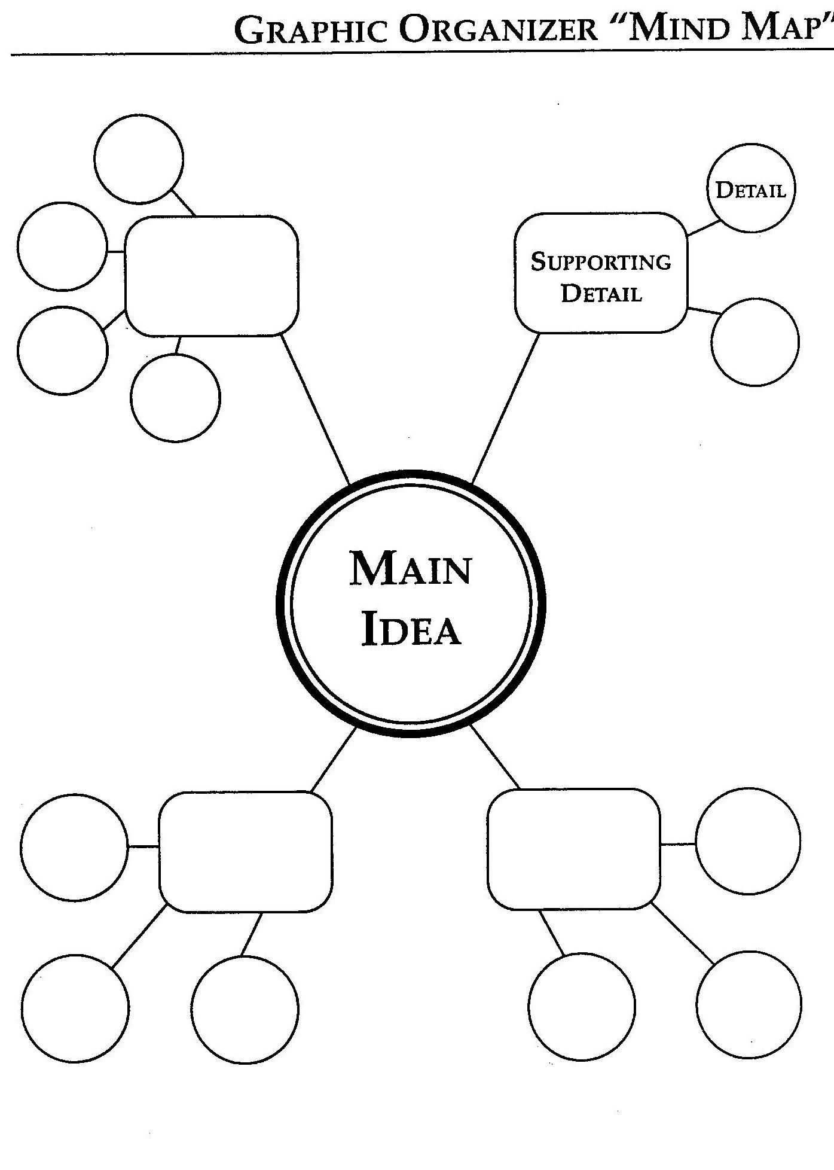

[**https://www.addictioncenter.com/community/these-are-the-5-most-addictive-substances-on-earth/**](https://www.addictioncenter.com/community/these-are-the-5-most-addictive-substances-on-earth/)

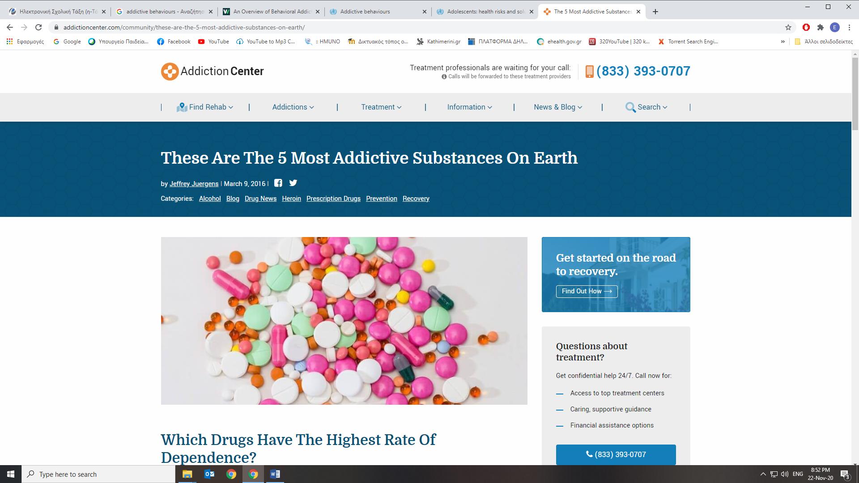

Over the years, there has been much debate among researchers regarding which substances should be classified as the “most addictive”. An [addiction](https://www.addictioncenter.com/addiction/) is marked by compulsive substance-seeking behavior, a growing tolerance to the [drug](https://www.addictioncenter.com/drugs/) or [alcohol](https://www.addictioncenter.com/alcohol/) and the presence of withdrawal symptoms when use is stopped.

According to the National Institute on Drug Abuse, approximately 22.7 million Americans (8.6 percent) have an addiction to drugs or alcohol.

1. **Nicotine**, the highly addictive substance found in tobacco products, is the most common addiction in America. More than two-thirds of Americans who tried cigarettes or chewing tobacco report being dependent at some point during their lifetime.

These substances are typically used to [treat anxiety](https://www.addictioncenter.com/benzodiazepines/xanax/) and [induce sleep](https://www.addictioncenter.com/sleeping-pills/). Popular street names for **2.barbiturates** include blue bullets, gorillas, nembies, bars and pink ladies. At low doses, these drugs can produce euphoria, but at higher doses it can result in overdose due to suppressed breathing.

An estimated 14-20 million people worldwide use **3.cocain**e, resulting in a billion-dollar industry. Cocaine reacts with the brain’s level of dopamine, preventing neurons from turning the “feel good” signal off. This results in abnormal activation of the brain’s reward pathways. An estimated 21 percent of people who try cocaine [will become addicted at some point](https://www.addictioncenter.com/drugs/cocaine/symptoms-signs/) in their lifetime.

Addiction to [beer](https://www.addictioncenter.com/alcohol/#Beer), [wine](https://www.addictioncenter.com/alcohol/#Wine) or[liquor](https://www.addictioncenter.com/alcohol/#Liquor) can have a very negative effect on the body and mind that is often irreversible. Studies have shown that **4.alcohol** increases the level of dopamine in the brain’s reward system by as much as 360 percent. This legalized substance has a death rate of over 3 million per year.

**5.Heroin** takes the number one spot as the most addictive substance on the planet. On Nutt’s addiction scale, it ranked a 2.5 out of a maximum score of 3. This potent opiate has an alarming rate of addiction, with one in four individuals who try heroin becoming addicted. What makes this drug particularly dangerous is that the dose that can cause death is only five times greater than the dose required for a high. Additionally, heroin has an extremely high [risk of death from a relapse](https://www.addictioncenter.com/community/in-remembrance-of-philip-seymour-hoffman-the-importance-of-education-in-recovery/).

* + Outpatient

***BEHAVIOURS:***



[**https://www.who.int/health-topics/addictive-behaviours#tab=tab_1**](https://www.who.int/health-topics/addictive-behaviours#tab=tab_1)

**Addictive behaviours**

* **Overview**

Many people around the world are engaged in (video) gaming and gambling behaviours which are recognized as addictive behaviours, but usually do not result in any significant health consequences. However, a small proportion of people engaged in such behaviours may develop disorders due to addictive behaviours associated with functional impairment or distress.

**Video gaming** is highly prevalent in modern culture, particularly among young people, and a healthy hobby for most users. However, in recent years there has been increasing global recognition among public health professionals and academics that particular patterns of video gaming may lead to marked impairment in personal, family, social, educational, occupational or other important areas of functioning and psychological distress for a significant minority of players. People who partake in gaming should be alert to the amount of time they spend on gaming activities, particularly when it is to the exclusion of other daily activities, as well as to any changes in their physical or psychological health and social functioning that could be attributed to their pattern of gaming behaviour.

**Gambling** in many countries and jurisdictions is considered a form of entertainment, characterized by betting/wagering mechanics and monetization features. Like gaming, repetitive gambling behaviour can potentially lead to gambling disorder associated with distress or impairment.

In recent years, there has been an increasing convergence between gaming and gambling on various platforms, significantly aided by the Internet. This convergence may give rise to migration from games to gambling and co- occurrence of the two disorders.

