**Taken from:**

<https://courses.lumenlearning.com/boundless-worldhistory/chapter/literature-in-the-renaissance/>

**Overview**

**Renaissance Literature**

The earliest Renaissance literature appeared in 14th century Italy; Dante, Petrarch, and Machiavelli are notable examples of Italian Renaissance writers. From Italy the influence of the Renaissance spread at different rates to other countries, and continued to spread throughout Europe through the 17th century. The English Renaissance and the Renaissance in Scotland date from the late 15th century to the early 17th century. In northern Europe the scholarly writings of Erasmus, the plays of Shakespeare, the poems of Edmund Spenser, and the writings of Sir Philip Sidney may be considered Renaissance in character.

The literature of the Renaissance was written within the general movement of the Renaissance that arose in 13th century Italy and continued until the 16th century while being diffused into the western world. It is characterized by the adoption of a Humanist philosophy and the recovery of the classical literature of Antiquity and benefited from the spread of printing in the latter part of the 15th century. For the writers of the Renaissance, Greco-Roman inspiration was shown both in the themes of their writing and in the literary forms they used. The world was considered from an anthropocentric perspective. Platonic ideas were revived and put to the service of Christianity. The search for pleasures of the senses and a critical and rational spirit completed the ideological panorama of the period. New literary genres such as the essay and new metrical forms such as the sonnet and Spenserian stanza made their appearance.

The creation of the printing press (using movable type) by Johannes Gutenberg in the 1450s encouraged authors to write in their local **vernacular** rather than in Greek or Latin classical languages, widening the reading audience and promoting the spread of Renaissance ideas.

The impact of the Renaissance varied across the continent; countries that were predominantly Catholic or predominantly Protestant experienced the Renaissance differently. Areas where the Orthodox Church was culturally dominant, as well as those areas of Europe under Islamic rule, were more or less outside its influence. The period focused on self-actualization and one’s ability to accept what is going on in one’s life.

Many argue that the ideas characterizing the Renaissance had their origin in late 13th century Florence, in particular in the writings of Dante Alighieri (1265–1321) and Petrarch (1304–1374). Italian prose of the 13th century was as abundant and varied as its poetry. In the year 1282 a period of new literature began. With the school of Lapo Gianni, Guido Cavalcanti, Cino da Pistoia, and Dante Alighieri, lyric poetry became exclusively Tuscan. The whole novelty and poetic power of this school consisted in, according to Dante, *Quando Amore spira, noto, ed a quel niodo Ch’ei detta dentro, vo significando—*that is, in a power of expressing the feelings of the soul in the way in which love inspires them, in an appropriate and graceful manner, fitting form to matter, and by art fusing one with the other. Love is a divine gift that redeems man in the eyes of God, and the poet’s mistress is the angel sent from heaven to show the way to salvation.

The literature and poetry of the Renaissance was largely influenced by the developing science and philosophy. The Humanist Francesco Petrarch, a key figure in the renewed sense of scholarship, was also an accomplished poet, publishing several important works of poetry. He wrote poetry in Latin, notably the Punic War epic *Africa*, but is today remembered for his works in the Italian vernacular, especially the *Canzoniere*, a collection of love sonnets dedicated to his **unrequited love**, Laura. He was the foremost writer of sonnets in Italian, and translations of his work into English by Thomas Wyatt established the sonnet form in England, where it was employed by William Shakespeare and countless other poets.

**Giovanni Boccaccio**

Petrarch’s disciple, Giovanni Boccaccio, became a major author in his own right. His major work was *The Decameron*, a collection of 100 stories told by ten storytellers who have fled to the outskirts of Florence to escape the black plague over ten nights. *The Decameron* in particular and Boccaccio’s work in general were a major source of inspiration and plots for many English authors in the Renaissance, including Geoffrey Chaucer and William Shakespeare. The various tales of love in *The Decameron* range from the erotic to the tragic. Tales of wit, practical jokes, and life lessons contribute to the mosaic. In addition to its literary value and widespread influence, it provides a document of life at the time. Written in the vernacular of the Florentine language, it is considered a masterpiece of classical early Italian prose.

Boccaccio wrote his imaginative literature mostly in the Italian vernacular, as well as other works in Latin, and is particularly noted for his realistic dialogue that differed from that of his contemporaries, medieval writers who usually followed formulaic models for character and plot.

Discussions between Boccaccio and Petrarch were instrumental in Boccaccio writing the *Genealogia deorum gentilium*; the first edition was completed in 1360 and it remained one of the key reference works on classical mythology for over 400 years. It served as an extended defense for the studies of ancient literature and thought. Despite the **Pagan beliefs** at the **core** of the *Genealogia deorum gentilium*, Boccaccio believed that much could be learned from antiquity. Thus, he challenged the arguments of clerical intellectuals who wanted to limit access to classical sources to prevent any moral harm to Christian readers. The revival of classical antiquity became a foundation of the Renaissance, and his defense of the importance of ancient literature was an essential requirement for its development.

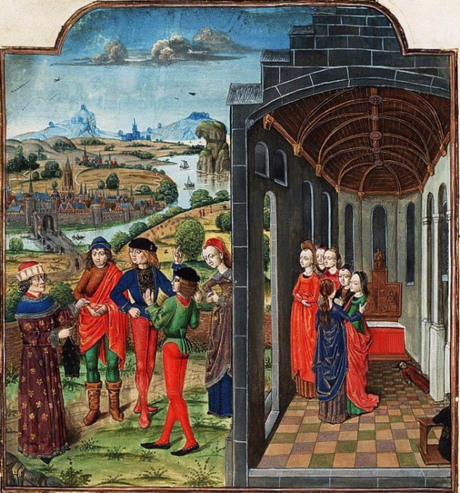

The Decameron

A depiction of Giovanni Boccaccio and Florentines who have fled from the plague, the frame story for *The Decameron*.

**Dante Alighieri**

A generation before Petrarch and Boccaccio, Dante Alighieri set the stage for Renaissance literature. His *Divine Comedy*, originally called *Comedìa* and later christened *Divina* by Boccaccio, is widely considered the greatest literary work composed in the Italian language and a masterpiece of world literature.

In the late Middle Ages, the overwhelming majority of poetry was written in Latin, and therefore was accessible only to affluent and educated audiences. In *De vulgari eloquentia* (On Eloquence in the Vernacular), however, Dante defended use of the vernacular in literature. He himself would even write in the Tuscan dialect for works such as *The New Life* (1295) and the aforementioned *Divine Comedy*; this choice, though highly unorthodox, set a hugely important precedent that later Italian writers such as Petrarch and Boccaccio would follow. As a result, Dante played an instrumental role in establishing the national language of Italy. Dante’s significance also extends past his home country; his depictions of Hell, Purgatory, and Heaven have provided inspiration for a large body of Western art, and are cited as an influence on the works of John Milton, Geoffrey Chaucer, and Lord Alfred Tennyson, among many others.

Dante, like most Florentines of his day, was **embroiled i**n the Guelph-Ghibelline conflict. He fought in the Battle of Campaldino (June 11, 1289) with the Florentine Guelphs against the Arezzo Ghibellines. After defeating the Ghibellines, the Guelphs divided into two factions: the White Guelphs—Dante’s party, led by Vieri dei Cerchi—and the Black Guelphs, led by Corso Donati. Although the split was along family lines at first, ideological differences arose based on opposing views of the papal role in Florentine affairs, with the Blacks supporting the pope and the Whites wanting more freedom from Rome. Dante was accused of corruption and financial wrongdoing by the Black Guelphs for the time that he was serving as city prior (Florence’s highest position) for two months in 1300. He was condemned to perpetual **exile**; if he returned to Florence without paying a fine, he could be burned **at the stake.**

At some point during his exile he conceived of the *Divine Comedy*, but the date is uncertain. The work is much more assured and on a larger scale than anything he had produced in Florence; it is likely he would have undertaken such a work only after he realized his political ambitions, which had been central to him up to his **banishment**, had been **halted** for some time, possibly forever. Mixing religion and private concerns in his writings, he invoked the worst anger of God against his city and suggested several particular targets that were also his personal enemies.

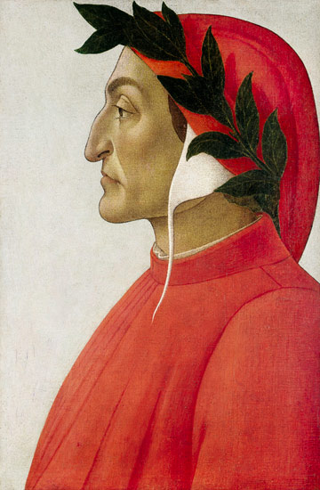

**Portrait of Dante:** Dante Alighieri was a major Italian poet of the Late Middle Ages who influenced and set the precedent for Renaissance literature.

<https://iep.utm.edu/renaissa/>

Taken from: ***Internet Encyclopedia of Philosophy***

**Renaissance Philosophy**

The Renaissance, that is, the period that extends roughly from the middle of the fourteenth century to the beginning of the seventeen century, was a time of intense, **all-encompassing**, and, in many ways, distinctive philosophical activity. A fundamental assumption of the Renaissance movement was that the remains of classical antiquity constituted an invaluable source of excellence to which **debased** and decadent modern times could turn in order to repair the damage brought about since the fall of the Roman Empire. It was often assumed that God had given a single unified truth to humanity and that the works of ancient philosophers had preserved part of this original deposit of divine wisdom. This idea not only laid the foundation for a scholarly culture that was centered on ancient texts and their interpretation, but also fostered an approach to textual interpretation that **strove** to harmonize and reconcile divergent philosophical accounts. Stimulated by newly available texts, one of the most important hallmarks of Renaissance philosophy is the increased interest in primary sources of Greek and Roman thought, which were previously unknown or little read. The renewed study of Neoplatonism, Stoicism, Epicureanism, and Skepticism eroded faith in the universal truth of Aristotelian philosophy and widened the philosophical horizon, providing a rich **seedbed** from which modern science and modern philosophy gradually emerged.

***Glossary:***

1. Vernacular:

everyday spoken language by the ordinary people in a particular region/country

2. unrequited love:

not felt the same way by the other person (αγάπη χωρίς ανταπόκριση )

3. pagan beliefs: follow polytheistic religion beliefs

4. at the core: central/key/basic/fundamental

5. embroiled: involve deeply in a conflict/mix up

6. exile/banishment: expel/bar/expatriate from their native country esp. for political, punitive reasons (εξορία)

7. at the stake ( method used in the Middle Ages for putting heretics to death): harsh/extreme punishment

8. halted: come to an abrupt end/stopped

9. strove ( strive): make great efforts to achieve or obtain sth (αγωνίζομαι, προσπαθώ πολύ )

10. seedbed: a situation from which sth develops/ origin in **agriculture**: prepare the soil for the seeds ( φυτώριο )

**Activities and Tasks:**

1. *Answer the questions after having studied the texts.*

1. Name some Renaissance writers and their work.

………………………………………………………………………………………………………………………………………………………………………………………………………………………………………………………………………………………………………………………………………………………………………………………………………………………………………………………………………………………………………

2. What are the characteristics of Renaissance literature?

………………………………………………………………………………………………………………………………………………………………………………………………………………………………………………………………………………………………………………………………………………………………………………………………

3. What was the impact of the invention of printing on people’s lives and the arts?

………………………………………………………………………………………………………………………………………………………………………………………………………………………………………………………………………………………………………………………………………………………………………………………………

4. What were the sources of Renaissance philosophy and its heritage on civilization?

………………………………………………………………………………………………………………………………………………………………………………………………………………………………………………………………………………………………………………………………………………………………………………………………

***Watch also the video*** “Renaissance-Overview-Goodbye-Atrt-Academy:, created by artist Phil Hansen on You Tube for the basics of the era.

<https://youtu.be/xf2G2Il8crw?t=19>