**The 1951 Refugee Convention**

© UN Archives

**The 1951 Refugee Convention and its 1967 Protocol are the key legal documents that form the basis of our work. With 149 State parties to either or both, they define the term ‘refugee’ and outlines the rights of refugees, as well as the legal obligations of States to protect them.**

The core principle is non-refoulement, which asserts that a refugee should not be returned to a country where they face serious threats to their life or freedom. This is now considered a rule of customary international law.

UNHCR serves as the ‘guardian’ of the 1951 Convention and its 1967 Protocol. According to the legislation, States are expected to cooperate with us in ensuring that the rights of refugees are respected and protected.

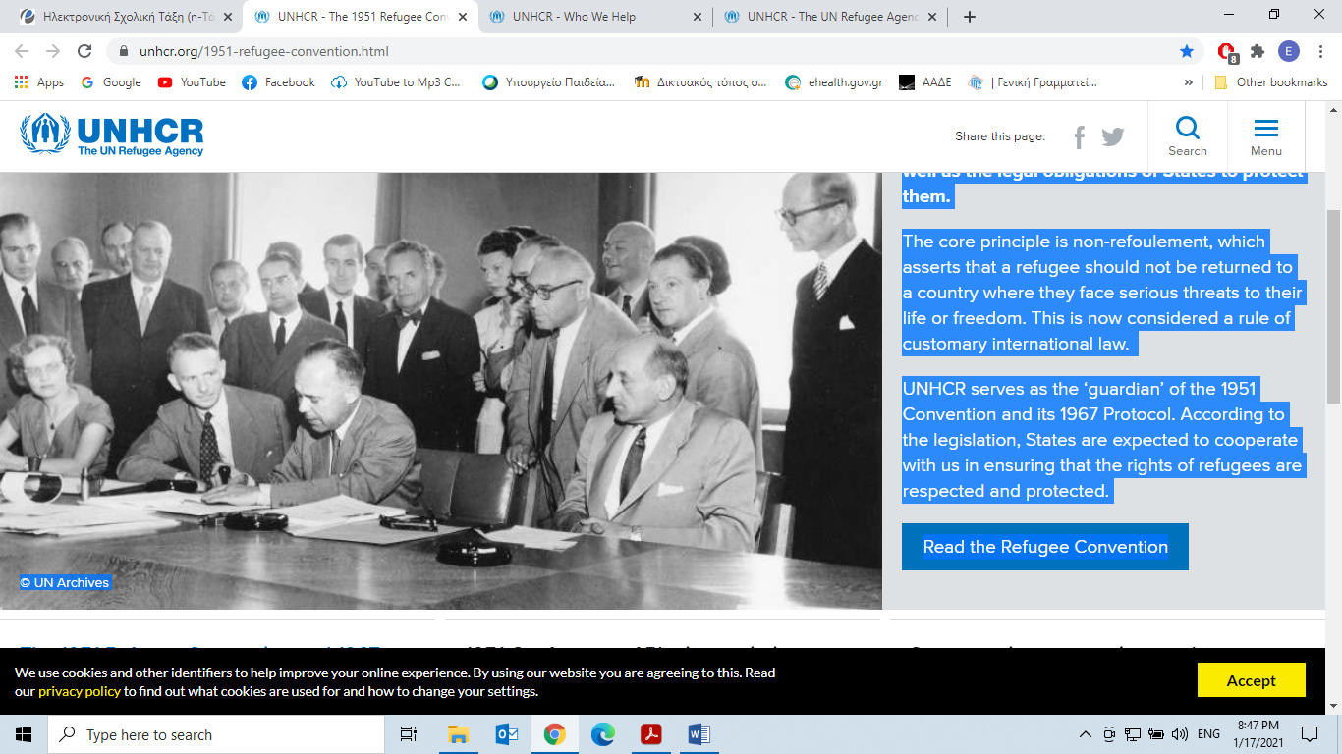

**Who We Help**

Our primary purpose at UNHCR is to safeguard the rights and well-being of people who have been forced to flee. Together with [partners](https://www.unhcr.org/49c3646c296) and communities, we work to ensure that everybody has the right to seek asylum and find safe refuge in another country. We also strive to secure lasting solutions.

For over half a century, UNHCR has helped millions of people to restart their lives. They include [refugees](https://www.unhcr.org/refugees.html), [returnees](https://www.unhcr.org/returnees.html), [stateless people](https://www.unhcr.org/stateless-people.html), the [internally displaced](https://www.unhcr.org/internally-displaced-people.html) and [asylum-seekers](https://www.unhcr.org/asylum-seekers.html). Our [protection](https://www.unhcr.org/protection.html), [shelter](https://www.unhcr.org/shelter.html), [health](https://www.unhcr.org/49c3646cd4) and [education](https://www.unhcr.org/education.html) has been crucial, healing broken pasts and building brighter futures.

[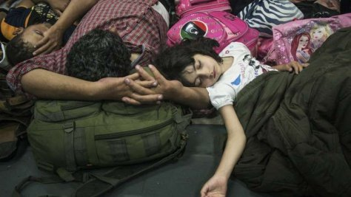](https://www.unhcr.org/asylum-seekers.html)

[Asylum-seekers](https://www.unhcr.org/asylum-seekers.html)

An asylum-seeker is an individual who is seeking international protection.

[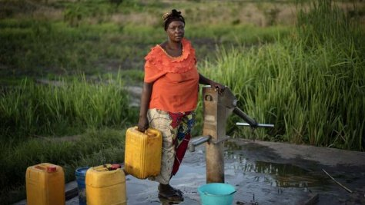](https://www.unhcr.org/internally-displaced-people.html)

[Internally Displaced People](https://www.unhcr.org/internally-displaced-people.html)

The internally displaced seek safety in other parts of their country.

[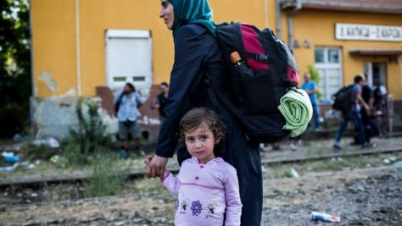](https://www.unhcr.org/refugees.html)

[Refugees](https://www.unhcr.org/refugees.html)

Refugees are people fleeing conflict or persecution.

[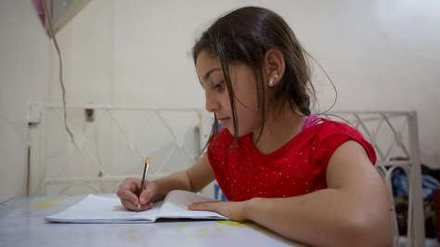](https://www.unhcr.org/ending-statelessness.html)

[Stateless People](https://www.unhcr.org/ending-statelessness.html)

Stateless people do not have a nationality and can struggle to realize their human rights.

[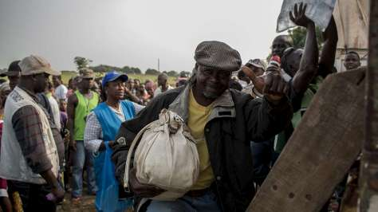](https://www.unhcr.org/returnees.html)

[Returnees](https://www.unhcr.org/returnees.html)

Returnees are people who have finally returned home.

[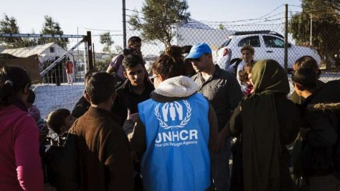](https://www.unhcr.org/safeguarding-individuals.html)

[Safeguarding Individuals](https://www.unhcr.org/safeguarding-individuals.html)

Every human being deserves a life free from persecution and discrimination.

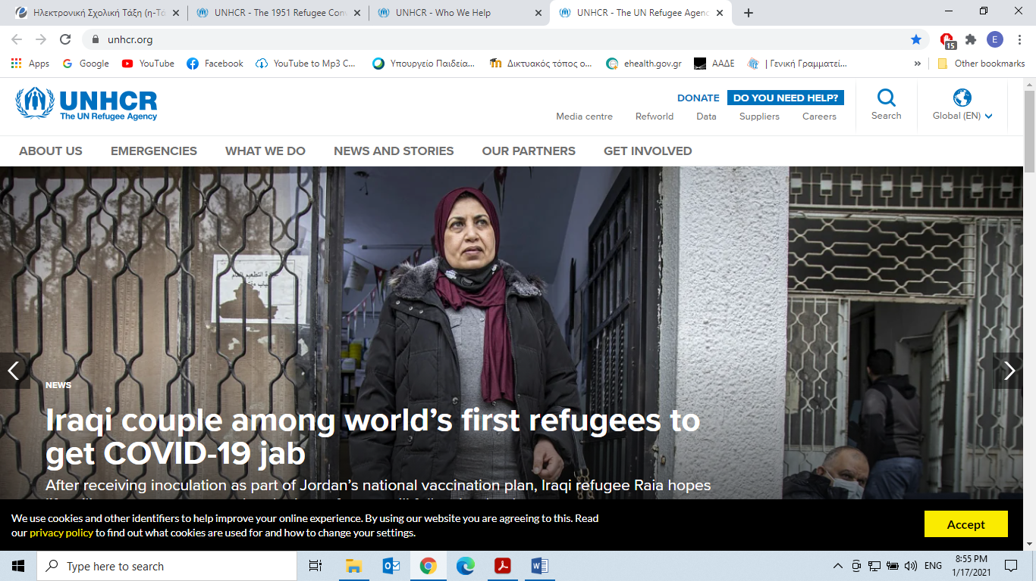

**Taken from:**

*https://www.unhcr.org/who-we-help.html*

**Fill in the gaps with One word:**

|  |  |  |  |  |
| --- | --- | --- | --- | --- |
| a. movement | b. persecution | c. nationality | d. repatriation | e. border |
| f. result | g. conflict | h. rights | i. processed | j. law |
| k. run | l. traumatic | m. account | n. request |  |

Refugees are people fleeing 1._______________or 2._____________. They are protected in international 3._______________.

Returning home concludes an often 4._________________ time in exile.UNHCR has managed numerous voluntary 5._________________ programmes that have brought millions of displaced people at home.

Today, millions of people around the world are denied a 6. ________________.As a 7._______________, they often aren’t allowed to go to school, see a doctor, get a job, open a bank 8. _______________, buy a house or even get married. Stateless people may have difficulty accessing basic 9. _____________ such as education, healthcare, employment and freedom of 10. ________________.

Internally displaced people (IDPs) have not crossed 11. _______________to find safety. Unlike refugees, they are on the 12. ____________at home.

An asylum seeker is someone whose 13. ____________ for sanctuary has yet to be 14. __________________.