**Welcome to**[**The (Not) Drinking Diary Series.**](http://girlandtonic.co.uk/category/conversations/)**Today I’m chatting to Millie, writer, speaker and founder of my absolute favourite instagram account and girl gang collective**[**Sober Girl Society**](https://www.instagram.com/sobergirlsociety)**.**

In her own words: I’m Millie, I am 27 and I’m a writer. On the 11th February 2018, I gave up alcohol and 7 months later in September 2018, I founded [Sober Girl Society](https://www.instagram.com/sobergirlsociety), an Instagram-based community of women who are ditching the drink for their own reasons. Millie’s book [The Sober Girl Society Handbook: An empowering guide to living hangover free](https://amzn.to/31UV1b9) will be out in January 2021 – and you can [pre-order it here](https://amzn.to/31UV1b9).

Millie share’s her story below, read on for her not drinking diary …

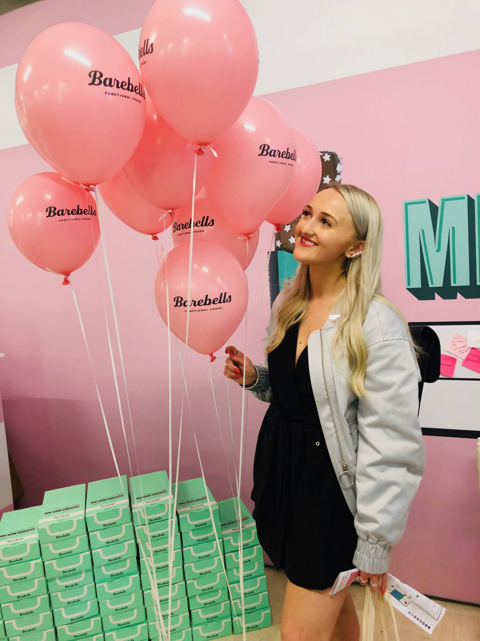

Name: Millie Gooch

Age: 27

Location: London, UK

**1. TELL ME A LITTLE BIT OF YOUR DRINKING STORY**

I’ve always had a tricky relationship with alcohol. Although I could quite easily have gone for days or weeks without a drink, when I did drink, I certainly made up for lost time. My speciality was weekend blackout **binge** (*do sth occasionally but to the extreme*) drinking which was a hobby I started at university and didn’t stop practising until, at 26, I suddenly become very aware that my partying and subsequent hangovers were **taking a noticeable toll** (*sth causes suffering, damage, death*)on my mental health, productivity and general fire for life.

So, after a particularly boozy night out, of which I remember precisely 3%, I knew that my relationship with alcohol needed to end. I downloaded [The Unexpected Joy of Being Sober](https://amzn.to/2JOLxGn) on Audible that morning and never looked back.

**2. WHAT LED YOU TO THINK DIFFERENTLY ABOUT DRINKING?**

[The Unexpected Joy of Being Sober](https://amzn.to/2JOLxGn) really did kick-start everything for me. I loved the way it looked at what you gained from **sobriety** (*alcohol-free, non-intoxicated*) rather than looking at the things you’d be leaving behind. I try to use the same philosophy for Sober Girl Society, it isn’t necessarily a step-by-step guide on how to give up alcohol but a look at how fun and amazing it can be when you do.

**3. HOW WOULD YOU DESCRIBE YOUR RELATIONSHIP WITH ALCOHOL NOW?**

My relationship with alcohol is over. I like to think of it as an ex-boyfriend that I have gone back to time and time again but I’ve finally realised he’s actually an a………..that will never change. I don’t like him but he is still in my friendship group and so I’ve had to get used to being around him. We’re civil but we’ll never get back together. I’m pretty happy with my new boyfriend – sobriety.

**4. WHAT’S BEEN THE BIGGEST CHALLENGE YOU’VE FACED SINCE YOUR APPROACH TO ALCOHOL SHIFTED?**

A lot of people find it difficult to understand why you would want to do such a big thing and as a result, can give you a bit of a hard time at the beginning. The trouble is that most people struggle to see problem drinking as a **spectrum** (*a range of different* *positions/views=φάσμα*) and if you haven’t lost your house and you’re not camping outside the **off-license** (*liquor store*) at 8am, they don’t understand that you can still have major issues around drink.

A few people tried to play the ‘you aren’t that bad’ card but those people only ever saw my hilarious 2am table dancing, not my 10am anxiety-induced shaking that left me quite paralysed and unable to get out of bed, and so I tried really hard not to let their comments discourage me. I don’t blame anyone for their reaction though, thanks to tote bags that label us ‘gin-dependent women’ and a **relentless onslaught (***continuous fierce attack*) of bottomless brunch invites, heavy drinking has become so normalised in our society that it can be really tough going against the grain without sticking a big old label on yourself that you may or may not be comfortable using.

**5. WHAT LESSONS HAVE YOU LEARNT ABOUT LIFE (AND YOURSELF) SINCE YOUR RELATIONSHIP WITH ALCOHOL HAS CHANGED?**

Contrary to what I used to think, being sober doesn’t make you boring! I’m actually more sociable now than ever. My two biggest reasons for turning down a night out used to be ‘I’ve got no money’ or ‘I don’t want to be hungover.’ Both are excuses that don’t fly anymore so now, instead of ending my night drunk crying in a toilet with people I’ve just met and then being carried into an Uber, I’m usually the last on a dance floor and instead I drive everyone home.

**6. WHAT BENEFITS OF CUTTING DOWN ON ALCOHOL OR STOPPING DRINKING HAVE YOU EXPERIENCED?**

There’s obviously a few surface benefits such as weight loss, more energy, brighter eyes, not having to call Lloyds bank on a night out to extend my overdraft and a sober-glow that’s pretty much always insta-ready. But for me, the role sobriety has played in improving my relationships, mental health and overall happiness and wellbeing has been, by far, the most important benefit.

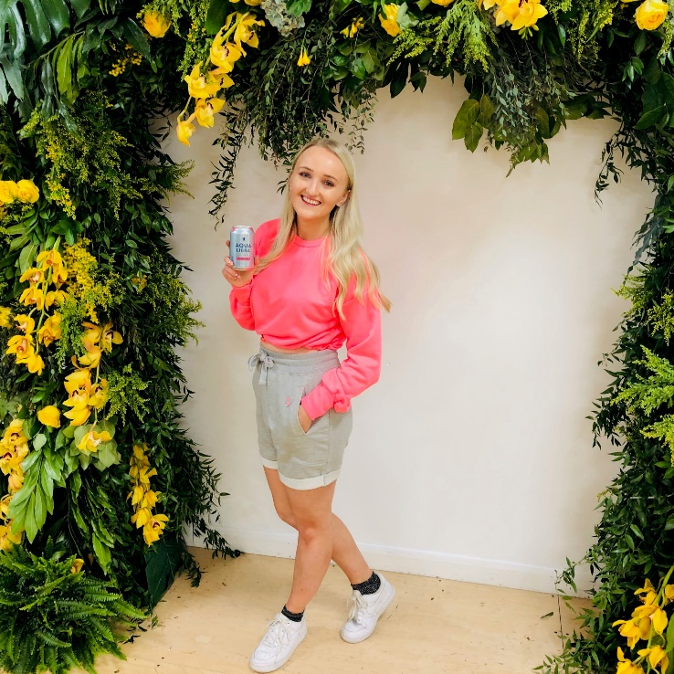

**7. ARE THERE ANY RESOURCES THAT HAVE HELPED YOU TO CUT DOWN OR STOP DRINKING?**

[The Unexpected Joy of Being Sober](https://amzn.to/2JOLxGn) was the main one for me. I love podcasts, [LoveSober](https://www.lovesober.com/podcast/) and [Alcohol Free Life](https://podcasts.apple.com/gb/podcast/janey-lee-grace-alcohol-free-life/id1448715889) are both great but I think it’s also helpful to listen to ones outside of not drinking. There’s no harm self-developing in other areas that can help you in your sober journey like resilience, mindful practices, kindess etc. I love [Fearne Cotton’s ‘Happy Place’](http://www.officialfearnecotton.com/news/2018/2/26/happy-place-podcast), [Clemmie Telford’s ‘Honestly’](https://podcasts.apple.com/gb/podcast/honestly-podcast-with-clemmie-telford/id1460659769) and [Elizabeth Day’s ‘How to Fail’](https://podcasts.apple.com/gb/podcast/how-to-fail-with-elizabeth-day/id1407451189).

**8. HOW DO YOU START YOUR DAY? DO YOU HAVE A MORNING ROUTINE?**

I have a bath every morning which shocks a lot of people but it sets me up perfectly. I’m not ashamed to say I spend a lot of time on my appearance, It’s not about attempting to be attractive but if I feel better on the outside I always feel better on the inside so I’ll always spend a while on my hair and make-up and I always overdress. I’ve learned from watching too many episodes of Queer Eye why looking after yourself on a surface level can be so important to what’s going on inside.

**9. DO YOU HAVE ANY RITUALS YOU ALWAYS MAKE TIME FOR?**

I take dance classes weekly. For me, exercise has to be something that gets me out of my head like having to follow a routine in a class. I know it’s different for everyone but for me, running just gives me more time to think and that means more time to overthink! Plus, a dance class can give you more confidence about busting some serious sober moves.

**10. WHAT’S YOUR FAVOURITE THING TO DO (HANGOVER FREE & NOT DRINKING) AT THE WEEKEND?**

Reclaim my Sunday – traditionally the day where I would waste away in bed, recovering from the weekend. I now love to paddle-board, eat a LOT of brunch and of course, work on [Sober Girl Society](https://www.instagram.com/sobergirlsociety) and all the exciting things planned for it.

**11. WHEN IT COMES TO YOUR OWN PERSONAL DEVELOPMENT, WHAT IS ONE THING THAT YOU’RE WORKING ON OR LEARNING RIGHT NOW?**

The most important thing for me now is kindness. I was quite selfish when I was drinking, I forgot birthdays and cancelled plans because I was hungover. People have stuck by me over the years when at times, I’ve been a pretty shitty friend because of alcohol.

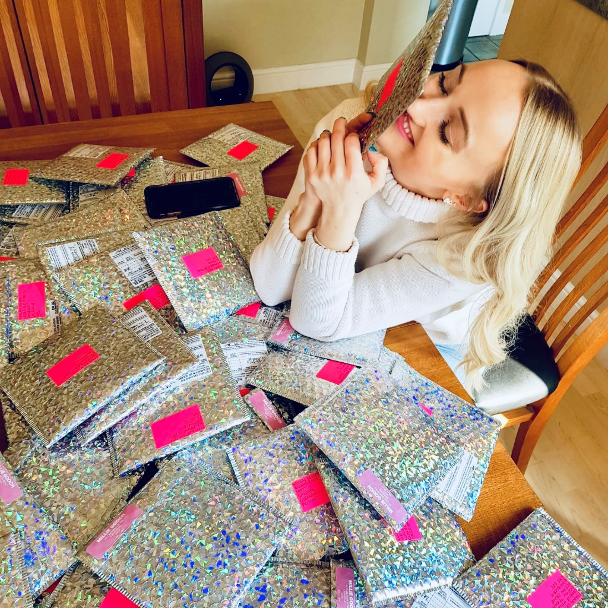

I want to try and be the best friend, daughter, granddaughter, girlfriend I can be and try just as hard with strangers. Sober Girl Society has massively evolved since its conception, from funny quotes to something with real purpose that I’m so very proud of. One of the main aims now is connection, I am **inundated** (*overwhelmed*) with messages from girls who haven’t had supportive reactions from their friends and because of that, we now run London-based meet-ups, which

We’re hoping to expand across the UK, and we try and link-up sober girls around the globe with monthly ‘Find Your Sober sisters’ threads which I also plan to morph into something greater.

We even sell a [little sober pin badge](https://www.etsy.com/uk/shop/SOBERGIRLSOCIETY) *(L’s note: I have one, I love it!)* so you can let everyone know that you’re part of the club. The feedback on those alone has been so incredible with people telling me that they’ve been great conversation starters whilst serving as a reminder to girls everywhere that there’s a society where sobriety is not only accepted, but applauded.

**12. WHAT IS THE ONE THING YOU’RE OBSESSED WITH AT THE MOMENT THAT’S MAKING YOUR LIFE BETTER?**

[Kombucha](https://en.wikipedia.org/wiki/Kombucha)! It’s such a good alcohol-free alternative and it’s so good for your gut. It’s worth pointing out that most Kombucha is >0.5% which is a similar trace alcohol to what’s in a glass of fresh orange juice but if you think it could be a trigger, it’s best avoided.

**13. ANY GO-TO PEOPLE WE SHOULD FOLLOW FOR INSPIRATION? (HEALTH, FITNESS, LIFE, TRAVEL YOU NAME IT!)**

In the spirit of being the best friend I can be and practising the ‘girls supporting girls’ ethos that I preach, I’m going to use this opportunity to plug my very best friends.

[@getfitwithkara](https://www.instagram.com/getfitwithkara) [@sophjames_](http://instagram.com/sophjames_) and [@jennifit_lee](http://instagram.com/jennifit_lee) for fitness

[@nikimahon](http://instagram.com/nikimahon) for jewellery and homeware

[@charmingarthur](http://instagram.com/charmingarthur) for all things kids

[@tasteofbeauty19](http://instagram.com/tasteofbeauty19) for everything nails

My favourite sobriety accounts are [@laurievmcallister](http://instagram.com/laurievmcallister) (obvs), [@theboywhodranktoo](http://instagram.com/theboywhodranktoo), [@mentalitymanaged](http://instagram.com/mentalitymanaged) [@soberstory](http://instagram.com/soberstory) [@boozeless](http://instagram.com/boozeless) [@unexpectedjoyof](http://instagram.com/unexpectedjoyof) and [@tellbetterstoriesmedia](http://instagram.com/tellbetterstoriesmedia)

**14. AND FINALLY, THINKING DIFFERENTLY ABOUT ALCOHOL CAN BE CHALLENGING AND ISOLATING, IS THERE ANY ADVICE YOU TURNED TO OR DO YOU HAVE ANY WORDS OF WISDOM FOR PEOPLE READING THIS?**

Be so honest with your nearest and dearest. Having frank conversations with my friends and family about the reasons for my sobriety has led to the biggest outpouring of love and support I could ever have imagined. They never pressure me to drink or try and persuade me to ‘just have one’ because they know how important it is for me.

**Follow Millie and Sober Girl Society on**[**Instagram**](https://www.instagram.com/sobergirlsociety)**and treat yourself to a**[**Sober Girl Society badge here**](https://www.etsy.com/uk/shop/SOBERGIRLSOCIETY)**.**

**Want to hear more from Millie? Pre-order her new book**[**The Sober Girl Society Handbook: An empowering guide to living hangover free! O**](https://amzn.to/31UV1b9)**ut in January 2021.**

**Taken from:**

[**https://girlandtonic.co.uk/millie-sober-girl-society/**](https://girlandtonic.co.uk/millie-sober-girl-society/)

**Short WRITING:** Why do you think to regain back your sobriety and fight alcohol is such a tough “job”?

Refer to Millie’s experience to get ideas. (50-80 words)

________________________________________________________________________________________________________________________________________________________________________________________________________________________________________________________________________________________________________________________________________________________________________________________________________________________________________________________________________________________________________________________________________________________________________________________________________________________________________________________________________________________________________________________________________________________________________________________________________________________________________________________________________________________________________________________________________________________________________________________________