***LEARNING TO FLY***

*The little blackbird’s story*. (Based on Activity 3 page 54)

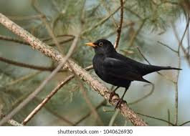

There was a blackbird once, which was very solitary. It perched on the branches of its favourite tree in the park and never seemed to be interested in flying away.

One day as it was singing, it looked up. A flock of birds was flying in formation.

It had never seen anything so beautiful before! All these birds fluttering their

wings up in the air! What a(n) _________________________________ this

could be!

It plunged into thinking.

“Perhaps I should try to fly, at least once”.

It couldn’t __________________________________________ but it was

_________________________________________to try.

Still, it wondered: “Am I going to ______________________________?”

“Are my wings_____________________________________________?”

It felt insecure as if lacking______________________________________

Despite feeling vulnerable, it tested its wings, spread them and _____________________________________________________________

_____________________________________________________________