WRITING PRODUCTION: Choose ONE of the following tasks.

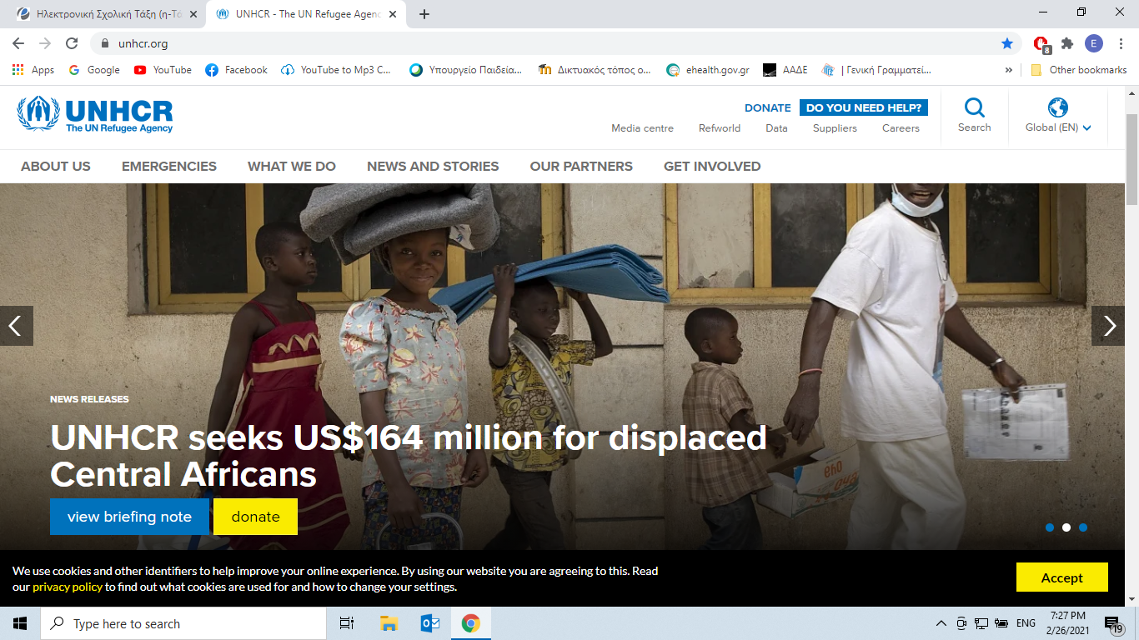

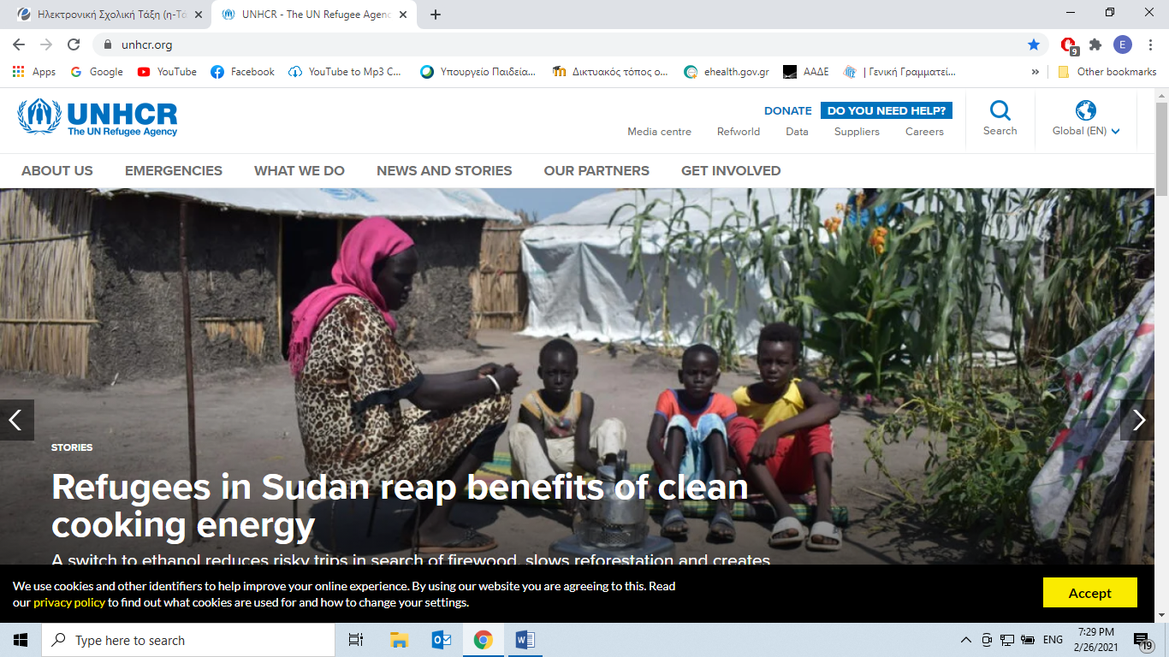

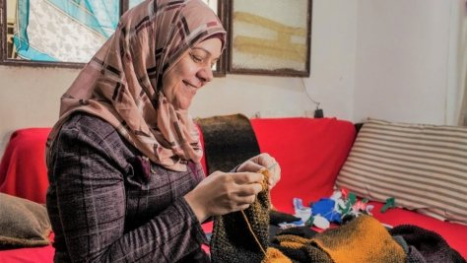

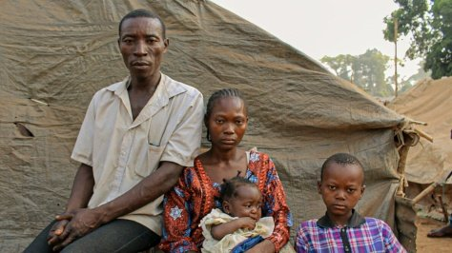

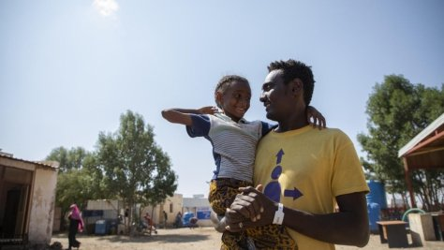

All photos have been retrieved from: [***https://www.unhcr.org/stories.html***](https://www.unhcr.org/stories.html)

**A. Choose a photo** showing refugees.

***Make up a story related to that phot*o.** You have to use **the key words** in the box. (150-200 words)

Imagine and write their **names**, their **family names**, their **background**, their **country** and **what happened**. You may also like to watch **the video** with Cate Blanchett campaigning with UNHCR and get ideas from what items refugees ***“Took with them”*** while fleeing.

|  |
| --- |
| * *Exploitation * danger *life jacket *trafficking *smuggling *dinghy *pain *suffer *army * asylum *borders * contract * detention * centre *education *deportation *fear * family * reunion *chance *parents * passport *persecution *poverty *protection *return * smuggler * labour *visa* |

_____________________________________________________________________________________________________________________________________________________________________________________________________________________________________________________________________________________________________________________________________________________________________________________________________________________________________________________________________________________________________________________________________________________________________________________________________________________________________________________________________________________________________________________________________________________________________________________________________________________________________________________________________________________________________________________________________________________________________________________________________________________________________________________________________________________________________________________________________________________________________________________________________________________________________________________________________________________________________________________________________________________________________________________________________________________________________________________________________________________________________

_______________________________________________________________________________________________________________________________________________________________________________________________________________________________________________________________

**OR**

**B. Write an interview about their background, the difficulties they face, their dreams. (150-200 words)**

­­­­­­­­­­­­­­­­­­­­­­­­­­­­­­­­­­­­­­­­­­__________________________________________________________________________________________________________________________________________________________________________________________________________________________________________________________________________________________________________________________________________________________________________________________________________________________________________________________________________________________________________________________________________________________________________________________________________________________________________________________________________________________________________________________________________________________________________________________________________________________________________________________________________________________________________________________________________________________________________________________________________________________________________________________________________________________________________________________________________________________________________________________________________________________________________________________________________________________________________________________________________________________________________________________________________________________________________________________________________________________________________________________________________________________________________________________