**5 PERSONALITIES THAT INFLUENCED**

**THE COMIC ART IN HISTORY**

**.1.**

**Rudolph Dirks** (February 26, 1877, [Heide](http://en.wikipedia.org/wiki/Heide" \o "Heide), [Schleswig-Holstein Province](http://en.wikipedia.org/wiki/Schleswig-Holstein_Province) – April 20, 1968, [New York City](http://en.wikipedia.org/wiki/New_York_City)) was one of the earliest and most noted [comic strip](http://en.wikipedia.org/wiki/Comic_strip) artists, well known for [*The Katzenjammer Kids*](http://en.wikipedia.org/wiki/The_Katzenjammer_Kids) (later known as [*The Captain and the Kids*](http://en.wikipedia.org/wiki/The_Captain_and_the_Kids)).

Dirks was born in [Heide](http://en.wikipedia.org/wiki/Heide" \o "Heide), Germany to Johannes and Margaretha Dirks.[[1]](http://en.wikipedia.org/wiki/Rudolph_Dirks#cite_note-1) When he was seven years old, his father, a woodcarver, moved the family to [Chicago, Illinois](http://en.wikipedia.org/wiki/Chicago,_Illinois). After having sold various cartoons to local magazines Rudolph moved to [New York City](http://en.wikipedia.org/wiki/New_York_City) and found work as a cartoonist. His younger brother Gus soon followed his brother's example.[[2]](http://en.wikipedia.org/wiki/Rudolph_Dirks#cite_note-2) He held several jobs as an illustrator, culminating in a position with [William Randolph Hearst](http://en.wikipedia.org/wiki/William_Randolph_Hearst)'s [*New York Journal*](http://en.wikipedia.org/wiki/New_York_Morning_Journal).

The circulation war between the *Journal* and [Joseph Pulitzer](http://en.wikipedia.org/wiki/Joseph_Pulitzer)'s [*New York World*](http://en.wikipedia.org/wiki/New_York_World) was raging. The *World* had a huge success with the full-color Sunday feature, *Down in Hogan's Alley*, better known as the [*Yellow Kid*](http://en.wikipedia.org/wiki/Yellow_Kid), starting in 1895. Editor Rudolph Block asked Dirks to develop a Sunday comic based on [Wilhelm Busch](http://en.wikipedia.org/wiki/Wilhelm_Busch)'s cautionary tale, [*Max und Moritz*](http://en.wikipedia.org/wiki/Max_and_Moritz). When Dirks submitted his sketches, Block dubbed them [*The Katzenjammer Kids*](http://en.wikipedia.org/wiki/The_Katzenjammer_Kids), and the first strip appeared on December 12, 1897. Gus Dirks assisted his brother with *The Katzenjammer Kids* during the first few years, until his suicide on June 10, 1902.

Dirks made substantial contributions to the graphic language of comic strips. Although not the first to use sequential panels or speech balloons, he was influential in their wider adoption. He also popularized such icons as speed lines, "seeing stars" for pain, and "sawing wood" for snoring.

As a pastime, Dirks produced serious paintings associated with the [Ashcan School](http://en.wikipedia.org/wiki/Ashcan_School). Like many of his cartoonist colleagues, he was an avid golfer. Dirks incrementally passed his cartooning duties on to his son John Dirks, who took over *The Captain and the Kids* in 1958. The elder Dirks died in New York City in 1968.[[3]](http://en.wikipedia.org/wiki/Rudolph_Dirks#cite_note-3)

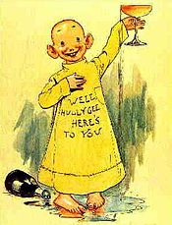 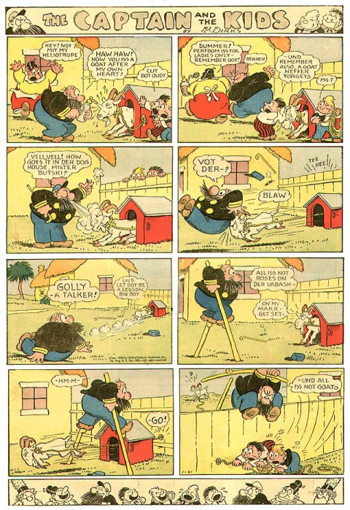

------------------------------------------------------------------------------------------

.2.

**George Joseph Herriman** (August 22, 1880 – April 25, 1944) was an American cartoonist best known for the comic strip *[Krazy Kat](http://en.wikipedia.org/wiki/Krazy_Kat" \o "Krazy Kat)*(1913–1944). More influential than popular, *Krazy Kat* had an appreciative audience among people in the arts. [Gilbert Seldes](http://en.wikipedia.org/wiki/Gilbert_Seldes)' article "The Krazy Kat Who Walks by Himself" was the earliest example of a critic from the high arts giving serious attention to a comic strip.[*The Comics Journal*](http://en.wikipedia.org/wiki/The_Comics_Journal) placed the strip first on its list of the greatest comics of the 20th century. Herriman's work has been a primary influence on cartoonists such as [Will Eisner](http://en.wikipedia.org/wiki/Will_Eisner), [Charles M. Schulz](http://en.wikipedia.org/wiki/Charles_M._Schulz), [Robert Crumb](http://en.wikipedia.org/wiki/Robert_Crumb), [Art Spiegelman](http://en.wikipedia.org/wiki/Art_Spiegelman), [Bill Watterson](http://en.wikipedia.org/wiki/Bill_Watterson), and [Chris Ware](http://en.wikipedia.org/wiki/Chris_Ware). Herriman was born in [New Orleans](http://en.wikipedia.org/wiki/New_Orleans), Louisiana, to [mulatto](http://en.wikipedia.org/wiki/Mulatto) [Creole](http://en.wikipedia.org/wiki/Louisiana_Creole_people) parents, and grew up in [Los Angeles](http://en.wikipedia.org/wiki/Los_Angeles). After he graduated from high school in 1897, he was employed in the newspaper industry as an illustrator and engraver. He moved on to cartooning and comic strips—a medium then in its infancy—and drew a variety of strips until he introduced his most famous character, Krazy Kat, in his strip *The Dingbat Family* in 1910. A *Krazy Kat* daily strip began in 1913, and from 1916 also appeared on Sundays. The strip was noted for its poetic, dialect-heavy dialogue; its fantastic, shifting backgrounds; and its bold, experimental page layouts. In the strip's main motif, Ignatz Mouse would pelt Krazy with bricks, which the naïve, [androgynous](http://en.wikipedia.org/wiki/Androgyny) Kat would interpret as symbols of love. As the strip progressed, a love triangle developed between Krazy, Ignatz and Offisa Pupp. Herriman lived most of his life in Los Angeles, but made frequent trips to the Navajo deserts in the southwestern U.S. He was drawn to the landscapes of [Monument Valley](http://en.wikipedia.org/wiki/Monument_Valley) and the [Enchanted Mesa](http://en.wikipedia.org/wiki/Enchanted_Mesa), and made [Coconino County](http://en.wikipedia.org/wiki/Coconino_County,_Arizona) the location of his *Krazy Kat* strips. His artwork made much use of [Navajo](http://en.wikipedia.org/wiki/Navajo_people) and Mexican themes and motifs against shifting desert backgrounds. He was a prolific cartoonist who produced a large number of strips and illustrated [Don Marquis](http://en.wikipedia.org/wiki/Don_Marquis)'s books of poetry about *[Archy and Mehitabel](http://en.wikipedia.org/wiki/Archy_and_Mehitabel" \o "Archy and Mehitabel)*, an alley cat and a cockroach. Newspaper magnate [William Randolph Hearst](http://en.wikipedia.org/wiki/William_Randolph_Hearst) was a proponent of Herriman and gave him a lifetime contract with [King Features Syndicate](http://en.wikipedia.org/wiki/King_Features_Syndicate), guaranteeing Herriman a comfortable living and an outlet for his work despite its lack of popularity.

Within the seeming strictures of the strip—the recurring characters, the Krazy–Ignatz–Offisa Pupp love triangle—Herriman improvised freely with the story, the shifting backgrounds, and the sex of the *Krazy Kat*'s title character.[[104]](http://en.wikipedia.org/wiki/George_Herriman#cite_note-FOOTNOTEAnderson1999147.E2.80.93148-110) Among the multicultural influences Herriman mixed in his work were those of the Navajo[[82]](http://en.wikipedia.org/wiki/George_Herriman" \l "cite_note-FOOTNOTEAnderson1999147-88) and Mexican.[[55]](http://en.wikipedia.org/wiki/George_Herriman#cite_note-FOOTNOTEMcDonnellO.27ConnellHavenon198678.E2.80.9379-59) He made creative use of language[[105]](http://en.wikipedia.org/wiki/George_Herriman#cite_note-FOOTNOTEBerger1996124Estren1974112Ito2003-111) with a poetical sense,[[106]](http://en.wikipedia.org/wiki/George_Herriman#cite_note-FOOTNOTEWaugh194757Johnson1999208-112) employing multilingual puns[[107]](http://en.wikipedia.org/wiki/George_Herriman#cite_note-FOOTNOTEBaetens2012109-113) in a fanciful mix of dialects from different ethnic backgrounds.[[108]](http://en.wikipedia.org/wiki/George_Herriman#cite_note-FOOTNOTEAnderson1999159McDonnellO.27ConnellHavenon198663-114) Herriman used [metafictional](http://en.wikipedia.org/wiki/Metafiction" \o "Metafiction) techniques associated with [postmodernism](http://en.wikipedia.org/wiki/Postmodernism);[[109]](http://en.wikipedia.org/wiki/George_Herriman#cite_note-FOOTNOTESoper200883-115) his characters were self-aware,[[110]](http://en.wikipedia.org/wiki/George_Herriman#cite_note-FOOTNOTEJohnson1999208-116) he frequently drew attention to himself and his drawings as drawings in his strips, and he emphasized the subjectivity of language and experience.

Herriman drew with what cartoonist Edward Sorel called a "liberated, spontaneous-looking style ... a cartoon counterpart of [expressionism](http://en.wikipedia.org/wiki/Expressionism)".[[65]](http://en.wikipedia.org/wiki/George_Herriman#cite_note-FOOTNOTESorel199225-69) It was organic, and his pen strokes had a dynamic, thick-and-thin range which Sorel describes as instantly recognizable and difficult to imitate. The *Krazy Kat* Sunday pages showed Herriman experimenting most freely—each had a unique panel layout and logo,[[65]](http://en.wikipedia.org/wiki/George_Herriman#cite_note-FOOTNOTESorel199225-69) and the jumbled panels could be circles, irregular shapes, or borderless.[[111]](http://en.wikipedia.org/wiki/George_Herriman#cite_note-FOOTNOTEAnderson1999152-117) In his last few years, Herriman's arthritis led to an ever-scratchier style of art; he used a knife to scratch out whites from inked surfaces, giving the artwork the look of a [woodcut](http://en.wikipedia.org/wiki/Woodcut).[[112]](http://en.wikipedia.org/wiki/George_Herriman#cite_note-FOOTNOTEMcDonnellO.27ConnellHavenon198685-118)

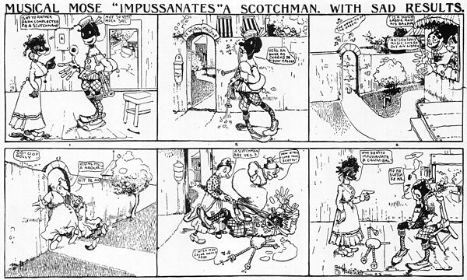

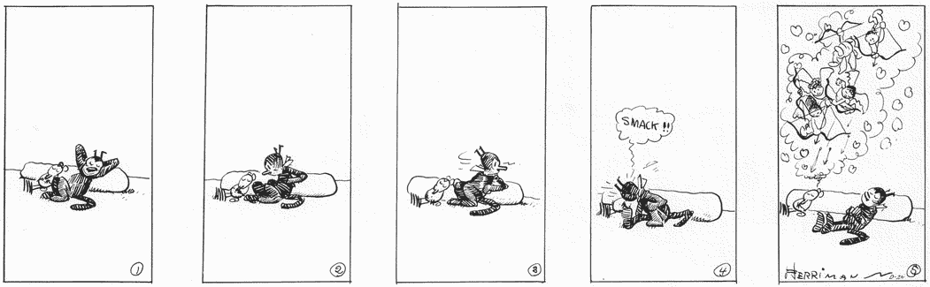

.3.

**Zenas Winsor McCay** (c. 1867–1871 – July 26, 1934) was an American [cartoonist](http://en.wikipedia.org/wiki/Cartoonist) and [animator](http://en.wikipedia.org/wiki/Animator). He is best known for the comic strip[*Little Nemo*](http://en.wikipedia.org/wiki/Little_Nemo) (1905–1914; 1924–1926) and the animated film *[Gertie the Dinosaur](http://en.wikipedia.org/wiki/Gertie_the_Dinosaur" \o "Gertie the Dinosaur)* (1914). For contractual reasons, he worked under the pen name **Silas** on the comic strip [*Dream of the Rarebit Fiend*](http://en.wikipedia.org/wiki/Dream_of_the_Rarebit_Fiend).

From a young age, McCay was a quick, prolific, and technically dextrous artist. He started his professional career making posters and performing for [dime museums](http://en.wikipedia.org/wiki/Dime_museum), and began illustrating newspapers and magazines in 1898. He joined the [*New York Herald*](http://en.wikipedia.org/wiki/New_York_Herald) in 1903, where he created popular comic strips such as [*Little Sammy Sneeze*](http://en.wikipedia.org/wiki/Little_Sammy_Sneeze) and *Dream of the Rarebit Fiend*. In 1905, his signature strip *Little Nemo in Slumberland* debuted, a fantasy strip in an [Art Nouveau](http://en.wikipedia.org/wiki/Art_Nouveau) style, about a young boy and his adventurous dreams. The strip demonstrated McCay's strong graphic sense and mastery of color and [linear perspective](http://en.wikipedia.org/wiki/Perspective_(graphical)). McCay experimented with the formal elements of the comic strip page, arranging and sizing panels to increase impact and enhance elements of the narrative. McCay also produced numerous detailed [editorial cartoons](http://en.wikipedia.org/wiki/Editorial_cartoon) and was a popular performer of [chalk talks](http://en.wikipedia.org/wiki/Chalk_talk) on the [vaudeville](http://en.wikipedia.org/wiki/Vaudeville) circuit.

McCay was an early animation pioneer. Between 1911 and 1921 McCay self-financed and animated ten films, some of which survive only as fragments. The first three served as part of his vaudeville act, *Gertie the Dinosaur*, an interactive routine in which McCay appeared to give orders to a trained dinosaur. McCay and his assistants worked for twenty-two months on his most ambitious film, [*The Sinking of the Lusitania*](http://en.wikipedia.org/wiki/The_Sinking_of_the_Lusitania) (1918), a patriotic recreation of the [German torpedoing in 1915](http://en.wikipedia.org/wiki/Sinking_of_the_RMS_Lusitania) of the [*RMS Lusitania*](http://en.wikipedia.org/wiki/RMS_Lusitania). *Lusitania* was not as commercially successful as the earlier films, and McCay's later movies attracted little attention. His animation, vaudeville, and comic strip work was gradually curtailed as newspaper magnate [William Randolph Hearst](http://en.wikipedia.org/wiki/William_Randolph_Hearst), his employer since 1911, expected McCay to devote his energies to editorial illustrations.

In his drawing, McCay made bold, prodigious use of linear perspective, particularly in detailed architecture and cityscapes. He textured his editorial cartoons with fine [hatching](http://en.wikipedia.org/wiki/Hatching), and made color a central element in *Little Nemo*. His comic strip work has influenced generations of cartoonists and illustrators. The technical level of McCay's animation—its naturalism, smoothness, and scale—was unmatched until [Walt Disney](http://en.wikipedia.org/wiki/The_Walt_Disney_Company)'s feature films arrived in the 1930s. He pioneered [inbetweening](http://en.wikipedia.org/wiki/Inbetweening" \o "Inbetweening), the use of [registration marks](http://en.wikipedia.org/wiki/Printing_registration), [cycling](http://en.wikipedia.org/wiki/Traditional_animation#Animation_loops), and other animation techniques that later became standard.

From January until November 1903, McCay drew an ongoing proto-comic strip for the *Enquirer* based on poems written by [George Randolph Chester](http://en.wikipedia.org/wiki/George_Randolph_Chester) called *A Tale of the Jungle Imps by Felix Fiddle*.[[24]](http://en.wikipedia.org/wiki/Winsor_McCay#cite_note-FOOTNOTECanemaker200560-26) Before the last two instalments appeared in print, McCay had moved to New York City to work for [James Gordon Bennett, Jr.](http://en.wikipedia.org/wiki/James_Gordon_Bennett,_Jr.)'s [*New York Herald*](http://en.wikipedia.org/wiki/New_York_Herald),[[25]](http://en.wikipedia.org/wiki/Winsor_McCay#cite_note-FOOTNOTECanemaker200564-27) at first doing illustrations and editorial cartoons.[[26]](http://en.wikipedia.org/wiki/Winsor_McCay#cite_note-FOOTNOTECanemaker200571-28) He worked alongside comic strip pioneer [Richard F. Outcault](http://en.wikipedia.org/wiki/Richard_F._Outcault), who was doing the [*Buster Brown*](http://en.wikipedia.org/wiki/Buster_Brown) strip at the *Herald*. A rivalry built up between the two cartoonists which resulted in Outcault leaving the *Herald* to return to his previous employer, [William Randolph Hearst](http://en.wikipedia.org/wiki/William_Randolph_Hearst) at [*The New York Journal*](http://en.wikipedia.org/wiki/New_York_Journal-American).[[27]](http://en.wikipedia.org/wiki/Winsor_McCay#cite_note-FOOTNOTECanemaker200574-29)

McCay's first continuing comic strip, *Mr. Goodenough*, debuted in the *Evening Telegram* on January 21, 1904. The formula for the strip was that a sedentary millionaire would seek ways to become more active, with embarrassing results. *Sister's Little Sister's Beau*, McCay's first strip with a child protagonist, lasted one instalment that April, and his first color strip, *Phurious Phinish of Phoolish Philipe's Phunny Phrolics*, appeared in the *Herald*'s Sunday supplement that May.[[28]](http://en.wikipedia.org/wiki/Winsor_McCay#cite_note-FOOTNOTECanemaker200575-30)

McCay's first popular comic strip was [*Little Sammy Sneeze*](http://en.wikipedia.org/wiki/Little_Sammy_Sneeze). The strip starred a young boy whose sneeze would build panel by panel until it was released, with explosively disastrous results, for which he was usually punished or chased away by those affected. The strip debuted in July 1904 and ran until December 1906.[[28]](http://en.wikipedia.org/wiki/Winsor_McCay#cite_note-FOOTNOTECanemaker200575-30)

McCay's longest-running strip, [*Dream of the Rarebit Fiend*](http://en.wikipedia.org/wiki/Dream_of_the_Rarebit_Fiend), first appeared in the *Evening Telegram* in September 1904. The strip was aimed at an adult audience,[[29]](http://en.wikipedia.org/wiki/Winsor_McCay" \l "cite_note-FOOTNOTECanemaker200578-31) and had no recurring characters. The characters that appeared in the strip would have fantastic, sometimes terrifying dreams, only to wake up in the last panel, cursing the [Welsh rarebit](http://en.wikipedia.org/wiki/Welsh_rarebit) they had eaten the night before, which they blamed for bringing on the dream.[[30]](http://en.wikipedia.org/wiki/Winsor_McCay#cite_note-FOOTNOTECanemaker200579-32) *Rarebit Fiend* was so popular that a book collection appeared in 1905 from publisher [Frederick A. Stokes](http://en.wikipedia.org/wiki/Frederick_A._Stokes). It was adapted to film by [Edwin S. Porter](http://en.wikipedia.org/wiki/Edwin_Stanton_Porter), and plans were made for a "comic opera or musical extravaganza" for stage that failed to materialize.[[29]](http://en.wikipedia.org/wiki/Winsor_McCay#cite_note-FOOTNOTECanemaker200578-31) McCay signed the *Rarebit Fiend* strips with the pen name "Silas", as his contract required that he not use his real name for his *Evening Telegram*work.[[31]](http://en.wikipedia.org/wiki/Winsor_McCay#cite_note-FOOTNOTEDover_editors1973ix-33)

The McCays had been living in Manhattan, close to the *Herald* offices; before 1905 they moved to [Sheepshead Bay](http://en.wikipedia.org/wiki/Sheepshead_Bay,_Brooklyn" \o "Sheepshead Bay, Brooklyn) in Brooklyn, New York, a seaside resort on [Long Island](http://en.wikipedia.org/wiki/Long_Island). It was an hour commute from the *Herald* offices, but they believed it to be a better place to raise children. They lived at a number of addresses before settling into a three-story house at 1901 Voorhies Avenue, where McCay resided for the rest of his life.[[32]](http://en.wikipedia.org/wiki/Winsor_McCay#cite_note-FOOTNOTECanemaker2005125.E2.80.93126-34) As his reputation grew, his employers allowed him to work from his home studio more often.[[33]](http://en.wikipedia.org/wiki/Winsor_McCay#cite_note-FOOTNOTECanemaker2005127-35)

While still turning out illustrations and editorial cartoons daily,[[34]](http://en.wikipedia.org/wiki/Winsor_McCay" \l "cite_note-FOOTNOTECanemaker200587-36) McCay began three more continuing strips in 1905. In January, he began*The Story of Hungry Henrietta*, in which the child protagonist visibly ages week by week, and eats compulsively in lieu of the love she craves from her parents.[[35]](http://en.wikipedia.org/wiki/Winsor_McCay#cite_note-FOOTNOTECanemaker200592-37) *A Pilgrim's Progress by Mister Bunion* was another "Silas" strip for the *Evening Telegram*, which ran from June 1905 until December 1910. Mr. Bunion spent each strip unsuccessfully scheming to rid himself of his suitcase, labeled "Dull Care".[[36]](http://en.wikipedia.org/wiki/Winsor_McCay#cite_note-FOOTNOTECanemaker200594-38)

McCay got "an idea from the *Rarebit Fiend* to please the little folk",[[34]](http://en.wikipedia.org/wiki/Winsor_McCay#cite_note-FOOTNOTECanemaker200587-36) and in October 1905 the full-page [Sunday strip](http://en.wikipedia.org/wiki/Sunday_comics) [*Little Nemo in Slumberland*](http://en.wikipedia.org/wiki/Little_Nemo) debuted in the *Herald*.[[37]](http://en.wikipedia.org/wiki/Winsor_McCay#cite_note-FOOTNOTECanemaker200597-39) Considered McCay's masterpiece,[[38]](http://en.wikipedia.org/wiki/Winsor_McCay" \l "cite_note-FOOTNOTEHarvey199421Hubbard2012Sabin1993134Dover_editors1973viiCanwell200919-40) its child protagonist had fabulous dreams, interrupted each week with his awakening in the final panel.[[39]](http://en.wikipedia.org/wiki/Winsor_McCay#cite_note-FOOTNOTEHarvey199421-41) Nemo's appearance was based on McCay's son Robert.[[40]](http://en.wikipedia.org/wiki/Winsor_McCay#cite_note-FOOTNOTECrafton199397-42) McCay experimented with formal aspects of the comics page: he made inventive use of timing and pacing, the size and shape of panels, perspective, and architectural and other details.[[39]](http://en.wikipedia.org/wiki/Winsor_McCay#cite_note-FOOTNOTEHarvey199421-41) The *Herald* was considered to have the highest quality color printing of any newspaper at the time; its printing staff used the[Ben Day process](http://en.wikipedia.org/wiki/Ben-Day_dots) for color,[[36]](http://en.wikipedia.org/wiki/Winsor_McCay#cite_note-FOOTNOTECanemaker200594-38) and McCay annotated the *Nemo* pages with precise color schemes for the printers.[[41]](http://en.wikipedia.org/wiki/Winsor_McCay#cite_note-FOOTNOTEHarvey199422Canemaker2005107-43)

Impresario [F. F. Proctor](http://en.wikipedia.org/wiki/Frederick_Freeman_Proctor) approached McCay in April 1906 to perform [chalk talks](http://en.wikipedia.org/wiki/Chalk_talk) for the [vaudeville](http://en.wikipedia.org/wiki/Vaudeville) circuit.[[42]](http://en.wikipedia.org/wiki/Winsor_McCay#cite_note-FOOTNOTECanemaker2005131-44) For $500 per week he was to draw twenty-five sketches in fifteen minutes before live audiences, as a pit band played a piece called "Dream of the Rarebit Fiend".[[43]](http://en.wikipedia.org/wiki/Winsor_McCay#cite_note-FOOTNOTECanemaker2005132-45) In his*The Seven Ages of Man* routine, he drew two faces and progressively aged them.[[44]](http://en.wikipedia.org/wiki/Winsor_McCay#cite_note-FOOTNOTEStabileHarrison20033-46) His first performance was on June 11, 1906,[[43]](http://en.wikipedia.org/wiki/Winsor_McCay" \l "cite_note-FOOTNOTECanemaker2005132-45) in a show that also featured entertainer [W. C. Fields](http://en.wikipedia.org/wiki/W._C._Fields).[[43]](http://en.wikipedia.org/wiki/Winsor_McCay#cite_note-FOOTNOTECanemaker2005132-45) It was a success, and McCay toured with the show throughout 1907,[[45]](http://en.wikipedia.org/wiki/Winsor_McCay" \l "cite_note-FOOTNOTECanemaker2005135-47) while managing to complete his comic strip and illustration work on time, often working in hotel rooms or backstage.[[46]](http://en.wikipedia.org/wiki/Winsor_McCay#cite_note-FOOTNOTECanemaker2005137-48)

As early as 1905, several abortive attempts were made to produce a stage version of *Little Nemo*. In mid-1907, [Marcus Klaw](http://en.wikipedia.org/wiki/Marcus_Klaw) and [A. L. Erlanger](http://en.wikipedia.org/wiki/A._L._Erlanger) announced they would put on an extravagant *Little Nemo*show for an unprecedented $100,000, with a score by [Victor Herbert](http://en.wikipedia.org/wiki/Victor_Herbert)[[47]](http://en.wikipedia.org/wiki/Winsor_McCay#cite_note-FOOTNOTECanemaker2005141-49) and lyrics by [Harry B. Smith](http://en.wikipedia.org/wiki/Harry_B._Smith).[[47]](http://en.wikipedia.org/wiki/Winsor_McCay#cite_note-FOOTNOTECanemaker2005141-49) It starred midget Gabriel Weigel as Nemo, [Joseph Cawthorn](http://en.wikipedia.org/wiki/Joseph_Cawthorn) as Dr. Pill, and [Billy B. Van](http://en.wikipedia.org/wiki/Billy_B._Van) as Flip.[[48]](http://en.wikipedia.org/wiki/Winsor_McCay#cite_note-FOOTNOTECanemaker2005143-50) Reviews were positive; it played to sold-out houses in New York and toured for two seasons.[[49]](http://en.wikipedia.org/wiki/Winsor_McCay#cite_note-FOOTNOTECanemaker2005148-51) McCay brought his vaudeville act to each city where *Little Nemo* played. When the [Keith](http://en.wikipedia.org/wiki/Benjamin_Franklin_Keith) circuit[[c]](http://en.wikipedia.org/wiki/Winsor_McCay#cite_note-52) refused McCay to perform in Boston without a new act, McCay switched to the [William Morris](http://en.wikipedia.org/wiki/William_Morris_Endeavor) circuit, with a $100-a-week raise.[[50]](http://en.wikipedia.org/wiki/Winsor_McCay#cite_note-FOOTNOTECanemaker2005149-53) In several cities, McCay brought his son, who as publicity sat on a small throne dressed as Nemo.[[51]](http://en.wikipedia.org/wiki/Winsor_McCay#cite_note-FOOTNOTECanemaker2005151-54)

As part of an improvised story, Cawthorn introduced a mythical creature he called a "[Whiffenpoof](http://en.wikipedia.org/wiki/Whiffenpoof" \o "Whiffenpoof)". The word caught on with the public, and became the name of a [hit song](http://en.wikisource.org/wiki/The_Whiffenpoof_Song) and a [singing group](http://en.wikipedia.org/wiki/The_Whiffenpoofs).[[48]](http://en.wikipedia.org/wiki/Winsor_McCay#cite_note-FOOTNOTECanemaker2005143-50) Despite the show's success, it failed to make back its investment due to its enormous expenses[[50]](http://en.wikipedia.org/wiki/Winsor_McCay" \l "cite_note-FOOTNOTECanemaker2005149-53) and came to an end in December 1910.[[51]](http://en.wikipedia.org/wiki/Winsor_McCay#cite_note-FOOTNOTECanemaker2005151-54)

McCay displayed his [social awareness](http://en.wikipedia.org/wiki/Social_consciousness) in the last strip he created for the *Herald*, *Poor Jake*. Its title character was a silent laborer who worked thanklessly for a Colonel and Mrs. Stall, who exploit him. The strip ran from 1909 until spring 1911.[[52]](http://en.wikipedia.org/wiki/Winsor_McCay#cite_note-FOOTNOTECanemaker2005121-55)

McCay was approached in early 1910 to bring his vaudeville show to Europe. McCay requested the *Herald*'s permission, but the plans never materialized. His show stayed within the eastern U.S. until he ceased performing in 1917. Biographer [John Canemaker](http://en.wikipedia.org/wiki/John_Canemaker) assumed McCay's request to tour Europe was turned down, and that the refusal added to McCay's growing frustration with the *Herald*. A distrust of big business became pronounced in McCay's work around this time, including a [story arc](http://en.wikipedia.org/wiki/Story_arc) in *Little Nemo* in which the characters visit a Mars oppressed by a greedy business magnate.[[53]](http://en.wikipedia.org/wiki/Winsor_McCay#cite_note-FOOTNOTECanemaker2005151.E2.80.93153-56)

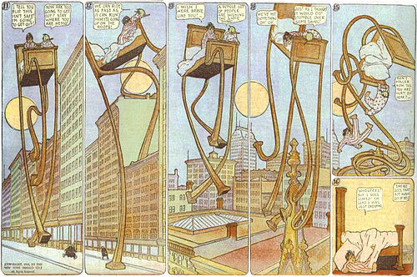

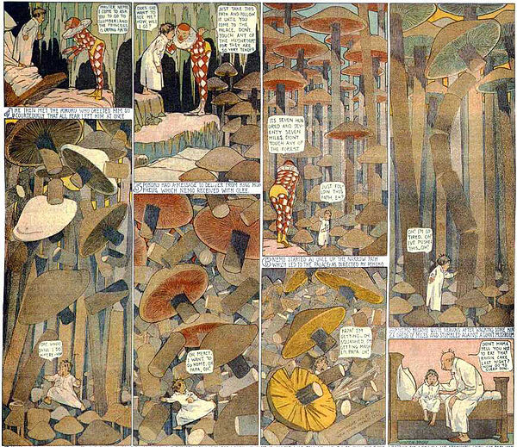

.4.

**Jack Kirby** (August 28, 1917 – February 6, 1994),[[5]](http://en.wikipedia.org/wiki/Jack_Kirby#cite_note-5) born **Jacob Kurtzberg**, was an [American](http://en.wikipedia.org/wiki/Americans) [comic book artist](http://en.wikipedia.org/wiki/Comic_artist), writer and [editor](http://en.wikipedia.org/wiki/Editing" \o "Editing)regarded by historians and fans as one of the major innovators and most influential creators in the comic book medium.

Kirby grew up poor in New York City and learned to draw cartoon figures by tracing characters from comic strips and editorial cartoons. He entered the nascent comics industry in the 1930s and drew various comics features under different [pen names](http://en.wikipedia.org/wiki/Pen_names), including Jack Curtiss, ultimately settling on Jack Kirby. In 1940, he and writer-editor [Joe Simon](http://en.wikipedia.org/wiki/Joe_Simon) created the highly successful [superhero](http://en.wikipedia.org/wiki/Superhero) character[Captain America](http://en.wikipedia.org/wiki/Captain_America) for [Timely Comics](http://en.wikipedia.org/wiki/Timely_Comics), predecessor of [Marvel Comics](http://en.wikipedia.org/wiki/Marvel_Comics). During the 1940s, Kirby, generally teamed with Simon, created numerous characters for that company and for National Comics, the company that later became [DC Comics](http://en.wikipedia.org/wiki/DC_Comics).

After serving in [World War II](http://en.wikipedia.org/wiki/World_War_II), Kirby returned to comics and worked in a variety of genres. He produced work for a number of publishers, including DC, [Harvey Comics](http://en.wikipedia.org/wiki/Harvey_Comics), [Hillman Periodicals](http://en.wikipedia.org/wiki/Hillman_Periodicals) and [Crestwood Publications](http://en.wikipedia.org/wiki/Crestwood_Publications), where he and Simon created the genre of [romance comics](http://en.wikipedia.org/wiki/Romance_comics). He and Simon launched their own short-lived comic company, [Mainline Publications](http://en.wikipedia.org/wiki/Mainline_Publications). Kirby ultimately found himself at Timely's 1950s iteration, [Atlas Comics](http://en.wikipedia.org/wiki/Atlas_Comics_(1950s)), soon to become Marvel. There, in the 1960s, he and writer-editor [Stan Lee](http://en.wikipedia.org/wiki/Stan_Lee) co-created many of Marvel's major characters, including the [Fantastic Four](http://en.wikipedia.org/wiki/Fantastic_Four), the [X-Men](http://en.wikipedia.org/wiki/X-Men), and the [Hulk](http://en.wikipedia.org/wiki/Hulk_(comics)). Despite the high sales and critical acclaim of the Lee-Kirby titles, Kirby felt treated unfairly, and left the company in 1970 for rival DC.

There Kirby created his [Fourth World](http://en.wikipedia.org/wiki/Fourth_World_(comics)) saga, which spanned several comics titles. While these series proved commercially unsuccessful and were canceled, the Fourth World's [New Gods](http://en.wikipedia.org/wiki/New_Gods) have continued as a significant part of the [DC Universe](http://en.wikipedia.org/wiki/DC_Universe). Kirby returned to Marvel briefly in the mid-to-late 1970s, then ventured into [television animation](http://en.wikipedia.org/wiki/Television_animation) and [independent comics](http://en.wikipedia.org/wiki/Independent_comics). In his later years, Kirby, who has been called "the [William Blake](http://en.wikipedia.org/wiki/William_Blake) of comics",[[6]](http://en.wikipedia.org/wiki/Jack_Kirby#cite_note-6) began receiving great recognition in the mainstream press for his career accomplishments, and in 1987 he was one of the three inaugural inductees of the [Will Eisner Comic Book Hall of Fame](http://en.wikipedia.org/wiki/List_of_Eisner_Award_winners#The_Will_Eisner_Award_Hall_of_Fame).

Kirby was married to Rosalind "Roz" Goldstein in 1942. They had four children, and remained married until his death from heart failure in 1994, at the age of 76. The [Jack Kirby Awards](http://en.wikipedia.org/wiki/Jack_Kirby_Awards) and [Jack Kirby Hall of Fame](http://en.wikipedia.org/wiki/Jack_Kirby_Hall_of_Fame) were named in his honor.

It was at Marvel with writer and editor-in-chief Lee that Kirby hit his stride once again in superhero comics, beginning with [*The Fantastic Four*](http://en.wikipedia.org/wiki/The_Fantastic_Four)#1 (Nov. 1961).[[72]](http://en.wikipedia.org/wiki/Jack_Kirby#cite_note-72)[[15]](http://en.wikipedia.org/wiki/Jack_Kirby#cite_note-gcdjack-15) The landmark series became a hit that revolutionized the industry with its comparative [naturalism](http://en.wikipedia.org/wiki/Naturalism_(arts)) and, eventually, a cosmic purview informed by Kirby's seemingly boundless imagination—one well-matched with the consciousness-expanding [youth culture](http://en.wikipedia.org/wiki/Youth_culture) of the 1960s.

For almost a decade, Kirby provided Marvel's house style, co-creating with Stan Lee many of the Marvel characters and designing their visual motifs. At Lee's request, he often provided new-to-Marvel artists "breakdown" layouts, over which they would pencil in order to become acquainted with the Marvel look. As artist [Gil Kane](http://en.wikipedia.org/wiki/Gil_Kane) described:

Jack was the single most influential figure in the turnaround in Marvel's fortunes from the time he rejoined the company ... It wasn't merely that Jack conceived most of the characters that are being done, but ... Jack's point of view and philosophy of drawing became the governing philosophy of the entire publishing company and, beyond the publishing company, of the entire field ... [Marvel took] Jack and use[d] him as a primer. They would get artists ... and they taught them the ABCs, which amounted to learning Jack Kirby. ... Jack was like the Holy Scripture and they simply had to follow him without deviation. That's what was told to me ... It was how they taught everyone to reconcile all those opposing attitudes to one single master point of view.[[73]](http://en.wikipedia.org/wiki/Jack_Kirby#cite_note-73)

Highlights other than the Fantastic Four include: the [Hulk](http://en.wikipedia.org/wiki/Hulk_(comics)),[[74]](http://en.wikipedia.org/wiki/Jack_Kirby#cite_note-74) [Thor](http://en.wikipedia.org/wiki/Thor_(Marvel_Comics)),[[75]](http://en.wikipedia.org/wiki/Jack_Kirby#cite_note-75) [Iron Man](http://en.wikipedia.org/wiki/Iron_Man), the original [X-Men](http://en.wikipedia.org/wiki/X-Men),[[76]](http://en.wikipedia.org/wiki/Jack_Kirby#cite_note-76) [Doctor Doom](http://en.wikipedia.org/wiki/Doctor_Doom), [Uatu the Watcher](http://en.wikipedia.org/wiki/Uatu" \o "Uatu), [Magneto](http://en.wikipedia.org/wiki/Magneto_(comics)), [Ego the Living Planet](http://en.wikipedia.org/wiki/Ego_the_Living_Planet), the[Inhumans](http://en.wikipedia.org/wiki/Inhumans)[[77]](http://en.wikipedia.org/wiki/Jack_Kirby#cite_note-77)[[78]](http://en.wikipedia.org/wiki/Jack_Kirby#cite_note-DeFalco111-78) and the [Black Panther](http://en.wikipedia.org/wiki/Black_Panther_(comics)),[[79]](http://en.wikipedia.org/wiki/Jack_Kirby#cite_note-79) and their hidden city of Attilan, and the [Black Panther](http://en.wikipedia.org/wiki/Black_Panther_(comics))—comics' first known [black](http://en.wikipedia.org/wiki/Black_people) superhero—and his African nation of [Wakanda](http://en.wikipedia.org/wiki/Wakanda_(comics)" \o "Wakanda (comics)).[[80]](http://en.wikipedia.org/wiki/Jack_Kirby#cite_note-80) Kirby drew the first [Spider-Man](http://en.wikipedia.org/wiki/Spider-Man) story intended for publication in [*Amazing Fantasy*](http://en.wikipedia.org/wiki/Amazing_Fantasy) #15 but Stan Lee chose to have [Steve Ditko](http://en.wikipedia.org/wiki/Steve_Ditko) redraw the story.[[81]](http://en.wikipedia.org/wiki/Jack_Kirby#cite_note-81) Lee and Kirby gathered several of their newly created characters together into the team title *The*[*Avengers*](http://en.wikipedia.org/wiki/Avengers_(comics))[[82]](http://en.wikipedia.org/wiki/Jack_Kirby#cite_note-82) and would revive characters from the 1940s such as the [Sub-Mariner](http://en.wikipedia.org/wiki/Namor),[[83]](http://en.wikipedia.org/wiki/Jack_Kirby#cite_note-83) Captain America,[[84]](http://en.wikipedia.org/wiki/Jack_Kirby#cite_note-84) and [Ka-Zar](http://en.wikipedia.org/wiki/Ka-Zar_(comics)).[[85]](http://en.wikipedia.org/wiki/Jack_Kirby#cite_note-85)The story frequently cited as Lee and Kirby's finest achievement[[86]](http://en.wikipedia.org/wiki/Jack_Kirby#cite_note-86)[[87]](http://en.wikipedia.org/wiki/Jack_Kirby#cite_note-87) is the three-part "[The Galactus Trilogy](http://en.wikipedia.org/wiki/The_Galactus_Trilogy)" that began in *Fantastic Four* #48 (March 1966), chronicling the arrival of [Galactus](http://en.wikipedia.org/wiki/Galactus" \o "Galactus), a cosmic giant who wanted to devour the planet, and his herald, the [Silver Surfer](http://en.wikipedia.org/wiki/Silver_Surfer).[[88]](http://en.wikipedia.org/wiki/Jack_Kirby#cite_note-88)[[89]](http://en.wikipedia.org/wiki/Jack_Kirby#cite_note-89) *Fantastic Four* #48 was chosen as #24 in the [100 Greatest Marvels of All Time](http://en.wikipedia.org/wiki/100_Greatest_Marvels_of_All_Time)poll of Marvel's readers in 2001. Editor [Robert Greenberger](http://en.wikipedia.org/wiki/Robert_Greenberger) wrote in his introduction to the story that "As the fourth year of the *Fantastic Four* came to a close, Stan Lee and Jack Kirby seemed to be only warming up. In retrospect, it was perhaps the most fertile period of any monthly title during the Marvel Age."[[90]](http://en.wikipedia.org/wiki/Jack_Kirby#cite_note-90) Comics historian [Les Daniels](http://en.wikipedia.org/wiki/Les_Daniels) noted that "[t]he mystical and metaphysical elements that took over the saga were perfectly suited to the tastes of young readers in the 1960s", and Lee soon discovered that the story was a favorite on college campuses.[[91]](http://en.wikipedia.org/wiki/Jack_Kirby#cite_note-91)

In 1968 and 1969, Joe Simon was involved in litigation with Marvel Comics over the ownership of Captain America, initiated by Marvel after Simon registered the [copyright](http://en.wikipedia.org/wiki/Copyright) renewal for Captain America in his own name. According to Simon, Kirby agreed to support the company in the litigation and, as part of a deal Kirby made with publisher Martin Goodman, signed over to Marvel any rights he might have had to the character.[[92]](http://en.wikipedia.org/wiki/Jack_Kirby#cite_note-92)

Kirby continued to expand the medium's boundaries, devising [photo-collage](http://en.wikipedia.org/wiki/Photomontage) covers and interiors, developing new drawing techniques such as the method for depicting energy fields now known as "[Kirby Dots](http://en.wikipedia.org/wiki/Kirby_Dots)", and other experiments.[[93]](http://en.wikipedia.org/wiki/Jack_Kirby#cite_note-93) Yet he grew increasingly dissatisfied with working at Marvel. There have been a number of reasons given for this dissatisfaction, including resentment over Stan Lee's increasing media prominence, a lack of full creative control, anger over breaches of perceived promises by publisher Martin Goodman, and frustration over Marvel's failure to credit him specifically for his story plotting and for his character creations and co-creations.[[94]](http://en.wikipedia.org/wiki/Jack_Kirby#cite_note-94) He began to both script and draw some secondary features for Marvel, such as "The Inhumans" in *Amazing Adventures*,[[95]](http://en.wikipedia.org/wiki/Jack_Kirby#cite_note-95) as well as horror stories for the anthology title [*Chamber of Darkness*](http://en.wikipedia.org/wiki/Chamber_of_Darkness)*,* and received full credit for doing so; but in 1970, Kirby was presented with a contract that included such unfavorable terms as a prohibition against legal retaliation. When Kirby objected, the management refused to negotiate any contract changes.[[96]](http://en.wikipedia.org/wiki/Jack_Kirby#cite_note-96) Kirby, although he was earning $35,000 a year freelancing for the company,[[97]](http://en.wikipedia.org/wiki/Jack_Kirby" \l "cite_note-97) subsequently left Marvel in 1970 for rival DC Comics, under editorial director [Carmine Infantino](http://en.wikipedia.org/wiki/Carmine_Infantino).[[9](http://en.wikipedia.org/wiki/Jack_Kirby#cite_note-CBHistoryOfComics-98)

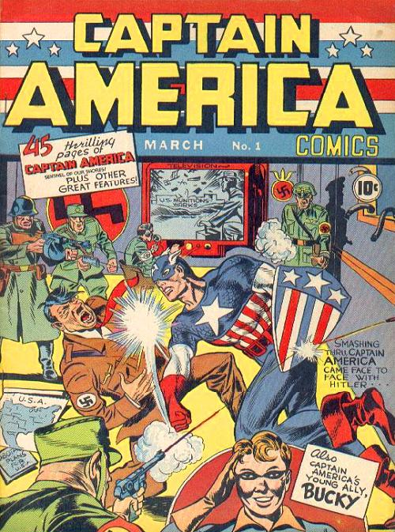 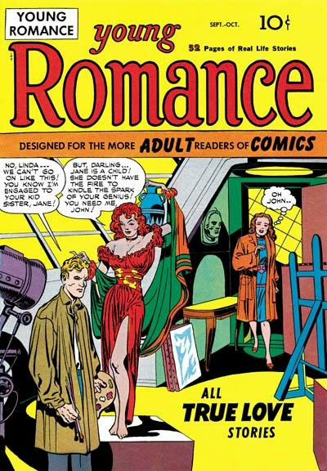 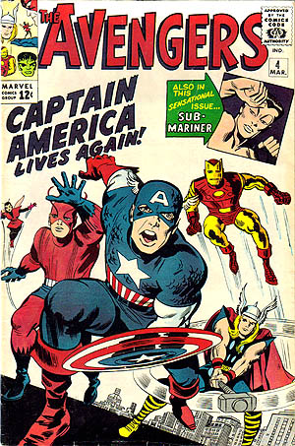

.5.

**Frank Miller** (born January 27, 1957)[[1]](http://en.wikipedia.org/wiki/Frank_Miller_(comics)#cite_note-CBG1650-1) is an American [writer](http://en.wikipedia.org/wiki/Comic_book_creator), artist, and film director best known for his dark comic book stories and[graphic novels](http://en.wikipedia.org/wiki/Graphic_novel) such as *[Ronin](http://en.wikipedia.org/wiki/Ronin_(DC_Comics)" \o "Ronin (DC Comics))*, [*Daredevil: Born Again*](http://en.wikipedia.org/wiki/Daredevil:_Born_Again), [*The Dark Knight Returns*](http://en.wikipedia.org/wiki/The_Dark_Knight_Returns), [*Sin City*](http://en.wikipedia.org/wiki/Sin_City) and [*300*](http://en.wikipedia.org/wiki/300_(comics)). He also directed the film version of[*The Spirit*](http://en.wikipedia.org/wiki/The_Spirit_(film)), shared directing duties with [Robert Rodriguez](http://en.wikipedia.org/wiki/Robert_Rodriguez) on [*Sin City*](http://en.wikipedia.org/wiki/Sin_City_(film)), [*Sin City: A Dame to Kill For*](http://en.wikipedia.org/wiki/Sin_City:_A_Dame_to_Kill_For) and produced the film [*300*](http://en.wikipedia.org/wiki/300_(film)). He is also known for creating the comic book character [*Elektra*](http://en.wikipedia.org/wiki/Elektra_(comics)).

Miller grew up a comics fan, with a letter he wrote to [Marvel Comics](http://en.wikipedia.org/wiki/Marvel_Comics) being published ([*The Cat*](http://en.wikipedia.org/wiki/Tigra) #3 (April 1973)).[[5]](http://en.wikipedia.org/wiki/Frank_Miller_(comics)#cite_note-5) His first published work was at [Western Publishing](http://en.wikipedia.org/wiki/Western_Publishing)'s [Gold Key Comics](http://en.wikipedia.org/wiki/Gold_Key_Comics) [imprint](http://en.wikipedia.org/wiki/Imprint), gotten at the recommendation of comics artist [Neal Adams](http://en.wikipedia.org/wiki/Neal_Adams), to whom a fledgling Miller, after moving to New York City, had shown samples and received much critique and occasional informal lessons.[[6]](http://en.wikipedia.org/wiki/Frank_Miller_(comics)#cite_note-6) Though no published credits appear, he is tentatively credited with the three-page story "Royal Feast" in the licensed [TV-series](http://en.wikipedia.org/wiki/TV-series) comic book [*The Twilight Zone*](http://en.wikipedia.org/wiki/The_Twilight_Zone) #84 (June 1978), by an unknown writer,[[7]](http://en.wikipedia.org/wiki/Frank_Miller_(comics)#cite_note-7) and is credited with the five-page "Endless Cloud", also by an unknown writer, in the following issue (July 1978).[[8]](http://en.wikipedia.org/wiki/Frank_Miller_(comics)#cite_note-8)By the time of the latter, however, Miller had his first confirmed credit in writer Wyatt Gwyon's six-page "Deliver Me From D-Day", inked by Danny Bulanadi, in [*Weird War Tales*](http://en.wikipedia.org/wiki/Weird_War_Tales) #64 (June 1978).[[9]](http://en.wikipedia.org/wiki/Frank_Miller_(comics)#cite_note-9)

One-time Marvel editor-in-chief [Jim Shooter](http://en.wikipedia.org/wiki/Jim_Shooter) recalled Miller going to [DC Comics](http://en.wikipedia.org/wiki/DC_Comics) after having broken in with "a small job from [Western Publishing](http://en.wikipedia.org/wiki/Western_Publishing), I think. Thus emboldened, he went to DC, and after getting savaged by [Joe Orlando](http://en.wikipedia.org/wiki/Joe_Orlando), got in to see art director [Vinnie Colletta](http://en.wikipedia.org/wiki/Vince_Colletta), who recognized talent and arranged for him to get a one-page war-comic job".[[10]](http://en.wikipedia.org/wiki/Frank_Miller_(comics)#cite_note-jimshooterinterview-10) The[Grand Comics Database](http://en.wikipedia.org/wiki/Grand_Comics_Database) does not list this job; there may have been a one-page DC story, or Shooter may have misremembered the page count or have been referring to the two-page story, by writer [Roger McKenzie](http://en.wikipedia.org/wiki/Roger_McKenzie_(comics)), "Slowly, painfully, you dig your way from the cold, choking debris..." in [*Weird War Tales*](http://en.wikipedia.org/wiki/Weird_War_Tales) #68 (Oct. 1978).[[11]](http://en.wikipedia.org/wiki/Frank_Miller_(comics)#cite_note-11) Other fledgling work at DC included the six-page "The Greatest Story Never Told", by writer [Paul Kupperberg](http://en.wikipedia.org/wiki/Paul_Kupperberg), in that same issue, and the five-page "The Edge of History", written by [Elliot S. Maggin](http://en.wikipedia.org/wiki/Elliot_S._Maggin), in[*Unknown Soldier*](http://en.wikipedia.org/wiki/Unknown_Soldier_(DC_Comics)) #219 (Sept. 1978). His first work for [Marvel Comics](http://en.wikipedia.org/wiki/Marvel_Comics) was penciling the 17-page story "The Master Assassin of Mars, Part 3" in [*John Carter, Warlord of Mars*](http://en.wikipedia.org/wiki/John_Carter,_Warlord_of_Mars) #18 (Nov. 1978).[[12]](http://en.wikipedia.org/wiki/Frank_Miller_(comics)#cite_note-12)

At Marvel, Miller would settle in as a regular fill-in and cover artist, working on a variety of titles. One of these jobs was drawing *Peter Parker,*[*The Spectacular Spider-Man*](http://en.wikipedia.org/wiki/The_Spectacular_Spider-Man) #27–28 (Feb.–March 1979), which guest-starred [Daredevil](http://en.wikipedia.org/wiki/Daredevil_(Marvel_Comics)).[[13]](http://en.wikipedia.org/wiki/Frank_Miller_(comics)#cite_note-13) At the time, sales of the Daredevil title were poor; however, Miller saw something in the character he liked and asked editor-in-chief [Jim Shooter](http://en.wikipedia.org/wiki/Jim_Shooter) if he could work on Daredevil's regular title. Shooter agreed and made Miller the new penciller on the title. As Miller recalled in 2008:

When I first showed up in New York, I showed up with a bunch of comics, a bunch of samples, of guys in trench coats and old cars and such. And [comics editors] said, 'Where are the guys in tights?' And I had to learn how to do it. But as soon as a title came along, when [*Daredevil* signature artist] [Gene Colan](http://en.wikipedia.org/wiki/Gene_Colan) left *Daredevil*, I realized it was my secret in to do crime comics with a superhero in them. And so I lobbied for the title and got it".[[3]](http://en.wikipedia.org/wiki/Frank_Miller_(comics)#cite_note-fji-3)

[*Daredevil: Born Again*](http://en.wikipedia.org/wiki/Daredevil:_Born_Again) and [*The Dark Knight Returns*](http://en.wikipedia.org/wiki/The_Dark_Knight_Returns) were both critical successes and influential on a new generation of creators. [*Batman: Year One*](http://en.wikipedia.org/wiki/Batman:_Year_One) was met with even greater praise for its gritty style. Works such as *[Ronin](http://en.wikipedia.org/wiki/Ronin_(DC_Comics)" \o "Ronin (DC Comics))*, [*300*](http://en.wikipedia.org/wiki/300_(comics)) and [*Sin City*](http://en.wikipedia.org/wiki/Sin_City) were also very successful. However, fellow comic book writer [Alan Moore](http://en.wikipedia.org/wiki/Alan_Moore) has described Miller's work from Sin City-onwards as [homophobic](http://en.wikipedia.org/wiki/Homophobic) and [misogynistic](http://en.wikipedia.org/wiki/Misogynistic), despite praising his early Batman and Daredevil work. Moore previously penned a flattering introduction to an early collected edition of *The Dark Knight Returns*.[[60]](http://en.wikipedia.org/wiki/Frank_Miller_(comics)#cite_note-60) [*Batman: The Dark Knight Strikes Again*](http://en.wikipedia.org/wiki/Batman:_The_Dark_Knight_Strikes_Again), a sequel to *The Dark Knight Returns*, received mixed reviews, while [*All Star Batman and Robin the Boy Wonder*](http://en.wikipedia.org/wiki/All_Star_Batman_and_Robin_the_Boy_Wonder) in particular consistently received harsh criticism and was hailed as a sign of Miller's creative decline.[[61]](http://en.wikipedia.org/wiki/Frank_Miller_(comics)#cite_note-61)[[62]](http://en.wikipedia.org/wiki/Frank_Miller_(comics)#cite_note-62)[[63]](http://en.wikipedia.org/wiki/Frank_Miller_(comics)#cite_note-63) The filmatization of [*300*](http://en.wikipedia.org/wiki/300_(film)) has been perceived as promoting [fascist](http://en.wikipedia.org/wiki/Fascism" \l "Tenets" \o "Fascism)values,[[64]](http://en.wikipedia.org/wiki/Frank_Miller_(comics)#cite_note-64)[[65]](http://en.wikipedia.org/wiki/Frank_Miller_(comics)#cite_note-65)[[66]](http://en.wikipedia.org/wiki/Frank_Miller_(comics)#cite_note-66)[[67]](http://en.wikipedia.org/wiki/Frank_Miller_(comics)#cite_note-67) as [denigrating Iranians](http://en.wikipedia.org/wiki/Anti-Iranian_sentiment),[[68]](http://en.wikipedia.org/wiki/Frank_Miller_(comics)#cite_note-metimes.com-68)[[69]](http://en.wikipedia.org/wiki/Frank_Miller_(comics)#cite_note-Iran_condemns_Hollywood_war_epic-69)[[70]](http://en.wikipedia.org/wiki/Frank_Miller_(comics)#cite_note-70)[[71]](http://en.wikipedia.org/wiki/Frank_Miller_(comics)#cite_note-71)[[72]](http://en.wikipedia.org/wiki/Frank_Miller_(comics)#cite_note-72)[[73]](http://en.wikipedia.org/wiki/Frank_Miller_(comics)#cite_note-73)[[74]](http://en.wikipedia.org/wiki/Frank_Miller_(comics)#cite_note-74) and as [hate speech](http://en.wikipedia.org/wiki/Hate_speech) against [disabled](http://en.wikipedia.org/wiki/Disability) people.[[75]](http://en.wikipedia.org/wiki/Frank_Miller_(comics)#cite_note-75)[[76]](http://en.wikipedia.org/wiki/Frank_Miller_(comics)#cite_note-76) [*Holy Terror*](http://en.wikipedia.org/wiki/Holy_Terror_(graphic_novel)) has been accused of being [anti-Islamic](http://en.wikipedia.org/wiki/Criticism_of_Islam)[propaganda](http://en.wikipedia.org/wiki/Propaganda).[[77]](http://en.wikipedia.org/wiki/Frank_Miller_(comics)#cite_note-77) In addition, some of Miller's works have been accused of lacking "humanity,"[[78]](http://en.wikipedia.org/wiki/Frank_Miller_(comics)#cite_note-78) particularly in regard to the abundance of prostitutes portrayed in Sin City.[[79]](http://en.wikipedia.org/wiki/Frank_Miller_(comics)#cite_note-79) In terms of his film work, Miller's scripts for *Robocop 2* and *3* were unsuccessful, while his [2008 film adaptation](http://en.wikipedia.org/wiki/The_Spirit_(film)) of [Will Eisner](http://en.wikipedia.org/wiki/Will_Eisner)'s [*The Spirit*](http://en.wikipedia.org/wiki/The_Spirit) met with largely negative reviews, earning a metascore of 30/100 at the review aggregation site [Metacritic.com](http://en.wikipedia.org/wiki/Metacritic.com).[[80]](http://en.wikipedia.org/wiki/Frank_Miller_(comics)#cite_note-80)



