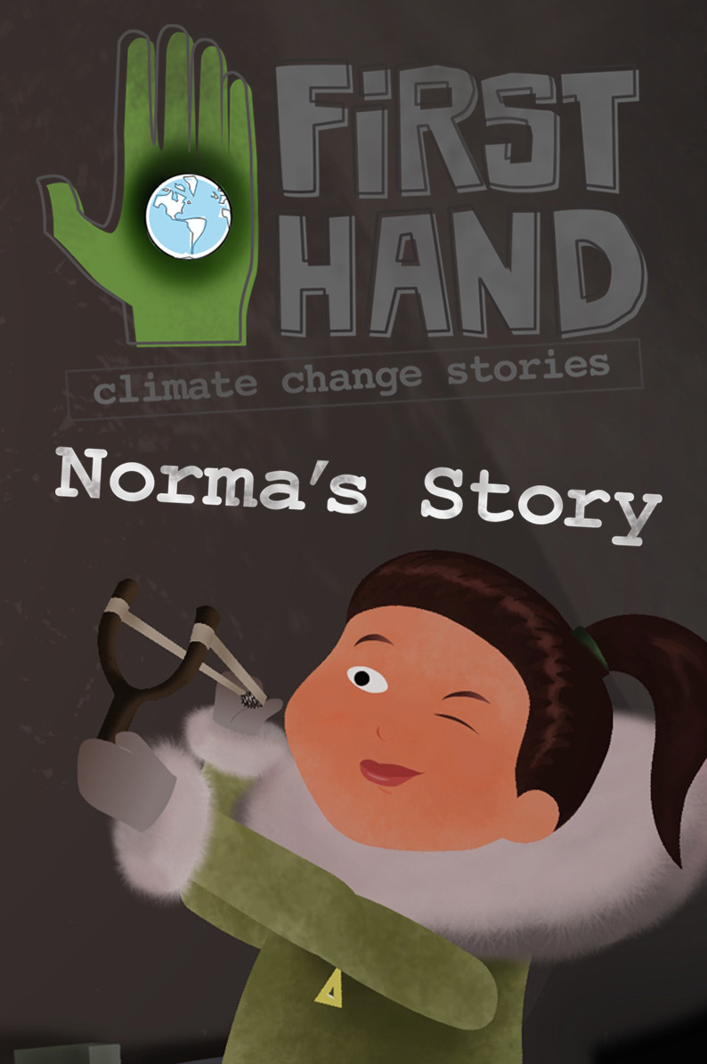The World Health Organization (WHO) states that food security exists “when all people at all times have access to sufficient, safe, nutritious food to maintain a healthy and active life”.
• Why has Norma’s community become food insecure?
Connect three key climate change impacts in the North to the potential threats to food security:
1. Irregular rainfall and snowfall
2. Increased average temperatures
3. More frequent storms
• What solutions could Norma’s community implement to improve their food security?
• What climate impacts might make other communities food insecure?
• How is our community’s food supply insecure?
• What solutions could your community implement to improve their food security?

Climate Change and its Impacts
We are upsetting the atmosphere upon which all life depends. In the late '80s when I began to take climate change seriously, we referred to global warming as a "slow-motion catastrophe" one we expected to kick in perhaps generations later. Instead, the signs of change have accelerated alarmingly.
- DR. DAVID SUZUKI
o Where do the greenhouse gases come from, that are causing the warming climate in Old Crow, Yukon?
ARCTIC WARMING
Norma tells us that arctic temperatures are increasing at twice the rate of global temperatures.
• What are some of the DIRECT climate change impacts in Norma’s community of Old Crow?
PERMAFROST MELT
• How does melting permafrost affect Norma’s community?
LAKES DRYING AND DRAINING
• What does it mean for the wildlife to lose the lakes?
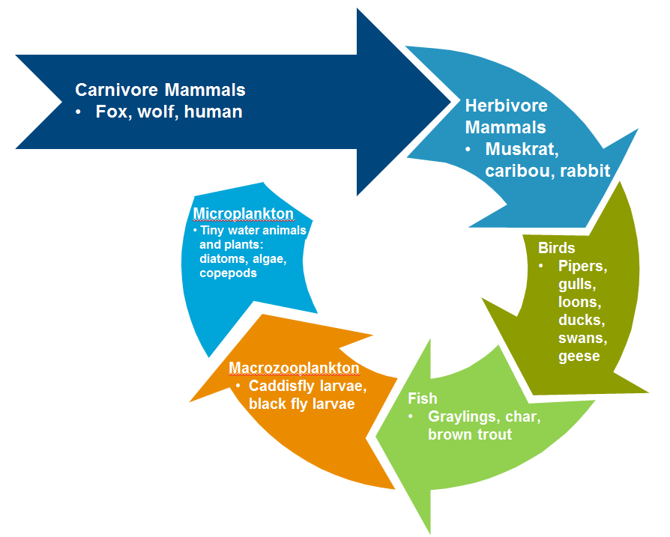
• Are there solutions that might stop the climate from changing?
These are solutions that fall under the Mitigation category.
Mitigation: lessening the force or intensity of something unpleasant, the act of making a condition or consequence less severe, the process of becoming milder, gentler, or less severe.
• Are there other solutions that might help Old Crow manage the changes to their environment?
These are solutions that fall under the Adaptation category.
Adaptation: modifying a structure or a process to fit a changed environment
• What can WE do to help Norma’s community?
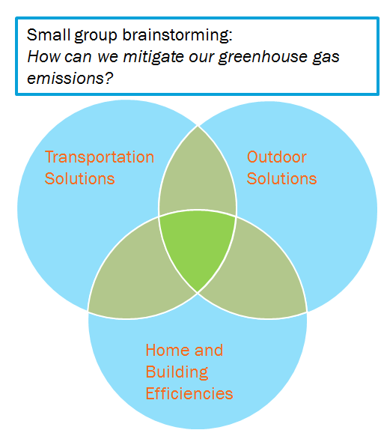
• Use words or drawings to show your ideas in each of these three categories.
• If you have other ideas, add in the white space.
• Where the circles overlap is where ideas connect to different categories, example: “Bike paths” fit where Outdoor Solutions and Transportation Solutions intersect.

