REAL STORIES OF REFUGEES

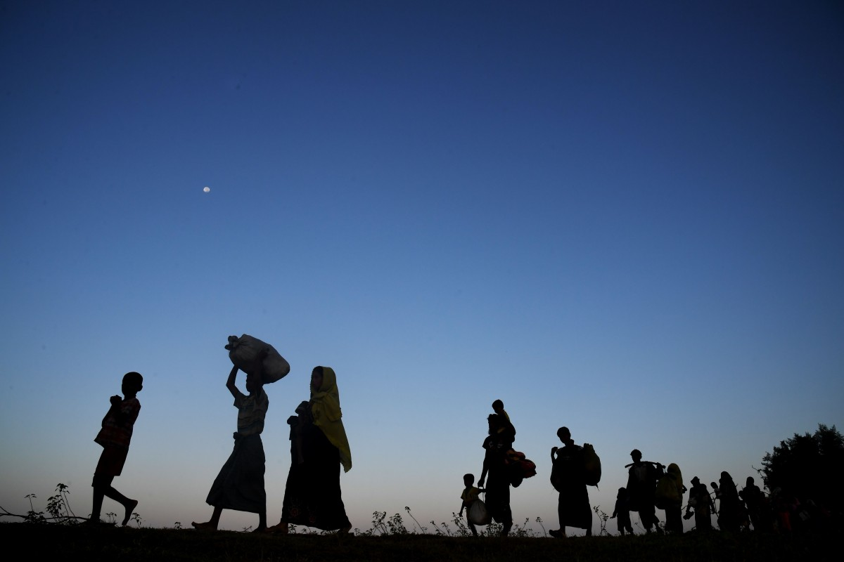

Every day, all over the world, people make one of the most difficult decisions in their lives: to leave their homes in search of a safer, better life.
Most people in the world have had the experience of leaving the place where they grew up. Maybe they will only move as far as the next village or city. But for some people, they will need to leave their country entirely – sometimes for a short time, but sometimes forever.
There are many reasons why people around the globe seek to rebuild their lives in a different country. Some people leave home to get a job or an education. Others are forced to flee persecution or human rights violations such as torture. Millions flee from armed conflicts or other crises or violence. Some no longer feel safe and might have been targeted just because of who they are or what they do or believe – for example, for their ethnicity, religion, sexuality or political opinions.
These journeys, which all start with the hope for a better future, can also be full of danger and fear. Some people risk falling prey to human trafficking and other forms of exploitation. Some are detained by the authorities as soon as they arrive in a new country. Once they’re settling in and start building a new life, many face daily racism, xenophobia and discrimination.

Doaa, Syrian refugee living in Greece

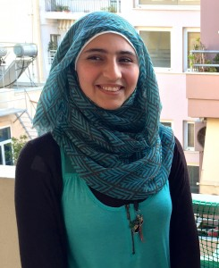

Doaa is a 19-year-old aspiring student who was forced by the war to live a grinding existence with her family in exile.
Without a work permit in Egypt, Doaa struggled through day shifts for low wages. As the months passed, she was getting more and more scared. One day, a motorcycle gang tried to kidnap her on the street. The war in Syria that drove her family away was in its fourth year. And the people who once welcomed them in Egypt had become weary of them.
Despite all this, Doaa still had hope, because she was in love with another refugee, called Bassem. He promised to take her to safety in Europe where they would marry and build a new life. Doaa knew the risks. It was August 2014, and more than 2,000 migrants and refugees had already died crossing the Mediterranean that year. She didn’t know how to swim, but for the second time in her life, she felt she had no choice but to flee.
So Bassem paid his life savings to smugglers, $2,500 each, to get them onto an old fishing boat. It was so packed with people that Doaa’s knees were bent to her chest.
After two days at sea she started to get worried, and on the third day she told Bassem: “We will never reach the shore. We will all sink.”
On day four, another boat approached the vessel. It was rusty and when the passengers were ordered to get on, they refused. The smugglers left angrily, and then returned to ram a hole in the side of the hull. “Let the fish eat your flesh,” they shouted, and then they laughed. Within minutes, the boat capsized and sank, with 300 people trapped below deck.
“The sea went black,” said Doaa. “I heard people screaming, and water crashing. I felt like I was going to drown.” She watched the propeller cut a child to pieces. Miraculously, Bassem found a water ring. He held Doaa’s hand and treaded water. There were corpses everywhere. The 100 survivors came together in small groups and prayed for rescue.
But as day turned to night and to day again, many lost hope. Doaa watched as men took off their life vests and drowned. Sensing his end was near, a Palestinian approached with his nine-month-old granddaughter, Malek. “Please take the baby,” he said. “I am very tired.” Then he gave up and let the sea take his life.
Soon after, Bassem had also reached his limit. His last words were, “I am sorry my love. Please forgive me.” He drowned before her eyes. Later that day, a mother struggled towards Doaa with Masa, an 18-month-old girl. “Save her,” she said, “I will not survive.”
Doaa, the 19-year-old who could not swim, who had just watched her fiancé drown, was now in charge of saving two fledgling lives. They were crying, agitated, hungry and thirsty. So she told them stories and played with them. Another day passed, and then another. On the fourth day in the sea, Doaa saw a merchant boat. For two hours she shouted. They spotted her with search lights in the dark and extended a rope – astonished to find a young woman clutching two babies.
Malek died in the boat’s clinic, but Masa pulled through. Doaa’s heroism was praised in the Greek media. On 19 December, one of Greece’s most respected institutions, the Academy of Athens, gave her an award for bravery.

Um Nawwaf, Syrian refugee in Jordan

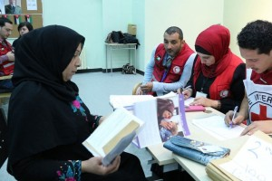

Um Nawwaf will never forget the day three years ago, when the shells were raining down on the family’s home in Ghouta, Syria. “My daughter was looking for a place to hide, but she fell on a rock and hit her head and since then, she has been suffering from epilepsy. That was the final straw – we simply had to move.”
Fearful for her children, she fled to Jordan, while her husband stayed in Syria. She now lives alone with her five children in a small apartment in Mafraq Governorate.
Um Nawwaf describes how hard it is to be a refugee: “I can barely afford to put a roof over my head. My son Nawwaf had to drop out of school and find a job to help me with the expenses.”
Barely holding back her tears, she says: “My heart breaks every time he leaves for work. He’s only 13 years old.”
For the past two years, Um Nawwaf has been receiving support from the International Committee of the Red Cross through its cash assistance programme, which is run in cooperation with the Jordan Red Crescent Society. “The money helps us pay the rent, fuel and electricity bills, in addition to buying food and other essential items. It makes our lives bearable.”
Most of the Syrian refugees living in host communities in Jordan depend on aid provided by humanitarian agencies. With the protracted nature of the conflict, many of them have exhausted their savings and other assets. With the arrival of winter, the pressures of daily life can only increase.
Some 3,000 Syrian families, the majority of whom are households headed by women, have been benefiting from the programme, through which they receive monthly cash installments – the amount depends on the size of the household – paid via a local bank.
On average, the amount is $100 per household and is intended to cover various daily expenditures. In addition, over the four months of winter, the supported households receive four installments, each worth $150, to cover heating-related expenditure.
For the Syrian refugees living in Jordan, life is a daily struggle. Humanitarian assistance makes their lives a little easier, but life is a constant mix of fear, anxiety and hope for a better future.
With a glimmer of hope in her eyes, Um Nawwaf says: “I wake up every day telling myself that this is a temporary situation and that things will get better soon. I hope so.”

Apostolia Pyrgerou

