[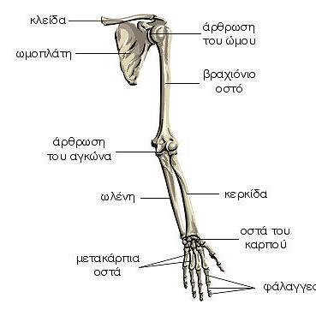](https://www.google.gr/url?sa=i&url=https%3A%2F%2Fwww.beautyview.gr%2F%25CE%25BF-%25CF%2583%25CE%25BA%25CE%25B5%25CE%25BB%25CE%25B5%25CF%2584%25CF%258C%25CF%2582-%25CF%2584%25CE%25BF%25CF%2585-%25CE%25AC%25CE%25BD%25CF%2589-%25CE%25AC%25CE%25BA%25CF%2581%25CE%25BF%25CF%2585%2F&psig=AOvVaw1V4cdLNSuSzh39lw3cznUp&ust=1607273892649000&source=images&cd=vfe&ved=0CAIQjRxqFwoTCLD8z4Kot-0CFQAAAAAdAAAAABAP)

ΒΙΟΛΟΓΙΑ Β΄ΓΥΜΝΑΣΙΟΥ

ΑΣΚΗΣΗ: Σημειώστε ποια είναι τα παρακάτω οστά των άνω άκρων,των κάτω άκρων και του θώρακα.

[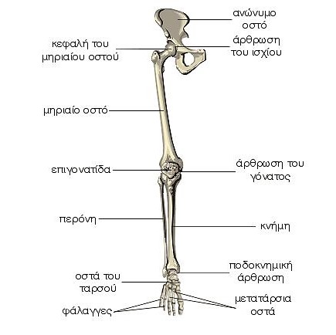](https://www.google.gr/url?sa=i&url=https%3A%2F%2Fwww.beautyview.gr%2F%25CE%25BF-%25CF%2583%25CE%25BA%25CE%25B5%25CE%25BB%25CE%25B5%25CF%2584%25CF%258C%25CF%2582-%25CF%2584%25CF%2589%25CE%25BD-%25CE%25BA%25CE%25AC%25CF%2584%25CF%2589-%25CE%25AC%25CE%25BA%25CF%2581%25CF%2589%25CE%25BD%2F&psig=AOvVaw1V4cdLNSuSzh39lw3cznUp&ust=1607273892649000&source=images&cd=vfe&ved=0CAIQjRxqFwoTCLD8z4Kot-0CFQAAAAAdAAAAABAU)

[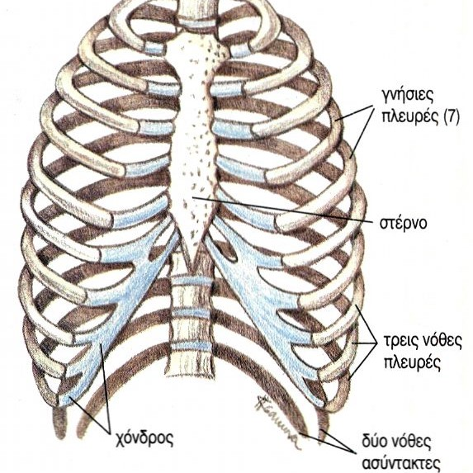](https://www.google.gr/url?sa=i&url=https://www.beautyview.gr/%CF%83%CE%BA%CE%B5%CE%BB%CE%B5%CF%84%CF%8C%CF%82-%CF%84%CE%BF%CF%85-%CE%B8%CF%8E%CF%81%CE%B1%CE%BA%CE%B1/&psig=AOvVaw0IPz790sW6iqjL1fy-E9oJ&ust=1607274108701000&source=images&cd=vfe&ved=0CAIQjRxqFwoTCKjHwveot-0CFQAAAAAdAAAAABAD)

[](https://www.google.gr/url?sa=i&url=https%3A%2F%2Fwww.beautyview.gr%2F%25CF%2583%25CE%25BA%25CE%25B5%25CE%25BB%25CE%25B5%25CF%2584%25CF%258C%25CF%2582-%25CF%2584%25CE%25BF%25CF%2585-%25CE%25B8%25CF%258E%25CF%2581%25CE%25B1%25CE%25BA%25CE%25B1%2F&psig=AOvVaw0IPz790sW6iqjL1fy-E9oJ&ust=1607274108701000&source=images&cd=vfe&ved=0CAIQjRxqFwoTCKjHwveot-0CFQAAAAAdAAAAABAD)