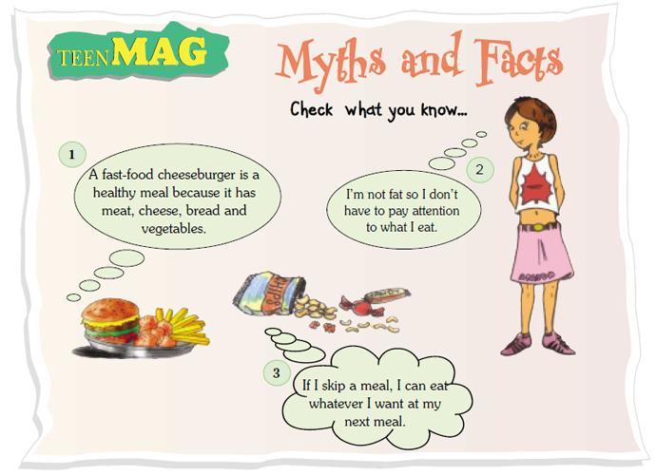

**Have a close look at the poster above;**

* **Which statement agrees with your food habits?**
* **Which one seems rather <<strange>> and why?**
* **Which idea do you disagree with? Why?**

………………………………………………………………………………………………………………………………………………………………………………………………………………………………………………………………………………………………………………………………………………………………………………………………………………………………………………………………………………………………………………………………………………………………………………………………………………………………………………………………………………………………………………………………………………………………………………………………………………………………………………………………………………………………………………………………………………………………………………………………………………………………………………………………………………………………………………………………………………….

*We all love chips and pizza but what are our favourite foods doing to our bodies?*

**Burger and chips or pizza**  
*What’s in ’em?*  
Huge amounts of fat, salt and additives!  
*What’s the damage?*  
All this fat and salt is really bad for your heart.  
*A good alternative:*  
Tofu burgers, roasted potatoes and homemade pizza!

**Fizzy drinks**  
What’s in ’em?  
Sugar, colouring, additives and carbonated water to give it the fizz!  
What’s the damage?  
It can damage your teeth - and that also means bad breath!.  
A good alternative:  
Plain water! Add a little fresh orange juice if you like.

**Chocolate cake**  
*What’s in it?*  
High amounts of sugar, fat and additives!  
*What’s the damage?*  
Like most fatty, sugary foods, cakes are very high in calories.  
*A good alternative:*  
Fresh fruit with yoghurt is a delicious dessert!

Eat More Healthily - Dr. Jackson says...

1. You must cut down on a lot of your fave foods. It may be difficult at the start, but soon you’ll have tons more energy.
2. Don’t skip meals. You must eat three healthy, normal-sized meals a day.
3. You have no problem with your weight? You’re lucky but it’s important to choose healthy food every day.
4. And remember, you don’t have to stop eating burgers and pizza completely. But you should make sure you eat more home cooked meals.

*Log on to www.teenagehealthfreak.org and*[*http://pbskids.org*](http://pbskids.org/)*for more info*

1. **Read the article about Healthy Eating Habits and complete the chart;**

|  |  |  |  |
| --- | --- | --- | --- |
|  | FIZZY DRINKS | BURGER/PIZZA | CHOCHOLATE CAKE |
| too fatty and salty |  |  |  |
| too fatty and sugary |  |  |  |
| Additives & colouring in it |  |  |  |
| Harms your teeth |  |  |  |
| Gives you smelly breath |  |  |  |
| Harms your heart |  |  |  |
| High in calories |  |  |  |

1. Read Dr Jacksons advice and mention **which piece of advice**;

* you follow.
* you have tried to follow but you failed and why.
* you completely disagree with and why.
* you feel all kids and teenagers should follow and why.

……………………………………………………………………………………………………………………………………………………………………………………………………………………………………………………………………………………………………………………………………………………………………………………………………………………………………………………………………………………………………………………………………………………………………………………………………………………………………………………………………………………………………………………………………………………………………………………………………………………………………………………………………………………………………………………………………………………………………………………………………………………………………………………………………………………………………………………………………………………………………………………………………………………………………………………………………………………………………………………………………………………………………………………………………………………………………………………………………………………………………………………………………………………………………………………………………………………………………………………………………………………………………………………………………………………………………………………………………………………………………………………………………………………………………………………………………………………………………………………………………………………………………………………………………………………………………………………………………………………………………………………………………………………………………………………………………………………………………………………………………………………………………………………………………………………………………………………………………………………………………………………………………………………………………………………………………………………………………………………………………………………………………………………

**Συμπληρώστε τις ασκήσεις, αποθηκεύστε το έγγραφο και ανεβάστε το στο χώρο των Μηνυμάτων**.

***Good luck!!***