Classic Scottish Shortbreadhttps://www.allrecipes.com/recipe/10059/scottish-shortbread-iii /

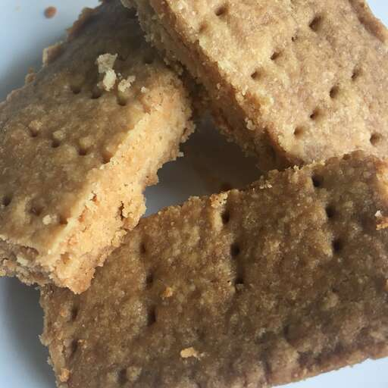

Prep Time:
20 mins
Cook Time:
50 mins
Additional Time:
5 mins
Total Time:
1 hr 15 mins
Servings:
36

Ingredients
- 1 pound unsalted butter
- 5 cups all-purpose flour
- 1 cup white sugar

Directions
- Preheat the oven to 350 degrees F (180 degrees C).
- Cream butter and sugar with mixer. Add flour and mix with a wooden spoon. Use hands to thoroughly mix.
- Press into a jelly roll pan. Prick to bottom all over with a fork being sure the fork hits the bottom and the pricks are close together.
- Bake for 10 minutes. Reduce the heat to 300 and continue to bake for 40 minutes more. Wait 2 minutes then cut into finger size bars. Cool thoroughly in pan.

