**Classic Scottish Shortbreadhttps://www.allrecipes.com/recipe/10059/scottish-shortbread-iii /**

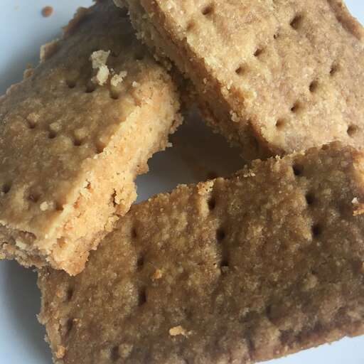

**Prep Time:**

20 mins

**Cook Time:**

50 mins

**Additional Time:**

5 mins

**Total Time:**

1 hr 15 mins

**Servings:**

36

**Ingredients**

* 1 pound unsalted butter
* 5 cups all-purpose flour
* 1 cup white sugar

**Directions**

1. Preheat the oven to 350 degrees F (180 degrees C).
2. Cream butter and sugar with mixer. Add flour and mix with a wooden spoon. Use hands to thoroughly mix.
3. Press into a jelly roll pan. Prick to bottom all over with a fork being sure the fork hits the bottom and the pricks are close together.
4. Bake for 10 minutes. Reduce the heat to 300 and continue to bake for 40 minutes more. Wait 2 minutes then cut into finger size bars. Cool thoroughly in pan.