**Κτίσματα του Ιουστινιανού – Αγία Σοφία**

**▶** Κατασκευάστηκαν έργα χρήσιμα στην άμυνα, τη θρησκεία, την υποδομή και την κοινή ωφέλεια

**▶ Η Αγία του Θεού Σοφία**

- Το λαμπρότερο κτίσμα της Βυζαντινής τέχνης

- Βασιλική μετά τρούλου (συνδυασμός βασιλικής και περίκεντρου κτιρίου

- Αρχιτέκτονες: ο Ανθέμιος (από Τράλλεις) και ο Ισίδωρος (από Μίλητο)

- Η κατασκευή διαρκεί πέντε χρόνια (532-537)

- Δίνεται έμφαση στον καθ’ ύψος άξονα.

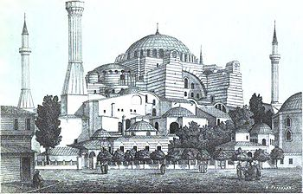

The "Church of Holy Wisdom", also called Agia Sophia, is in Constantinople – now Istanbul. It was built by the emperor Justinian after the riots of AD 532. Anthemios and Isidoros were two of the Greek architects who designed it. It took six years to build and about ten thousand men worked on it. The first stone of the foundations was laid by the emperor himself. The building had brick walls, marble linings inside, amazing mosaics made up of tiny cubes of coloured glass, marble or gold and massive marble pillars. Of all its fascinating features though, perhaps the most remarkable is its huge, shallow dome, supported on piers made of limestone. There are also smaller half-domes around the largest, supported by arches - a typical feature of Byzantine design for big buildings. Agia Sophia is well over 45m high and over 60m long and wide. Today we are accustomed to seeing buildings as large as this, sometimes even larger. But in Justinian’s time, Agia Sophia must have been truly awe-inspiring

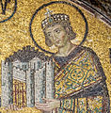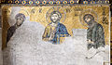

Κάτοψη της Αγια Σοφιάς. Από δεξιά προς αριστερά: το αίθριο, ο έξω και έσω [νάρθηκας](https://el.wikipedia.org/wiki/%CE%9D%CE%AC%CF%81%CE%B8%CE%B7%CE%BA%CE%B1%CF%82_(%CE%B1%CF%81%CF%87%CE%B9%CF%84%CE%B5%CE%BA%CF%84%CE%BF%CE%BD%CE%B9%CE%BA%CE%AE)), ως κάθετοι διάδρομοι, με την άνω ΝΔ. πύλη, όπου το Προπύλαιο του Νάρθηκα και δεξιά το αποδυτήριο και την κάτω ΒΑ. πύλη και

ο κυρίως Ναός