***Agia Sphia***

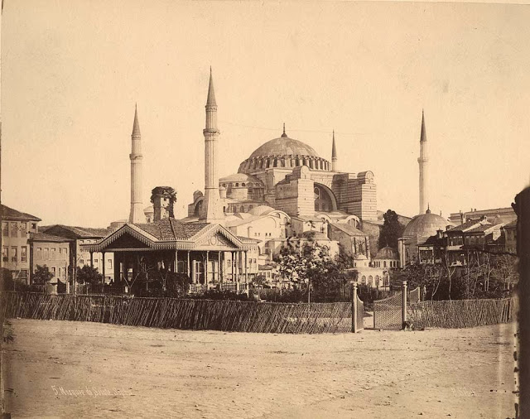

The "Church of Holy Wisdom", also called [Agia Sophia](http://www.youtube.com/watch?v=PPgCzoQb6E4), is in  
Constantinople – now Istanbul. It was built by the emperor Justinian after the riots of AD 532. Anthemios and Isidoros were two of the Greek architects who designed it. It took six years to build and about ten thousand men worked on it. The first stone of the foundations was laid by the emperor himself. The building had brick walls, marble linings inside, amazing mosaics made up of tiny cubes of coloured glass, marble or gold and massive marble pillars. Of all its fascinating features though, perhaps the most remarkable is its huge, shallow dome, supported on piers made of limestone. There are also smaller half-domes around the largest, supported by arches - a typical feature of Byzantine design for big buildings. Agia Sophia is well over 45m high and over 60m long and wide. Today we are accustomed to seeing buildings as large as this, sometimes even larger. But in Justinian’s time, Agia Sophia must have been truly awe-inspiring

|  |  |
| --- | --- |
| **Agia Sofia** |  |
| a) Where is it? |  |
| b) How old is it? |  |
| c) Who designed it? |  |
| d) What is its most  striking feature? |  |

You are a member of a committee preparing the questions for a quiz show about famous buildings.  
Read the answers and write the questions. Don’t forget to include the name of the building in each question.

1. *………………………………………………………………….?*

*It was built after the riots of AD 532.*

1. *……………………………………………………………………….?*

*It’s most striking feature is its huge, striking dome.*

1. *………………………………………………………………………………?*

*It’s over 45 m. tall.*

1. *……………………………………………………………………………..?*

*Anthemios and Isidoros.*

1. *…………………………………………………………………………….?*

*The first stone of the foundations was laid by Justinian.*