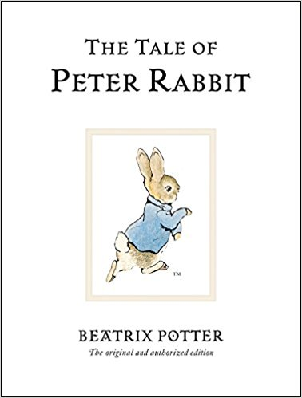
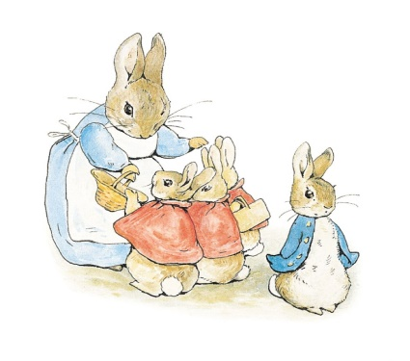

Read the story of Peter the Rabbit and answer the questions that follow.

- How many little rabbits are there in this story?

- Put the names of the rabbits in Alphabetical order (A-Z)

- What are two places that the rabbits are allowed to go?

- What happened to Mr. Rabbit?

- Where was Mrs. Rabbit going at the start of the story?

- Which items did she buy there?

- Describe Peter Rabbit’s jacket.

- Where did Peter lose his shoes?

- What was Peter doing in Mr. Mcgregor’s garden?

- What did Mr. Mcgregor shout at Peter?

- Which animal was sat by the pond?

- What did Peter’s mother give him to drink before bed?

- What did the other little rabbits eat in the evening that day?

