*Read the text about Edinburgh and decide if the sentences below are True or False.*

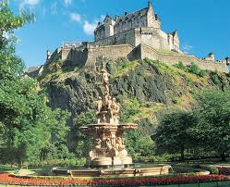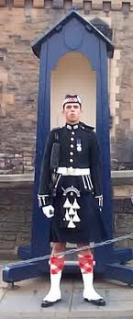 **Edinburgh**

A visit to Scotland often begins in Edinburgh, the capital city of Scotland. Edinburgh is an old city with many important and interesting buildings. After London, Edinburgh is the second city for visitors in Britain.

If you come to Edinburgh by train from the south, the first thing you see when you leave Waverley Station is Edinburgh Castle. It stands high over the city. Soldiers in kilts take visitors around and tell them the castle’s story.

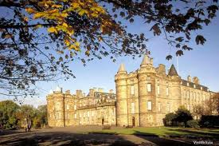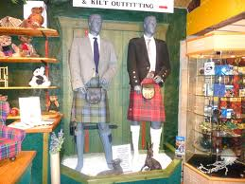Edinburgh is a hilly city but it is a good city to visit on foot. After the castle, you can visit more of the Old Town. Go down the Royal Mile to Holyroodhouse - the Queen’s home when she comes to Edinburgh. It is three hundred years old.

You can look at the shops on the Royal Mile or on Princes Street in the New Town. Some shops sell the famous Scottish tartans and you can see the name of the family which goes with each tartan. Near Princes Street is Charlotte Square, which is very beautiful. There is also the National Gallery of Scotland, with pictures from Scotland and from many other countries too.

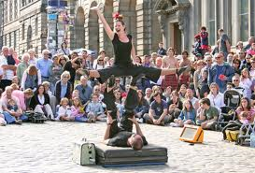In August, you can visit the Edinburgh Festival, the biggest arts festival in the world with hundreds of different things to do and see.

adapted from: *Oxford Bookworms*, 2002

|  |  |  |  |
| --- | --- | --- | --- |
|  |  | TRUE | FALSE |
| 1 | More people visit London than Edinburgh every year. |  |  |
| 2 | Edinburgh Castle is situated on a hill. |  |  |
| 3 | The Queen lives in Edinburgh Castle when she comes to Edinburgh. |  |  |
| 4 | In the national Gallery of Scotland you can see only Scottish paintings. |  |  |
| 5 | The Edinburgh Festival takes place in summer. |  |  |
| 6 | The text is taken from a Scottish novel. |  |  |