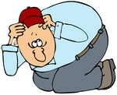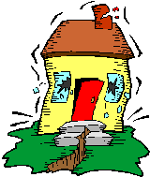

Earthquakes are natural disasters that humans cannot control. Sometimes earthquakes can be very dangerous and people need to know more about where earthquakes come from, and how to ***protec****t* themselves from them and any other natural disasters.

Earthquakes are the shaking, rolling or suddenshock of the earth’s surface. They are the Earth’s natural means of releasing pressure. More than a million ***occur*** in the world each year. Earthquakes can be felt over large areas although they usually last less than a minute. However, earthquakes cannot be predicted although scientists are still working on the problem.

There are about 20 plates along the surface of the earth that move***continuously***and slowly past each other. When the plates squeeze orstretch, huge rocks form at their edges and the rocks shift with great force, causing an earthquake. As the plates move ,they put forces on themselves and each other. When the force is large enough, the ***crust*** is forced to break..

Shaking and ground breaking are the main effects created by earthquakes, principally resulting in more or less severe damage to buildings and other structures. The severity of the effect ***depends on*** the complex combination of the earthquake magnitude. Ground break is a major risk for large engineering structures such as dams, bridges and nuclear power stations and requires careful mapping of existing faults to identify any likely to break the ground surface within the life of the structure.

**1- The above reading is mainly about**

a. the destruction caused by earthquakes b. protecting people from earthquakes

c. describing a violent earthquake d. why and where earthquakes occur

**2- Earthquake are considered natural disaster because**

a. they are man-made b. man has no control over them

c. man can control them d. they are always expected

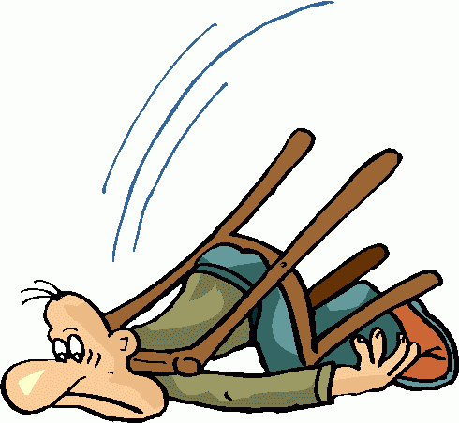

3. **The word " *protect* ", line(2) is a/an**

a. adjective b. verb

c. adverb d. noun

**4- What does the shaking of the ground result in?**

a- damage to buildings and structures b- releasing energy into air

c- breaking and shifting of rocks d- all of the above

**5. Earthquakes are considered disastrous for people and properties because:**

a- earthquakes happen in cities b- man can control them

c- they are unpredictable d- they result in little destruction

**6. According to the text, how long does an earthquake usually last?**

a. few minutes b. less than a minute

c. more than a minute d. exactly a minute

**7.** **The word *"occur*" line (5) means:**

a. happen b. injure

c. insure d. inform

**8. To which paragraph does the following sentence BEST belong?**

**‘*When the break occurs, much energy is released and moves through the earth in the form of waves causing an earthquake’***

**a**. [ 1 ] **b**. [ 2 ]

**c**. [ 3 ] **d**. [ 4 ]



**9. The word "*crust"* line (11) means:**

a. bottom layer of the earth b. huge plates of the earth

b. upper layer of the earth d. huge rocks in the earth

**10.The word " *continuously*" line( 8 ) is a/an**

a. noun b. adjective

c. verb d. adverb

**11. The word "*depends on* " line( 13 ) means:**

a. fights against b. relies on

c. protects from c. gets on

**12.** **Which of the following is NOT TRUE about an earthquake?**

a. an earthquake is a controllable disaster

b. an earthquake is always unpredictable

c. an earthquake causes severe damage

d. the earth is cracked when an earthquake occurs

**Complete the following table**

|  |  |  |
| --- | --- | --- |
| **Dangerous Results of Earthquakes** | | |
| **13………………….** | **14………………………** | **15………………….** |