# READING COMPREHENSION

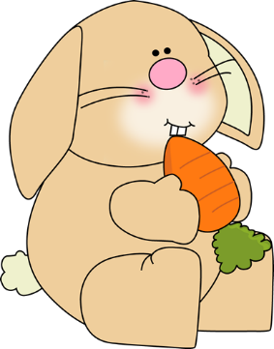Rabbit loved to go to Mrs. Holly’s garden. Each morning when the sun came up, Rabbit would creep under the fence. He would chew on the green carrot tops. This made Mrs. Holly sad. When the green carrot tops were gone, she could not find her carrots! Mrs. Holly knew that she had many carrots. They were growing under the ground. But the green tops were gone. She could not find the carrots. Every time Mrs. Holly saw Rabbit in the garden, she would run after him. He would run to his home under the tree. One day, Mrs. Holly came to the place where Rabbit lived. She knocked on the tree. “Rabbit,” she called, “you are making me sad. You eat the tops off my carrots. Now I cannot find carrots to eat.” Rabbit looked out from under the tree. “You make me sad, too. I do not like you to run after me.” Then Mrs. Holly told Rabbit her idea. “When the sun comes up each morning, I will pick some carrots. I will leave the tops for you.” Rabbit liked that idea. Now he and Mrs. Holly share the good things from the garden.

**1. Rabbit went to Mrs. Holly’s ___________.**

a. morning

b. garden

c. green

**2. Rabbit liked to ______the green carrot tops.**

a. make

b. creep

c. eat

**3. This made Mrs. Holly feel ___________.**

a. sad

b. lost

c. hungry

**4. What is another good title for the story?**

a. Mrs. Holly’s Garden

b. Carrots for Lunch

c. Planting a Garden

**5. What did Rabbit like to eat from the garden?**

a. orange carrots

b. green carrot tops

c. green lettuce

**6. Why couldn’t Mrs. Holly find her carrots?**

a. Rabbit took all the carrots.

b. She forgot to plant the carrots.

c. The carrots were under the ground.

**7. Why did Mrs. Holly go to visit Rabbit?**

a. to yell at him

b. to work out a plan for the garden

c. to bring him some carrots

**8. What lesson did Mrs. Holly and Rabbit learn?**

a. Gardens are hard work.

b. Carrots are good for you.

c. It is better to share.

**Answer the questions with a complete sentence.**

1. Where did Rabbit live?

___________________________________________________________________________________________

2. What did Rabbit tell Mrs. Holly?

___________________________________________________________________________________________

3. Where did the story take place?