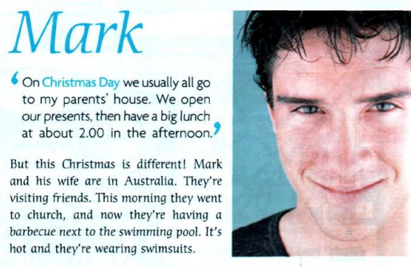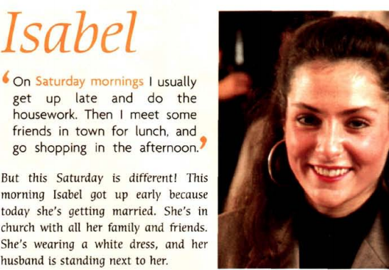**Read the two texts carefully. Then answer the questions.**

Write a short paragraph talking about what you usually do, and what you are doing right now.

**Complete the text about Leo by putting the verbs in the correct tense.**

‘On my birthday I (go/ sometimes)……………………… out with friends, or I (go) ………… out to a restaurant with my family. My Mum (make/ usually) ………………………me a birthday cake. My Dad and sisters (get/ usually) ………………………… me birthday presents.’

But this birthday is different! It’s Leo’s eighteenth birthday, so now he’s an adult. This morning he got a lot of presents. Now he (have) ……………………………a big party with all his friends. They (dance)……………….. and (sing) ……………………………….. They (eat) ……………………………. delicious food and cakes, and (drink)……………………………. different sweet drinks. Leo (wear) ……………………………….. a blue jumber.

1. What does Isabel usually do on Saturday mornings?
2. What is she doing this Saturday?
3. What does Mark usually do on Christmas day?
4. What is he doing this Christmas?
5. Underline the verbs in the two text, compare between the verbs that describe habits (usually) and the verbs that describe actions at the time of speaking (this Saturday/ Christmas…/ Now …) . Then complete the rules:
6. When we **describe habits**, we put the verb in the ……………………………………. tense.
7. When we **describe actions at the time of speaking**, we put the verb in the ……………………….………….. tense.