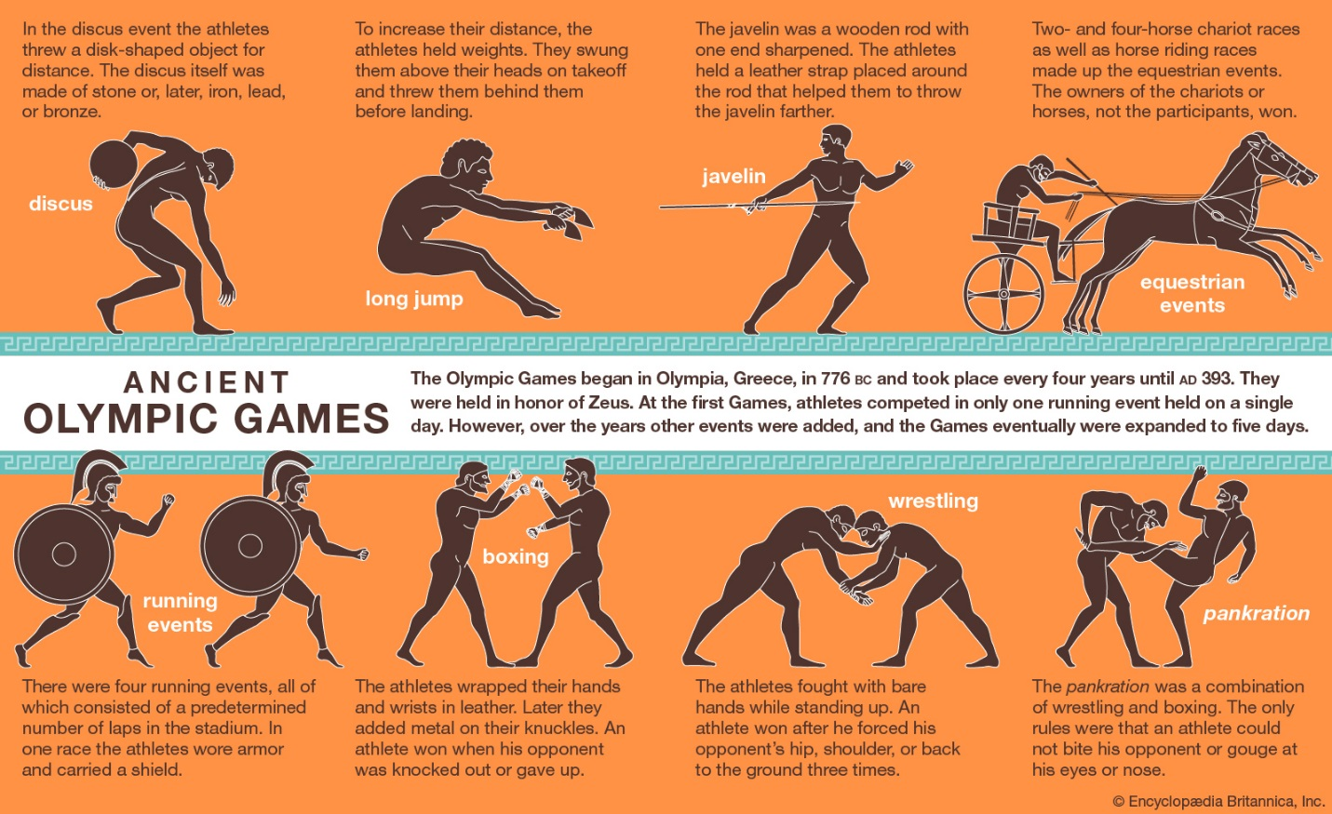

Check out these videos! https://www.youtube.com/watch?v=pp4Sytm9fe0
https://www.youtube.com/watch?v=KTrWQOztqoo

