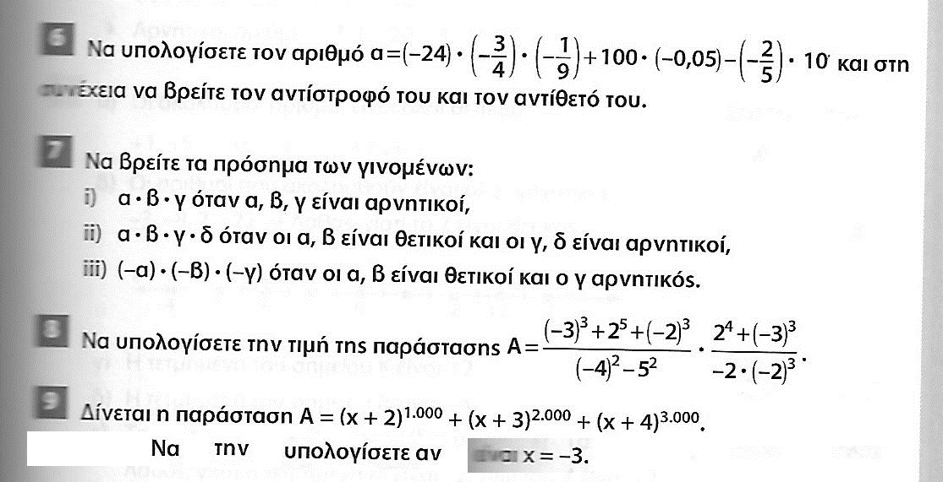

$−3$

$\frac{−\text{11}}{\text{18}}$
2

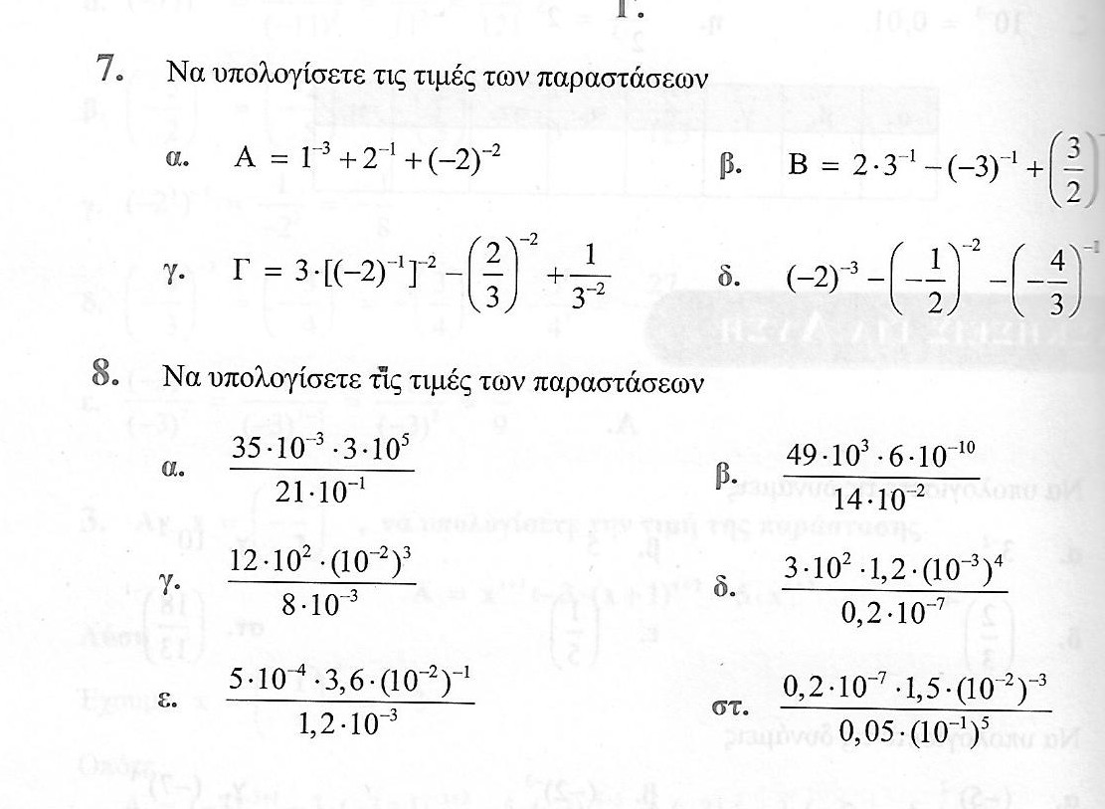

$\frac{7}{4}$ $\frac{5}{3}$
$\frac{\text{75}}{4}$ $\frac{−\text{27}}{8}$

5000 $\frac{\text{21}}{\text{100000}}$
$\frac{3}{\text{20}}$ $\frac{9}{\text{50}}$

150 60000

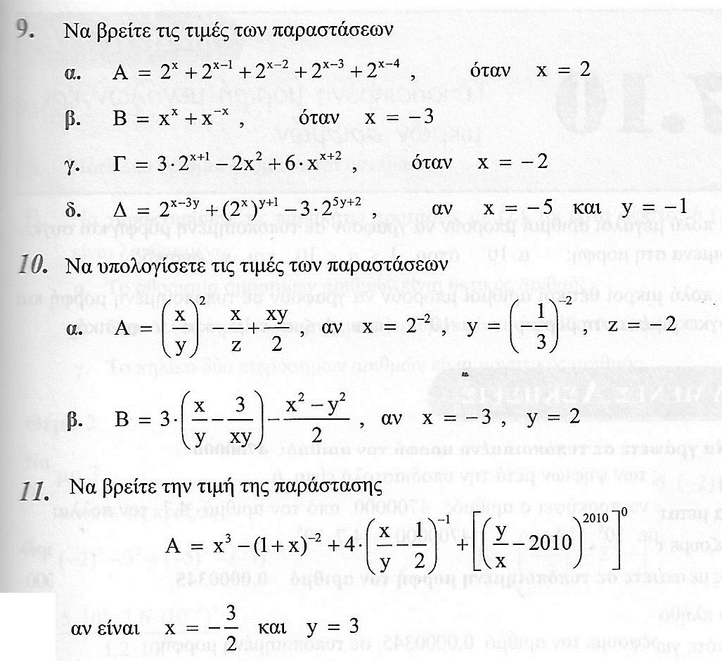
$\frac{\text{31}}{4}$
$\frac{−\text{730}}{\text{27}}$
$\frac{−1}{2}$
$\frac{7}{8}$
$\frac{\text{1621}}{\text{1296}}$
$\frac{−\text{11}}{2}$

$\frac{−\text{83}}{8}$

