[**P. Andreas Konanos**](https://www.facebook.com/AndreasKonanosPage/?hc_ref=ARTiox3rSiL8AJfgPGZcJTZfCD-fYPoGv9TeNyVZZdfGpHmPuSbIMo5F0AdRoqrxxcY&fref=nf&__xts__%5B0%5D=68.ARB552O1PI7jb6soBFAniz7Gz39zFDvddpL5RuKHBM8Cm8GJqK2fVa5_upGXwn2hnun5lmU2_t82MHDTmXHGv4vM-c9FlOuhEAcXCVCTgjoReHeqS5PHmW5QWkyOWte3-SuWaTdzgEKKWRFYvy3GAo13xSbM8gA2CIvtWY_qlIsRcQ_mdnwOJVmA6RnXR0g4GFeNA3_1oKPoTMHE7yKs6KZIFwG6hoS2mGoIzA01Q-fOnEE3ZUpny3frOJopz6L9MGOxg2jDOLpBrkRenApJ3XZiGfVObJtg0AqtmgykV9DmJJxVdwoM59gxCJa7xIqb45eb9KBKo1hZ6WLmCNEQy_TxYg&__tn__=kC-R)

Αυτή η κάθαρση.  
Προηγούνται αστραπές,  
βροντές, άνεμοι  
και υδάτινοι καταρράκτες  
που μοιάζουν να απειλούν  
τα πάντα.

Η υπομονή νικά.

[[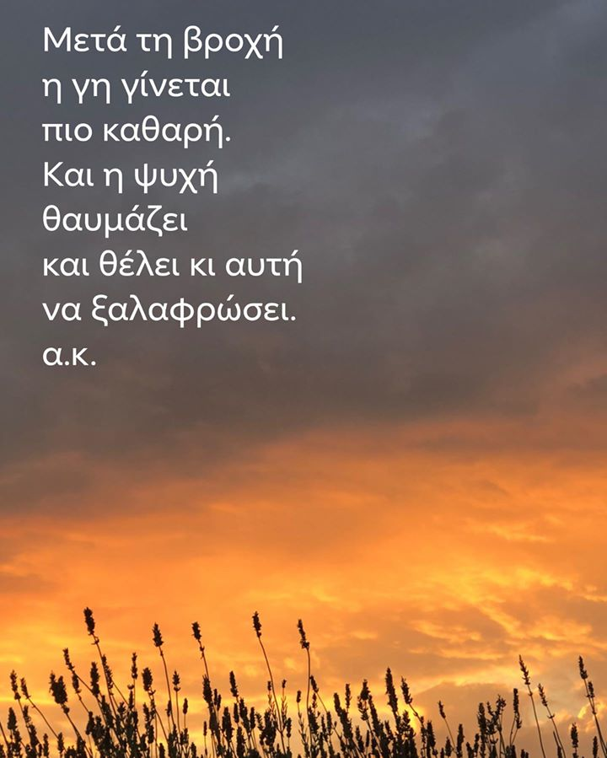](https://www.facebook.com/AndreasKonanosPage/photos/a.764448240255651/3523308207702960/?type=3&eid=ARDCzqNvjoh205guaoRb_gvE_byVkY7Myq3jFMPhBihoZ3IgYN8ChLHg_zpDVzbtQ8Jm73xV14TXttKn&__xts__%5B0%5D=68.ARB552O1PI7jb6soBFAniz7Gz39zFDvddpL5RuKHBM8Cm8GJqK2fVa5_upGXwn2hnun5lmU2_t82MHDTmXHGv4vM-c9FlOuhEAcXCVCTgjoReHeqS5PHmW5QWkyOWte3-SuWaTdzgEKKWRFYvy3GAo13xSbM8gA2CIvtWY_qlIsRcQ_mdnwOJVmA6RnXR0g4GFeNA3_1oKPoTMHE7yKs6KZIFwG6hoS2mGoIzA01Q-fOnEE3ZUpny3frOJopz6L9MGOxg2jDOLpBrkRenApJ3XZiGfVObJtg0AqtmgykV9DmJJxVdwoM59gxCJa7xIqb45eb9KBKo1hZ6WLmCNEQy_TxYg&__tn__=EEHH-R)](https://www.facebook.com/AndreasKonanosPage/photos/a.764448240255651/3523308207702960/?type=3&eid=ARDCzqNvjoh205guaoRb_gvE_byVkY7Myq3jFMPhBihoZ3IgYN8ChLHg_zpDVzbtQ8Jm73xV14TXttKn&__xts__%5B0%5D=68.ARB552O1PI7jb6soBFAniz7Gz39zFDvddpL5RuKHBM8Cm8GJqK2fVa5_upGXwn2hnun5lmU2_t82MHDTmXHGv4vM-c9FlOuhEAcXCVCTgjoReHeqS5PHmW5QWkyOWte3-SuWaTdzgEKKWRFYvy3GAo13xSbM8gA2CIvtWY_qlIsRcQ_mdnwOJVmA6RnXR0g4GFeNA3_1oKPoTMHE7yKs6KZIFwG6hoS2mGoIzA01Q-fOnEE3ZUpny3frOJopz6L9MGOxg2jDOLpBrkRenApJ3XZiGfVObJtg0AqtmgykV9DmJJxVdwoM59gxCJa7xIqb45eb9KBKo1hZ6WLmCNEQy_TxYg&__tn__=EEHH-R)