**ΚΑΤΙ ΓΙΑ ΝΑ ΓΕΛΑΣΟΥΜΕ ΛΙΓΟ**

[](https://1.bp.blogspot.com/-cHgicXiv3BI/XodKAHZxpcI/AAAAAAAAGDs/P5r79PCi6z0Eta9auXDFOv5qeR7ASoGywCNcBGAsYHQ/s1600/0%2B%25CF%2580%25CE%25B9%25CE%25BB%25CF%258C%25CF%2584%25CE%25BF%25CF%2582.jpg)

***

Όταν έχεις ήπια συμπτώματα  
και ο οικογενειακός γιατρός δεν απαντά στο τηλέφωνο ...

[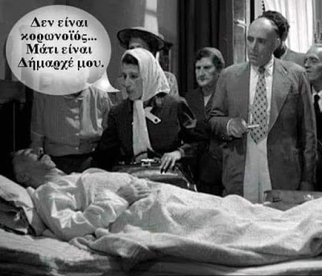](https://1.bp.blogspot.com/-RVyaGDs2oU8/XodJ8wJFxlI/AAAAAAAAGC4/NjVUKn3xBDcPqbRG0oKG1g6N0Z4lAZvngCNcBGAsYHQ/s1600/0%2B%25CE%2592%25CE%25B1%25CF%2583%25CE%25B9%25CE%25BB%25CE%25B5%25CE%25B9%25CE%25AC%25CE%25B4%25CE%25BF%25CF%2585.jpg)

***

Είπαμε!

Social distancing

[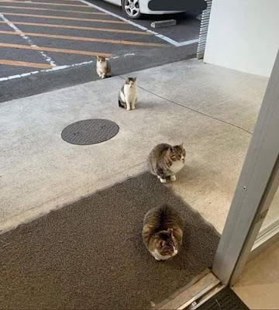](https://1.bp.blogspot.com/-PeYyaZQI_fU/XodJ-JhsJfI/AAAAAAAAGDM/dP-wqC-QdeMZa5cQz4euwpJ4HpS3IexqACNcBGAsYHQ/s1600/0%2B%25CE%25B3%25CE%25AC%25CF%2584%25CE%25B5%25CF%2582%2B%25282%2529.jpg)

[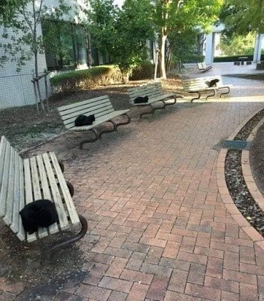](https://1.bp.blogspot.com/-BMy1Y2_-OQA/XodJ-UcnUFI/AAAAAAAAGDQ/xY3AsnZIvs8BSctskzeKu3zTSeLrZi5vACNcBGAsYHQ/s1600/0%2B%25CE%25B3%25CE%25AC%25CF%2584%25CE%25B5%25CF%2582.jpg)

***

Μένουμε σπίτι !

Και γυμναζόμαστε εκεί.

***

Μένουμε σπίτι!

Και εργαζόμαστε από το σπίτι!

[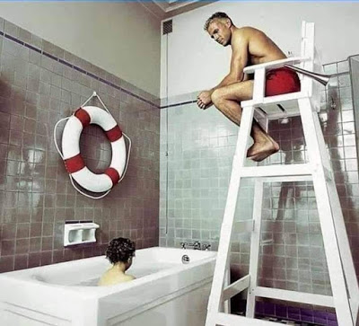](https://1.bp.blogspot.com/-A9OP9ZQU2rE/XodJ_oVva_I/AAAAAAAAGDk/PQ97Jw1QSMoUIyCxl9QCcLxS0ntam7veQCNcBGAsYHQ/s1600/0%2B%25CE%25BD%25CE%25B1%25CF%2585%25CE%25B1%25CE%25B3%25CE%25BF%25CF%2583%25CF%258E%25CF%2583%25CF%2584%25CE%25B7%25CF%2582.jpg)

***

Γυρνώντας από το Super Market

***

Περιμένοντας το Πάσχα

[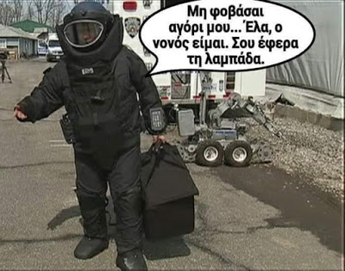](https://1.bp.blogspot.com/-xFJkcTJkhTg/XodJ__y4SUI/AAAAAAAAGDo/Jjt7XAf_5DMPkX0DMVpRBdUhsdA3GfG9QCNcBGAsYHQ/s1600/0%2B%25CE%25BD%25CE%25BF%25CE%25BD%25CF%258C%25CF%2582%2B.jpg)

***

Διάσκεψη στο χωριό  
εν όψει πιθανής επιδρομής εκδρομέων

***

Τηλεκπαίδευση

[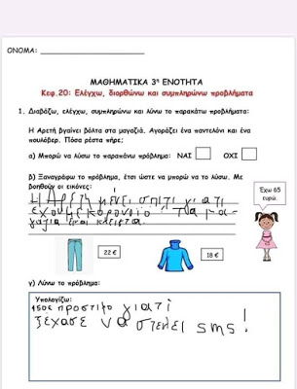](https://1.bp.blogspot.com/-wfE8t_AcgZ4/XodJ9pbAPeI/AAAAAAAAGDE/_e6Jda3-_2IoKVD1unNpO0XaO-hRpV1IwCNcBGAsYHQ/s1600/0%2B%25CE%25A4%25CE%25B7%25CE%25BB%25CE%25B5%25CE%25BA%25CF%2580%25CE%25B1%25CE%25AF%25CE%25B4%25CE%25B5%25CF%2585%25CF%2583%25CE%25B7.jpg)

***

Όταν η κουτσομπόλα της γειτονιάς  
μένει στο διπλανό διαμέρισμα

***

[](https://1.bp.blogspot.com/-FCXeAaCiDE4/XodW45znkhI/AAAAAAAAGE8/9sXOPh4r8kwlwlW3v35JJBNz5oRPI7NkQCNcBGAsYHQ/s1600/%25CE%2591%25CF%2583%25CF%2584%25CE%25B5%25CE%25AF%25CE%25B1%2B%25281%2529.jpg)

[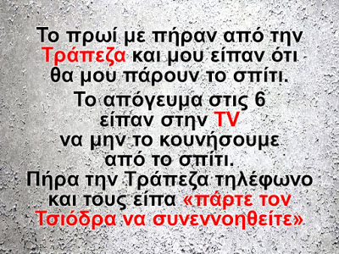](https://1.bp.blogspot.com/-nQILz5llDYU/XodW7wcfEoI/AAAAAAAAGFg/wyUwNM-qibkqO7lC92JXW_htn6xol995ACNcBGAsYHQ/s1600/%25CE%2591%25CF%2583%25CF%2584%25CE%25B5%25CE%25AF%25CE%25B1%2B%25282%2529.JPG)

[](https://1.bp.blogspot.com/-JFa4ycBD98Y/XodW-MflItI/AAAAAAAAGGE/mNCLYTpwbeglxTNWWBJoe9gHOTnYXubDwCNcBGAsYHQ/s1600/%25CE%2591%25CF%2583%25CF%2584%25CE%25B5%25CE%25AF%25CE%25B1%2B%25283%2529.JPG)

[](https://1.bp.blogspot.com/-QvN9O8xcaN4/XodW-Qo834I/AAAAAAAAGGI/QGZodgLxt2kc2xOJYsI5a5KzEol-H_bOgCNcBGAsYHQ/s1600/%25CE%2591%25CF%2583%25CF%2584%25CE%25B5%25CE%25AF%25CE%25B1%2B%25284%2529.JPG)

[](https://1.bp.blogspot.com/-K3g2Y8ruMHk/XodW-l4djjI/AAAAAAAAGGM/8FjP4B4LykM3tUFsrMDVYKycnOdVUV6RQCNcBGAsYHQ/s1600/%25CE%2591%25CF%2583%25CF%2584%25CE%25B5%25CE%25AF%25CE%25B1%2B%25285%2529.JPG)

[](https://1.bp.blogspot.com/-uQATYtjrGsg/XodW--cngcI/AAAAAAAAGGQ/jXuCSfe9EWQkNtsY7g9lhyYmO7fe4PSSgCNcBGAsYHQ/s1600/%25CE%2591%25CF%2583%25CF%2584%25CE%25B5%25CE%25AF%25CE%25B1%2B%25286%2529.JPG)

[](https://1.bp.blogspot.com/-BQ-yj_8ouCA/XodW_ENrhWI/AAAAAAAAGGU/zFO8iAgI30kxhUcf4UpQuNp5R88dfeOugCNcBGAsYHQ/s1600/%25CE%2591%25CF%2583%25CF%2584%25CE%25B5%25CE%25AF%25CE%25B1%2B%25287%2529.JPG)

[](https://1.bp.blogspot.com/-c2VNTCzB68M/XodW_ap7D1I/AAAAAAAAGGY/5gUeWicT7Wwmx8hvcuPKBmb-bTvEPcBrQCNcBGAsYHQ/s1600/%25CE%2591%25CF%2583%25CF%2584%25CE%25B5%25CE%25AF%25CE%25B1%2B%25288%2529.JPG)

[](https://1.bp.blogspot.com/-PRgIZRrGuFo/XodW_ojX3FI/AAAAAAAAGGc/L1Fg7i03w-QE9GKO7juPsazyKC_TogIhwCNcBGAsYHQ/s1600/%25CE%2591%25CF%2583%25CF%2584%25CE%25B5%25CE%25AF%25CE%25B1%2B%25289%2529.JPG)

[](https://1.bp.blogspot.com/-MiFycmWbaRM/XodW41YEJkI/AAAAAAAAGE0/l7XyBwiGWuw2htjDGGjopJ9rBcj0fYZQACNcBGAsYHQ/s1600/%25CE%2591%25CF%2583%25CF%2584%25CE%25B5%25CE%25AF%25CE%25B1%2B%252810%2529.JPG)

[](https://1.bp.blogspot.com/-naVvCukAtHE/XodW4_zU8bI/AAAAAAAAGE4/VXn0V8kIRB0zmhH64TCGIG9T9a3jZ9BxQCNcBGAsYHQ/s1600/%25CE%2591%25CF%2583%25CF%2584%25CE%25B5%25CE%25AF%25CE%25B1%2B%252811%2529.JPG)

[](https://1.bp.blogspot.com/-htLezCNll-A/XodW5XKWsjI/AAAAAAAAGFA/lWn_utfax2wTOOyVtWv-9kjWLnuFWR0oQCNcBGAsYHQ/s1600/%25CE%2591%25CF%2583%25CF%2584%25CE%25B5%25CE%25AF%25CE%25B1%2B%252812%2529.JPG)

[](https://1.bp.blogspot.com/-C8_zKk_EKpc/XodW5-nQ4UI/AAAAAAAAGFE/jNpjdRqCSMs2WWXqAtV4FL-xhMdw8CBUQCNcBGAsYHQ/s1600/%25CE%2591%25CF%2583%25CF%2584%25CE%25B5%25CE%25AF%25CE%25B1%2B%252813%2529.JPG)

[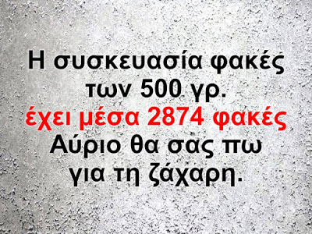](https://1.bp.blogspot.com/-tJk2RYI3USc/XodW6K9ojEI/AAAAAAAAGFM/0Tsvkyq1Ookt4X1f2fVpQLeJw5eeHvddACNcBGAsYHQ/s1600/%25CE%2591%25CF%2583%25CF%2584%25CE%25B5%25CE%25AF%25CE%25B1%2B%252814%2529.JPG)

[](https://1.bp.blogspot.com/-Nz9givwDIRg/XodW6ECHBpI/AAAAAAAAGFI/VL0bUVa-OuMvZlvAg0XoOU8Qrr7AmZVOQCNcBGAsYHQ/s1600/%25CE%2591%25CF%2583%25CF%2584%25CE%25B5%25CE%25AF%25CE%25B1%2B%252815%2529.JPG)

[](https://1.bp.blogspot.com/-h13AUA0BqEQ/XonVm18CzbI/AAAAAAAAGJE/jenogBrh_XYE50yi71q4_ckL9meXzhFywCNcBGAsYHQ/s1600/3.jpg)

[](https://1.bp.blogspot.com/--vefgoidGCs/XomshuYB5lI/AAAAAAAAGHw/k6iX3tPlr-Q-J2lhSaKABuu6bMHbFUZBQCNcBGAsYHQ/s1600/2.jpg)

[](https://1.bp.blogspot.com/-Gte2jPOHqlQ/XodW6__x5OI/AAAAAAAAGFU/qZOVXltz_tAvCpkFdW8JGZp1fxXiWDeZQCNcBGAsYHQ/s1600/%25CE%2591%25CF%2583%25CF%2584%25CE%25B5%25CE%25AF%25CE%25B1%2B%252817%2529.JPG)

[](https://1.bp.blogspot.com/-p2DzBsfUMIE/XodW7Pl0b0I/AAAAAAAAGFY/_wIycPBT2OYtAo_aLrYAnSOi9LwwlM05gCNcBGAsYHQ/s1600/%25CE%2591%25CF%2583%25CF%2584%25CE%25B5%25CE%25AF%25CE%25B1%2B%252818%2529.JPG)

[](https://1.bp.blogspot.com/-LmVKYPQ06qU/XodW7s18T4I/AAAAAAAAGFc/V98IYHgXKJsRnW3AvmPa9ZW8VrOaYZugACNcBGAsYHQ/s1600/%25CE%2591%25CF%2583%25CF%2584%25CE%25B5%25CE%25AF%25CE%25B1%2B%252819%2529.JPG)

[](https://1.bp.blogspot.com/-CVtiMrTEfDI/XodW71WIDZI/AAAAAAAAGFk/ub6Uj39abnURgh0DB4VFEB0ZuHJpt_rCgCNcBGAsYHQ/s1600/%25CE%2591%25CF%2583%25CF%2584%25CE%25B5%25CE%25AF%25CE%25B1%2B%252820%2529.JPG)

[](https://1.bp.blogspot.com/-p6ZhaaDote0/XodW8elD2AI/AAAAAAAAGFo/wbCjN9MkHAwuimP_GLdpx_X6ahQxi4KJACNcBGAsYHQ/s1600/%25CE%2591%25CF%2583%25CF%2584%25CE%25B5%25CE%25AF%25CE%25B1%2B%252821%2529.JPG)

[](https://1.bp.blogspot.com/-Ch-GlwkpALE/XodW8uulZgI/AAAAAAAAGFs/XIYhVdDsMxU7z-2sqzkdbGGB2oSQI8P8QCNcBGAsYHQ/s1600/%25CE%2591%25CF%2583%25CF%2584%25CE%25B5%25CE%25AF%25CE%25B1%2B%252822%2529.JPG)

[](https://1.bp.blogspot.com/-8pfekKnibZM/XodW8tfEEfI/AAAAAAAAGFw/Ahnl3-O9y0MYdoVb4nVb8_IxlKauZbwUwCNcBGAsYHQ/s1600/%25CE%2591%25CF%2583%25CF%2584%25CE%25B5%25CE%25AF%25CE%25B1%2B%252823%2529.JPG)

[](https://1.bp.blogspot.com/-m2CECFmf82M/XodW9HjBweI/AAAAAAAAGF0/CY0OJRpeKksUIVx07UMBQGO5xEGlvYQ3QCNcBGAsYHQ/s1600/%25CE%2591%25CF%2583%25CF%2584%25CE%25B5%25CE%25AF%25CE%25B1%2B%252824%2529.JPG)

[](https://1.bp.blogspot.com/-rSqLoW7TIvo/XodW9hIJ8qI/AAAAAAAAGF4/iP2lal7WIxwc5NgtqD1nOt-93nD4BC3CQCNcBGAsYHQ/s1600/%25CE%2591%25CF%2583%25CF%2584%25CE%25B5%25CE%25AF%25CE%25B1%2B%252825%2529.JPG)

[](https://1.bp.blogspot.com/-gkK6ct1wxYc/XodW9-IVGgI/AAAAAAAAGF8/h2L3QMn4IkAAGCN2upAMZrhw1lWgMuV7QCNcBGAsYHQ/s1600/%25CE%2591%25CF%2583%25CF%2584%25CE%25B5%25CE%25AF%25CE%25B1%2B%252826%2529.JPG)

[](https://1.bp.blogspot.com/-5Pv5D_zXRI0/XodW9_2y4VI/AAAAAAAAGGA/y7-0mwQGSIcDWdnR-hv1GqcTqOJV41vKQCNcBGAsYHQ/s1600/%25CE%2591%25CF%2583%25CF%2584%25CE%25B5%25CE%25AF%25CE%25B1%2B%252827%2529.jpg)

***

Μην το μάθει η γιαγιά !

Σημείωση (αμφ.)  
Η φωτογραφία είναι αυθεντική  
και πέρα από το αστείο της τελευταίας γραμμής  
μας θυμίζει την, ενίοτε χωρίς όρια,  
αγάπη των ηλικιωμένων.

Ας τους έχουμε στην έγνοια μας,  
τώρα που αισθάνονται  
πιο μόνοι  
και πιο ευάλωτοι.

[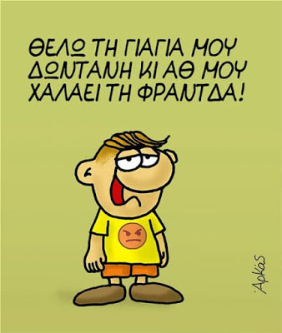](https://1.bp.blogspot.com/-O-cLEhCa46A/XodMyLwst8I/AAAAAAAAGEU/L65z9jH4ZrgGlgFsecsGET1SHJ_sFf8dACNcBGAsYHQ/s1600/0%2B%25CE%2591%25CF%2581%25CE%25BA%25CE%25AC%25CF%2582.jpg)