**SCIENCE THROUGH EXPERIMENT IN EUROPE**

Project of Erasmus+ started on the 1st of September 2016 and will finish in August 2018. It includes 6 European countries – Romania, Poland, Turkey, Spain, Greece and Slovenia.

**Erasmus+ KA2 project from 1st of September 2016 to August 2018.**

**(Romania, Poland, Turkey, Spain, Greece and Slovenia)**

Schools during the project want to trigger a greater interest in science, they will try to make experiments a tool for motivation, as the pupils can realize making experiments can be extremely entertaining, and another reason for which the partners are so eager to pursue this project is breaking stereotypes (making experiments serve mankind in a good way, our health depends on them). Pupils also tend to store scientific knowledge out of way from interfering with their real life experience, so the goal is to reduce this gap (also teaching chemistry can provide much intellectual pleasure in understanding how things work).

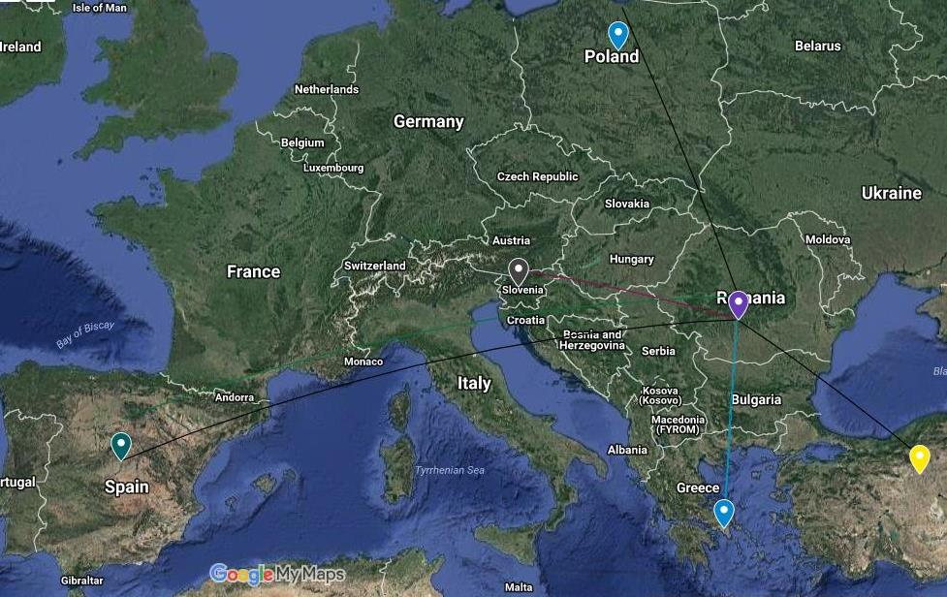

Throughout the project, the partners will focus on areas which are chosen as follows:  
* Air, colour and light - Turkey  
* Water - Romania  
 Space and Astronomy - Slovenia  
* The human body - Spain  
* Other creatures (animals, plants, etc.) - Greece  
* Electricity and magnetism - Poland

Through the project both students and teachers will meet at international exchanges, where they want the pupils to learn to ask questions and discuss science, to develop skills of cooperation, teamwork, to acquire and exchange new knowledge, experience and to improve their knowledge in the field of ICT and language skills.

Over the course of the project will be created 6 different e-books with experiments, towards the end of the project schools will organize a festival of experiments, where 6 different festival magazines will be created and final Project DVD. It will be possible to monitor the actual process of the project (all the work, activities etc.) on a public website which hopefully will reach wider community.

At the end of the project participants wishes to make students understand how scientific ideas contribute to technological change, to recognize the cultural significance of experiments and trace its world-wide development.

Author: Tatjana Gulič

**Schools in project:**

* SCOALA GIMNAZIALA NR.10, RM.VALCEA, Romania http://www.scoalagimnazialanr10vl.ro/
* Szkola Podstawowa w Ciechocinie, Ciechocin, Poland http://spciechocin.szkolnastrona.pl/
* CEIP BLAS DE OTERO, Madrid, SpainWeb link http://centros2.pntic.mec.es/cp.blas.de.otero1/
* OŠ Preska, Medvode, Poland http://www.os-preska.si/
* PEIRAMATIKO GYMNASIO AGION ANARGYRON, AGIOI ANARGYRO, Athenn-Greece http://gym-peir-ag-anarg.att.sch.gr/new/
* ERZURUMLU IBRAHIM HAKKI ORTAOKULU, ANKARA, Turkey http://www.erzurumluibrahimo.meb.k12.t

Project Information Leaflet

brochures, leaflets and presentations on our :

school

cities

country

1. SCOALA GIMNAZIALA NR.10, RM.VALCEA, Romania
2. Szkola Podstawowa w Ciechocinie, Ciechocin, Poland
3. CEIP BLAS DE OTERO, Madrid, Spain
4. OŠ Preska, Medvode, Slovenia
5. PEIRAMATIKO GYMNASIO AGION ANARGYRON, AGIOI ANARGYROI , Greece
6. ERZURUMLU IBRAHIM HAKKI ORTAOKULU, ANKARA , Turkey