**ΑΣΚΗΣΗ: Κατάλογοι ανταλλακτικών (Service parts lists)**

|  |  |
| --- | --- |
| Ονοματεπώνυμο Μαθητή: | |
| Τμήμα: | Ημερομηνία: |

Μεταβείτε στην ιστοσελίδα:

<https://www.epc-data.com/>

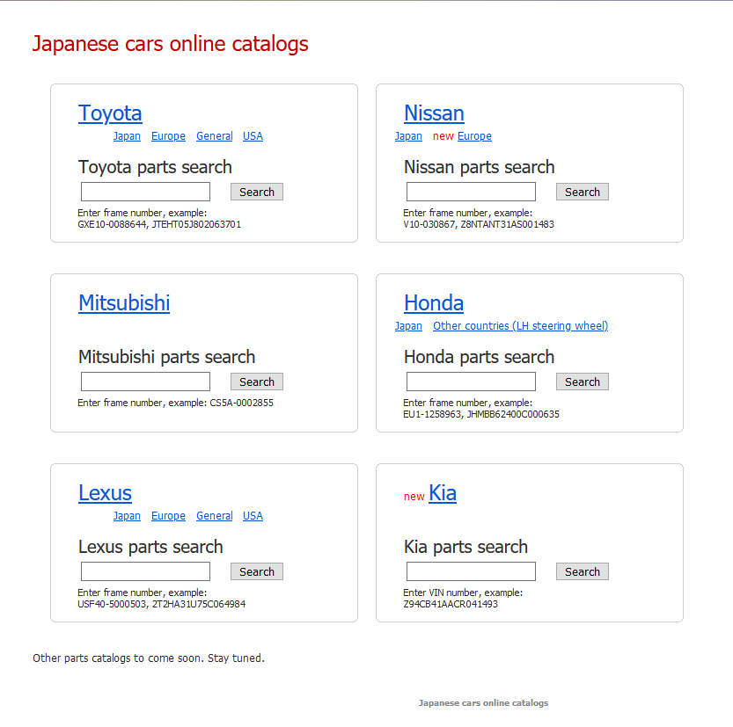

Αναζητήστε στο [Honda](https://honda.epc-data.com/) [Other countries (LH steering wheel)](https://honda-europe.epc-data.com/) **Honda parts catalog Choose model** [Jazz](https://honda-europe.epc-data.com/jazz/) **Choose year and transmission type** 2009 [5MT](https://honda-europe.epc-data.com/jazz/2009_5mt/) **Choose complectation** L13Z1 [1.4 EXHT](https://honda-europe.epc-data.com/jazz/2009_5mt/21054/)  γράψτε τα χαρακτηριστικά **Options** του οχήματος

____________________________________________________________________________________________________________________________________________________________________________________________________________________________________________________________________________________________________________και γράψτε μια λίστα με τα **part number** και τις τιμές (κάνοντας κλικ πάνω στο κάθε part number) των παρακάτω ανταλλακτικών από **Choose parts group**: [Transmission](https://honda-europe.epc-data.com/jazz/2009_5mt/21054/transmission/):

Του [M-8 DIFFERENTIAL (MT)](https://honda-europe.epc-data.com/jazz/2009_5mt/21054/transmission/M__0800/)

________________________________________________________________________________________________________________________________________________________________________________________________________________________________________________________________________________________________________________________________________________________________________________________________________________________________________________________________________________________________________________________________________________________________________________________________________________________

Συνολικό κόστος:__________________

Και [Engine](https://honda-europe.epc-data.com/jazz/2009_5mt/21054/engine/) του [E-5 PLUG TOP COIL](https://honda-europe.epc-data.com/jazz/2009_5mt/21054/engine/E__0500/)

__________________________________________________________________________________________________________________________________________________________________________________________________________________________________________________________________________________________________________________________________________________________________________________________________________________________________________________________________________________________________________________________________________________________________________________________________________________________________________________________________________________________________________________________________________________________________________________________________________________________________________________________________________________________________________________________________________________________________________________________________________________________________________________________________________________________________________________________________________________________________________________________________________________________________________________________________________________________________________________________________________________________________________________________________________________________________________________________________________________________________________________________________________________________________________________________________________________________________________________________________________________________________________________

Συνολικό κόστος:__________________