**ΑΣΚΗΣΗ: Κατάλογοι ανταλλακτικών (Service parts lists)**

|  |  |
| --- | --- |
| Ονοματεπώνυμο Μαθητή: | |
| Τμήμα: | Ημερομηνία: |

Μεταβείτε στην ιστοσελίδα:

<https://www.epc-data.com/>

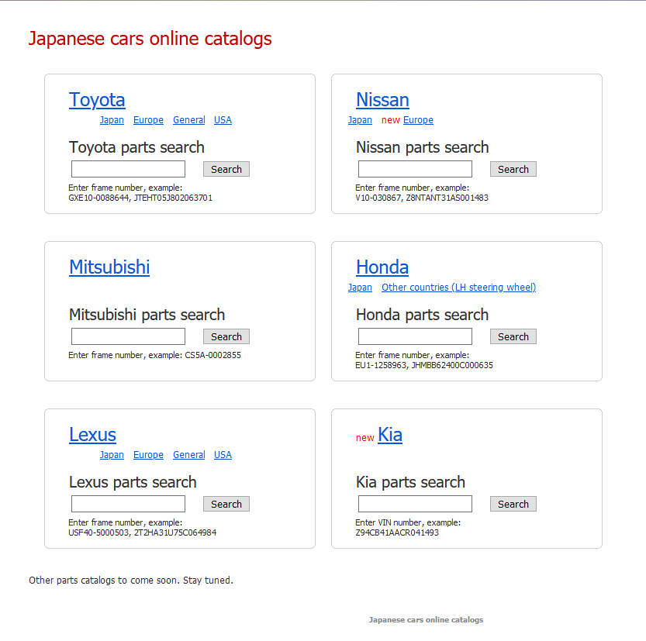

Αναζητήστε στο [Toyota](https://toyota.epc-data.com/) [Europe](https://toyota-europe.epc-data.com/) **Choose model** [Starlet](https://toyota-europe.epc-data.com/starlet/) **Choose frame name** [EP81L](https://toyota-europe.epc-data.com/starlet/ep81l/) **Choose complectation** [EP81L-AGMSEC](https://toyota-europe.epc-data.com/starlet/ep81l/681/) γράψτε τα χαρακτηριστικά του οχήματος

Αρ. βαλβίδων:______________Κιβώτιο ταχυτήτων:______________________________

Σύστημα τροφοδοσίας καυσίμου:__________________________________Αρ. Θυρών:________

και γράψτε μια λίστα με τα **part number** και τις τιμές (κάνοντας κλικ πάνω στο κάθε part number)των παρακάτω ανταλλακτικών από **Choose parts group**: [Transmission and chassis](https://toyota-europe.epc-data.com/starlet/ep81l/681/chassis/) Scheme 1:

Του [31-01 - CLUTCH & RELEASE FORK](https://toyota-europe.epc-data.com/starlet/ep81l/681/chassis/3101/)

________________________________________________________________________________________________________________________________________________________________________________________________________________________________________________________________________________________________________________________________________________________________________________________________________________________________________________________________________________________________________________________________________________________________________________________________________________________

Συνολικό κόστος:__________________

Και του [43-02 - FRONT DRIVE SHAFT](https://toyota-europe.epc-data.com/starlet/ep81l/681/chassis/4302/) Scheme 2

__________________________________________________________________________________________________________________________________________________________________________________________________________________________________________________________________________________________________________________________________________________________________________________________________________________________________________________________________________________________________________________________________________________________________________________________________________________________________________________________________________________________________________________________________________________________________________________________________________________________________________________________________________________________________________________________________________________________________________________________________________________________________________________________________________________________________________________________________________________________________________________________________________________________________________________________________________________________________________________________________________________________________________________________________________________________________________________________________________________________________________________________________________________________________________________________________________________________________________________________________________________________________________________

Συνολικό κόστος:__________________