**ΘΕΣΗ ΑΝΑΝΗΨΗΣ**

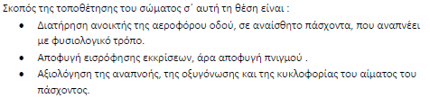

**ΒΗΜΑΤΑ:**

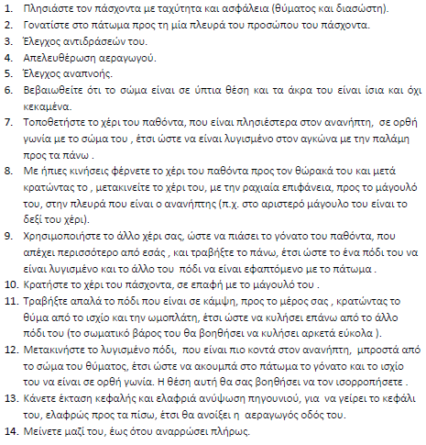



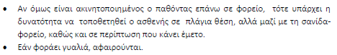

[**https://www.bing.com/videos/riverview/relatedvideo?&q=%ce%98%ce%95%ce%a3%ce%97+%ce%91%ce%9d%ce%91%ce%9d%ce%97%ce%a8%ce%97%ce%a3+Kids+Saving+Lives&&mid=A07CC78C45FF259AD59CA07CC78C45FF259AD59C&&FORM=VRDGAR**](https://www.bing.com/videos/riverview/relatedvideo?&q=%ce%98%ce%95%ce%a3%ce%97+%ce%91%ce%9d%ce%91%ce%9d%ce%97%ce%a8%ce%97%ce%a3+Kids+Saving+Lives&&mid=A07CC78C45FF259AD59CA07CC78C45FF259AD59C&&FORM=VRDGAR)