Past Simple Practice

To practice the Past Simple of regular verbs watch this [video](https://learnenglishteens.britishcouncil.org/grammar/beginner-grammar/past-simple-regular-verbs) from the British Council.

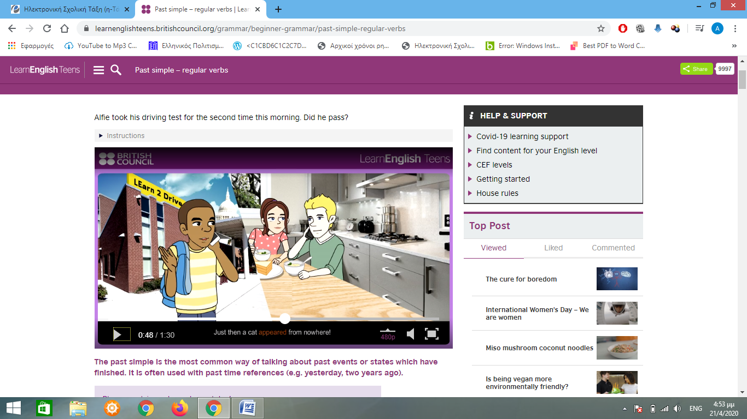

In this episode Oliver is calling his friend, Alphie to tell him about his driving test.

Then read the theory which is presented below the video

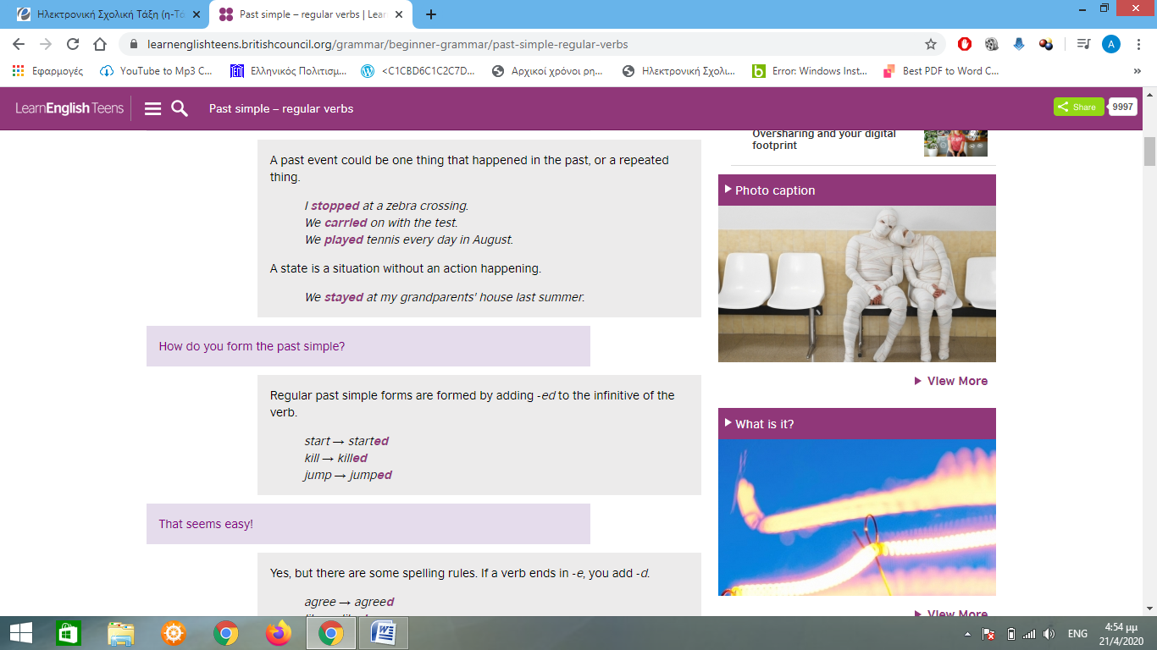

and do the three online activities at the bottom of the page :

* Check your grammar True or False
* Check your grammar gap fill
* Check your grammar multiple choice

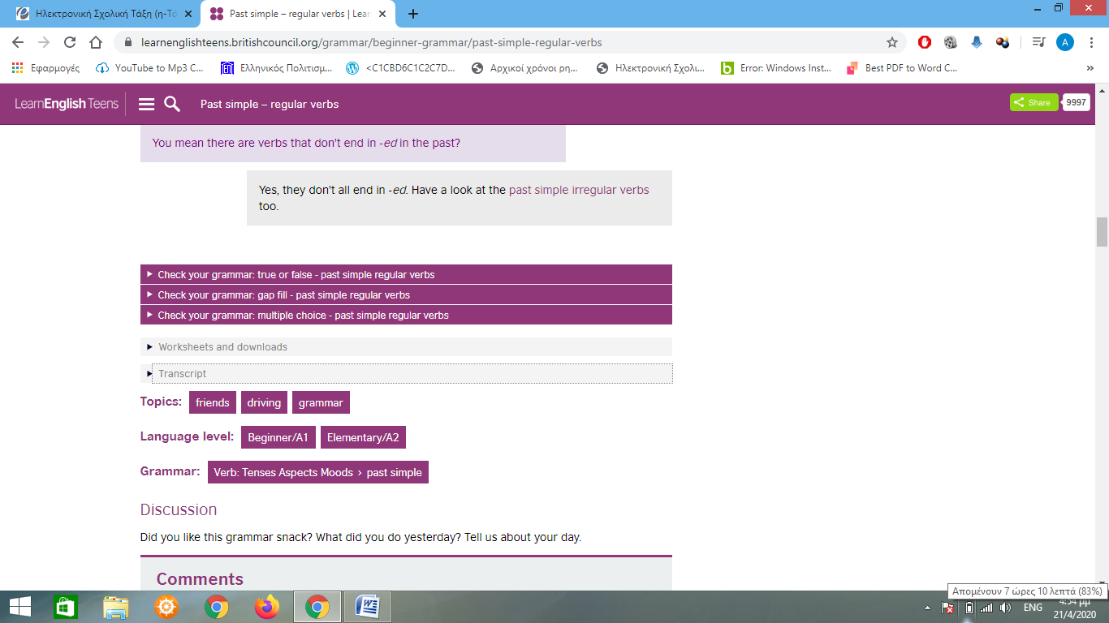

Report your score in the online activities and write a short paragraph to describe what is happening at the episode you watched.

Begin with the following sentence :

Alphie just had his second driving test. ………………………..