**Most commonly used hand tools**

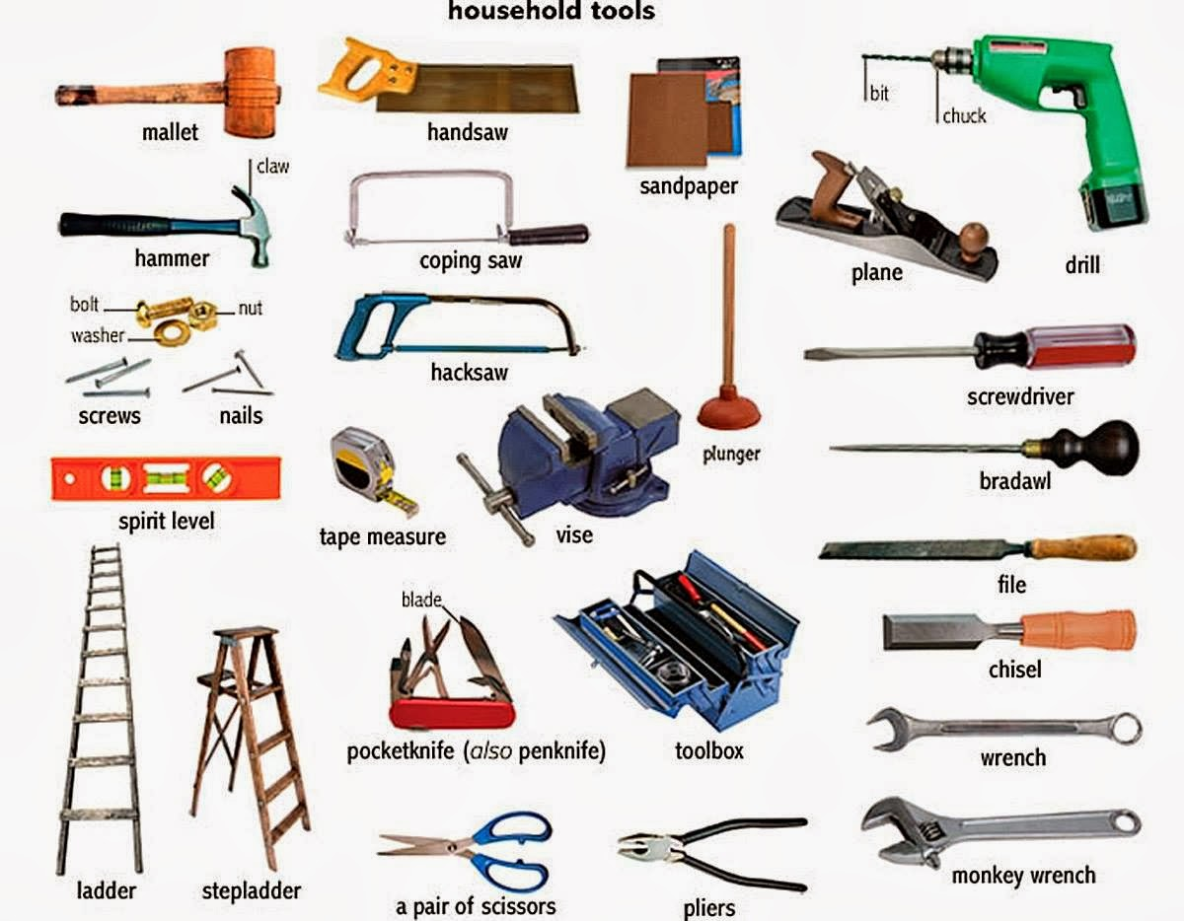

<http://kitchentoolstools.blogspot.com/2016/04/27-kitchen-hand-tools-and-their-uses.html>

Look at the pictures above and study pages 78-86 of your Coursebook for Mechanical Engineering Technicians. Write sentences as in the example to talk about what each tool is used for.

Here are the most common uses of tools: **gripping/holding objects, cutting, screwing/unscrewing, tightening/loosening, scribing, marking/starting a hole, filing, scraping, bending, forging, drilling, measuring, rubbing, striking, etc.**

Για άγνωστες λέξεις πατήστε [εδώ.](https://www.wordreference.com/engr/)

e.g A tool box is used for storing tools / to store tools

A ladder is used for reaching up a high spot / to reach up a high spot

Can you write the greek words for the above tools?

e.g pocketknife / penknife σουγιάς