Renewable Sources of Energy

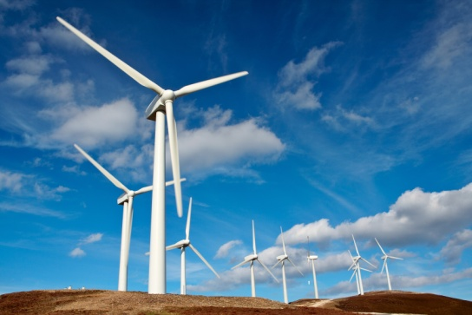

* Do you know what the renewable sources of energy are?
* Why are they governments turning to them?
* Read this [article](https://www.dw.com/en/wind-farms-climate-protection-vs-nature-protection/a-49994827) from DW and answer the questions.

1. What are wind turbines used for?
2. What problems can they cause?
3. Which countries produce the greatest amount of energy through the wind?
4. Why is it important to involve local people from African countries in the renewable sources project?

<https://www.electrochem.org/ecs-blog/large-scale-wind-power-could-cause-warming/>

<https://www.dw.com/en/wind-farms-climate-protection-vs-nature-protection/a-49994827>