TOP 10 CAREERS IN TOURISM AND HOSPITALITY
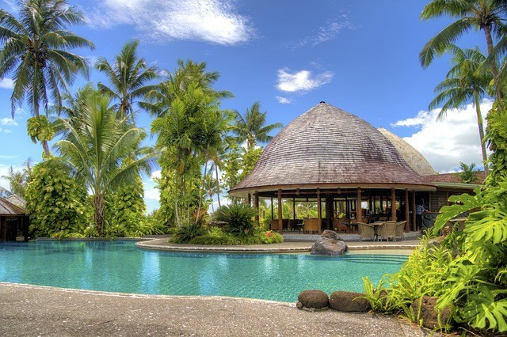
If you think back to the last holiday you had, what were the highlights that you remember? The spacious hotel room with a view of the sea? The planned excursions while you were away? Or the mouth-watering food served at the fancy restaurant you went to?
There are many people behind the scenes who make things happen so that you can enjoy your holiday, from the travel agent who booked your flights and accommodation, to the housekeeper at the hotel, and the local travel guide who showed you around.
If you’re looking for exciting career opportunities in this line of work, look no further. Here are the top 10 careers in Tourism & Hospitality.

1) TRAVEL AGENT
Travel Agents research, plan, and book trips for individuals and groups. Although people are starting to research and book their travel plans online, it’s often easier to use a Travel Agent, as they have years of experience and knowledge. They are able to help with flight bookings, hotel selection, transfer arrangements, and holiday activities.
If you’re considering becoming a Travel Agent, you will need great organisational skills, attention to detail, and the ability to think on your feet.
2) HOTEL MANAGER
Hotel Managers oversee all aspects of running a hotel – from housekeeping and general maintenance to budget management and marketing of the hotel. If you’re considering a career as a Hotel Manager, you will need excellent interpersonal skills, experience in the hospitality industry, and a number of years’ experience in managing employees.
You will be responsible for the daily running of the hotel, including recruiting, training and supervising staff; managing budgets; planning maintenance work; dealing with customers’ complaints; overseeing reservations; promoting and marketing the hotel; and ensuring that the hotel complies with health and safety regulations.

3) SPA MANAGER
Spa Managers are responsible for the day-to-day running of health and/or beauty spas. They manage a spa’s finances, employees, and services. Many of the tasks are business-related and can include recordkeeping, getting involved in promotional campaigns, maintaining stock inventories, and payroll management.
Spa Managers typically create weekly work schedules, oversee general spa maintenance, train new employees, and arrange staff workshops on new treatments. Often, experience in spa management is essential when applying for a position.

4) TOUR OPERATOR
A Tour Operator typically combines tour and travel components to create holiday packages. He or she will deal with various service providers, including bus operators, airlines and hoteliers.
Tour Operators prepare itineraries for various destinations and will often monitor trends in popular destinations in order to put together attractive holiday packages for clients. Tour Operators mainly deal with Travel Agents, while Travel Agents deal with the public. Tour Operators will often visit destinations to check whether they should include them in their packages. If you enjoy travelling, this might be the job for you.

5) EVENT & CONFERENCE ORGANISER
Organising any event or conference is time consuming, so an Event and Conference Organiser will help with the finer details of planning an event. The role is hands-on and often involves working as part of a bigger team. Event and Conference Organisers co-ordinate every detail of meetings and conferences, from the speakers and meeting locations to the printed materials and audio-visual equipment.
If you’re interested in becoming an Event and Conference Organiser, you will need to be able to think on your feet, pay attention to detail, deal with clients and suppliers, and work under tight deadlines. You will also have to be willing to work long hours in order to ensure the success of an event.

6) TOUR GUIDE
Tour Guides work in the travel industry, and give guided tours to groups of visitors/tourists. Tour Guides must have expert knowledge of specific areas, including natural features, historic sites, museums, and other tourist destinations. Guides may give walking tours, bus tours, or even boat tours.
If you decide to become a Tour Guide, you will probably get most of your experience on the job. You will need excellent communication skills – and speaking more than one language will definitely benefit you.

7) EXECUTIVE CHEF
If you hear “Executive Chef”, you might think of the local celebrity chef Reuben Riffel, or the renowned UK-based chef Gordon Ramsay. The Executive Chef is in charge of a restaurant’s kitchen, and is responsible for managing the kitchen staff, planning the menu, sourcing the freshest ingredients, and making sure that food hygiene is maintained throughout the restaurant. An Executive Chef must be able to spot problems and resolve them quickly and efficiently.
If you’re passionate about cooking for a crowd and think you might have what it takes, this might be the perfect career for you.

8) SOMMELIER
In short, a Wine Sommelier is an expert in wines. A Wine Sommelier is passionate about wine. He or she is a highly trained and knowledgeable wine professional, specialising in all aspects of wine service. Five-star restaurants will often employ a Sommelier to develop their wine list and to help customers find a wine within their budget that suits their tastes and complements their food.
As a Sommelier, your day might not start until 14:00, when you review your inventory, meet with suppliers, and arrange to taste wines. Before the restaurant opens for dinner, you go over the wine list with your staff. Then you work the floor, seeing to customer’s needs. Your day might not end until 01:00 or 02:00 in the morning.

9) PR MANAGER
A PR Manager manages a brand’s reputation, and will plan, develop, and implement specific strategies to build and maintain the overall brand and reputation. Often, the PR Manger will also act as the company’s spokesperson. In the Tourism and Hospitality environment, a PR Manager might work for a hotel chain, a cruise company, or a game reserve.
The job will involve writing and syndicating positive press releases about the brand, arranging events at the hotel (including press conferences, exhibitions, open days, and tours) and connecting with relevant influencers in the industry. PR Managers will also have to deal with potential crisis situations. If you’re interested in becoming a PR Manager, you will have to have excellent communication and problem-solving skills.

10) LEISURE ACTIVITY CO-ORDINATOR
Leisure Activity Co-ordinators usually work for resorts and hotel chains. They’re the people on the ground who make sure that any planned activities run smoothly. They’re also responsible for every aspect of the day-to-day management of a leisure centre, organising health and fitness programmes, promoting and marketing the business, and interacting with guests. To become a Leisure Activity Co-ordinator, you will need excellent interpersonal skills, as you will spend most of your time interacting with guests.

Which of the above careers do you think would suit you? Why?

Match the words with their meaning in Greek.

- coordinator  - resort  - expert  - passionate  - reputation  - implement  - maintain  - resolve  - responsible for  - promote  - oversee | - επιλύω  - διατηρώ  - επιβλέπω  - προωθώ  - συντονιστής  - ειδικός, εξπέρ  - φήμη  - εφαρμόζω  - υπεύθυνος για  - παθιασμένος  - θέρετρο

