ΥΠΟΥΡΓΕΙΟ ΠΑΙΔΕΙΑΣ, ΕΡΕΥΝΑΣ ΚΑΙ ΘΡΗΣΚΕΥΜΑΤΩΝ ΙΝΣΤΙΤΟΥΤΟ ΕΚΠΑΙΔΕΥΤΙΚΗΣ ΠΟΛΙΤΙΚΗΣ

ΑΓΓΛΙΚΑ ΕΠΑΛ
ΤΟΜΕΑΣ ΠΛΗΡΟΦΟΡΙΚΗΣ

ΙΝΣΤΙΤΟΥΤΟ ΤΕΧΝΟΛΟΓΙΑΣ ΥΠΟΛΟΓΙΣΤΩΝ ΚΑΙ ΕΚΔΟΣΕΩΝ «ΔΙΟΦΑΝΤΟΣ»

ΣΥΝΤΟΝΙΣΜΟΣ

ΕΚΠΟΝΗΣΗ-ΑΝΑΜΟΡΦΩΣΗ- ΕΠΙΜΕΛΕΙΑ ΠΕΡΙΕΧΟΜΕΝΟΥ- ΦΙΛΟΛΟΓΙΚΗ ΕΠΙΜΕΛΕΙΑ

ΕΚΠΟΝΗΣΗ

ΕΙΚΑΣΤΙΚΗ ΕΠΙΜΕΛΕΙΑ
Παπαδημητρίου Ευαγγελία, Σύμβουλος Β΄ ΙΕΠ

Νίκα Μαρία, Σύμβουλος Α΄ ΙΕΠ

Εξωτερική Εμπειρογνώμονας
Παπαχρίστου Ευτυχία,
Συντονίστρια Εκπαιδευτικού Έργου Αγγλικής Γλώσσας
Νίκα Μαρία, Σύμβουλος Α΄ ΙΕΠ

ΣΕΛΙΔΟΠΟΙΗΣΗ- ΓΡΑΦΙΣΤΙΚΗ ΕΠΙΜΕΛΕΙΑ

Κομνηνού Δήμητρα, Προσωπικό ΙΕΠ


Γεράσιμος Κουζέλης, Πρόεδρος του Ινστιτούτου Εκπαιδευτικής Πολιτικής

Δράση για την εκπόνηση Προγραμμάτων Σπουδών και συμπληρωματικού εκπαιδευτικού υλικού για το γνωστικό αντικείμενο των Αγγλικών Γενικού Λυκείου και ΕΠΑ.Λ.
βάσει των υπ’ αριθ. 10/01-03-2018 και 12/15-03-2018 Πράξης του Δ.Σ. του Ι.Ε.Π. (αρ. πρωτ. 3379/20-03-2018 και ΑΔΑ: ΩΖΞΕΟΞΛΔ-ΓΡΥ).

Το παρόν εκπονήθηκε αμισθί, με ευθύνη της Υπομονάδας Ξένων Γλωσσών του Ι.Ε.Π., στο πλαίσιο της ανωτέρω δράσης.

ΥΠΟΥΡΓΕΙΟ ΠΑΙΔΕΙΑΣ, ΕΡΕΥΝΑΣ ΚΑΙ ΘΡΗΣΚΕΥΜΑΤΩΝ ΙΝΣΤΙΤΟΥΤΟ ΕΚΠΑΙΔΕΥΤΙΚΗΣ ΠΟΛΙΤΙΚΗΣ

ΦΑΚΕΛΟΣ ΥΛΙΚΟΥ

ΑΓΓΛΙΚΑ ΕΠΑΛ
ΤΟΜΕΑΣ ΠΛΗΡΟΦΟΡΙΚΗΣ

ΙΝΣΤΙΤΟΥΤΟ ΤΕΧΝΟΛΟΓΙΑΣ ΥΠΟΛΟΓΙΣΤΩΝ ΚΑΙ ΕΚΔΟΣΕΩΝ «ΔΙΟΦΑΝΤΟΣ»



NetworK Devices and Equipment . . . . . . . . . . . . . . . . . . . . . . . 9
1
Table of Contents
Operating System 29
2




Εισαγωγικό σημείωμα

Το παρόν διδακτικό υλικό προτείνεται για τη διδασκαλία της αγγλικής γλώσσας στο ΕΠΑ.Λ., προκειμένου να προσφέρει στους μαθητές και τις μαθήτριες ευκαιρίες να αξιοποιήσουν τις ήδη υπάρχουσες γλωσσικές επικοινωνιακές τους ικανότητες και να εμπλακούν ενεργά σε δρα- στηριότητες που έχουν ως απώτερο στόχο την περαιτέρω γλωσσική, κοινωνική και ψυχοσυ- ναισθηματική τους ανάπτυξη. Ειδικότερα, στοχεύει στην ανάπτυξη γλωσσικών δεξιοτήτων σε επικοινωνιακές περιστάσεις που αφορούν τον επαγγελματικό τομέα της επιλογής τους.
Το υλικό είναι χωρισμένο σε θεματικές ενότητες, σχετικές με τον τομέα Πληροφορικής. Κάθε ενότητα περιλαμβάνει δραστηριότητες κατανόησης και παραγωγής προφορικού και γραπτού λόγου στην ξένη γλώσσα, οι οποίες στοχεύουν στην καλλιέργεια των γλωσσικών επικοινωνι- ακών δεξιοτήτων τους μέσα από αυθεντικά κείμενα και αυθεντικές επικοινωνιακές περιστά- σεις. Οι μαθητές και οι μαθήτριες καλούνται να διαβάσουν, να γράψουν, να συνομιλήσουν, να κατανοήσουν, να παρατηρήσουν, να αναζητήσουν, να παρουσιάσουν και να επεξεργαστούν πληροφορίες κριτικά και δημιουργικά, ατομικά ή και ομαδικά.
Μέσα από βιωματικές και ομαδο-συνεργατικές δραστηριότητες, οι μαθητές και μαθήτριες αναμένεται να κατακτήσουν προοδευτικά το λεξιλόγιο και την ορολογία του επαγγελματικού τομέα που έχουν επιλέξει, και κυρίως να καταστούν ικανοί/-ές να κατανοούν κείμενα αλλά και να παράγουν γραπτό και προφορικό λόγο σε σχέση με το αντικείμενο της ειδικότητάς τους.
Η χρήση αυθεντικών κειμένων αποτελεί αναμφίβολα ιδιαίτερα αποτελεσματική μέθοδο στη διδασκαλία της ξένης γλώσσας, και ιδιαίτερα στη διδασκαλία της για ειδικούς σκοπούς (ESP). Τα εν λόγω κείμενα δεν έχουν σε γενικές γραμμές υποστεί επεξεργασία για την προσαρμογή τους σε συγκεκριμένα επίπεδα γλωσσομάθειας, στοιχείο που αποτελεί το βασικό τους πλεονέκτημα καθώς ενισχύει το βαθμό της πρόκλησης αλλά και τα κίνητρα των μαθητών και μαθητριών για την κατανόησή τους. Επιπλέον, παρουσιάζουν επικοινωνιακές περιστάσεις στις οποίες πρόκειται να εκτεθούν μελλοντικά οι μαθητές και οι μαθήτριες προκειμένου να αναζητήσουν πληροφορίες σχετικές με τον επαγγελματικό τους τομέα.
Σκοπός της χρήσης τους στην τάξη επομένως δεν είναι η προσαρμογή των κειμένων στο επίπεδο των μαθητών και μαθητριών. Αντίθετα, κλειδί της επεξεργασίας τους αποτελεί η προσαρμογή των δραστηριοτήτων που τα συνοδεύουν ανάλογα με τις ικανότητες και τα ενδιαφέροντα των μαθητών και μαθητριών. Ενδεικτικά προτείνεται, πριν από την ανάγνωση του κειμένου, η χρήση κατάλληλα διαμορφωμένων ερωτήσεων, η παρουσίαση του λεξιλογίου που θα χρειαστούν για την κατανόησή του ή και συζήτηση σχετικά με το θέμα του κειμένου στη μητρική τους γλώσσα (pre-reading tasks) κ.λπ., έτσι ώστε να προετοιμαστούν οι μαθητές και οι μαθήτριες κατάλληλα και να μειωθεί ο βαθμός δυσκολίας του κειμένου.

Ο/η εκπαιδευτικός μπορεί να αξιοποιήσει επίσης τεχνικές ανάγνωσης και διαχείρισης άγνω- στου/νέου λεξιλογίου για την ανάπτυξη σχετικών μεταγνωστικών στρατηγικών και δεξιοτήτων. Σε κάθε περίπτωση, θα πρέπει να τονίζεται στους μαθητές και τις μαθήτριες ότι το ζητούμενο δεν είναι να κατανοήσουν κάθε λέξη του κειμένου αλλά να αναπτύξουν τη δεξιότητα και την αυτοπεποίθηση που απαιτούνται, ώστε να χειρίζονται κείμενα με άγνωστες λέξεις και να ανταποκρίνονται με επιτυχία σε μελλοντικές πραγματικές επικοινωνιακές συνθήκες. Αυτό επιτυγχάνεται αποτελεσματικά μέσα από δραστηριότητες εντοπισμού της γενικής ιδέας ή συ- γκεκριμένων πληροφοριών σε ένα κείμενο (π.χ. χώρων, αντικειμένων, κατηγοριών), μέσα από τεχνικές “skimming” και “scanning”, μέσα από τη χρήση τεχνικών ανακαλυπτικής μάθησης και στρατηγικών όπως SQ3R (Survey, Question, Read, Recite, Review), KWL (What do I know, What do I want to know, What have I learned) ή άλλα είδη γραφικών οργανωτών (mind-maps, spidergrams etc).
Σε αυτό το πλαίσιο, οι εκπαιδευτικοί έχουν τη δυνατότητα να σχεδιάσουν τη διδασκαλία τους με βάση τις ανάγκες και τα ενδιαφέροντα των μαθητών και μαθητριών τους. Σύμφωνα με τα παραπάνω, προτείνεται οι εκπαιδευτικοί να:
- συμπληρώσουν ή και να προσαρμόσουν το παρόν διδακτικό υλικό σύμφωνα με τις ανάγκες της τάξης τους,
- παράσχουν στους μαθητές και τις μαθήτριες ευκαιρίες ενεργού μάθησης εμπλέκοντάς τους σε διαδικασίες αναστοχασμού, διερεύνησης, προβληματισμού, κριτικής σκέψης, σύνθεσης, αλληλεπίδρασης, αξιολόγησης, λήψης απόφασης κ.λπ.,
- στοχεύουν στον εμπλουτισμό των προσωπικών εμπειριών των μαθητών και μαθητριών, συνδέοντας τη σχολική τάξη με τον κόσμο του μελλοντικού τους επαγγέλματος.

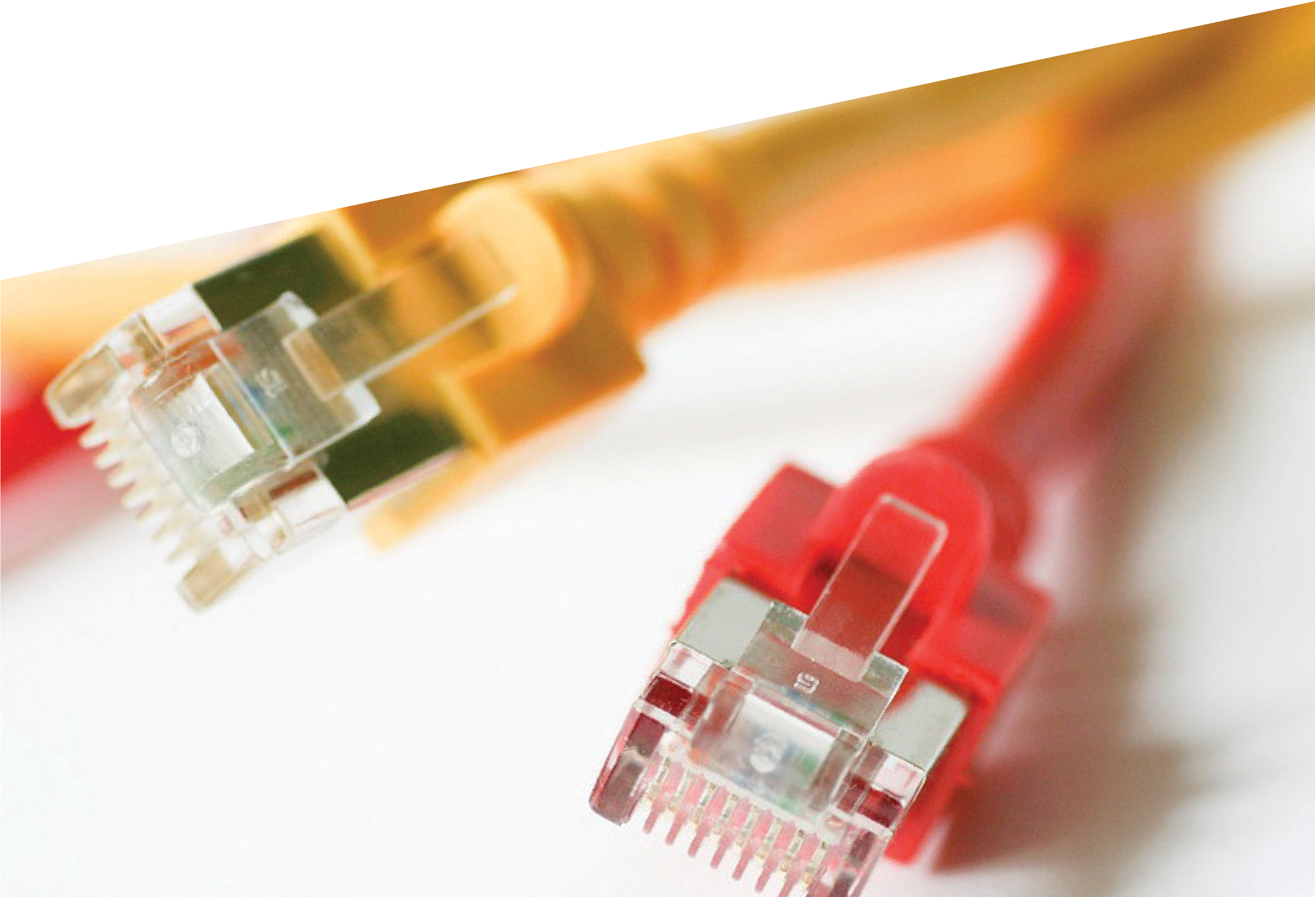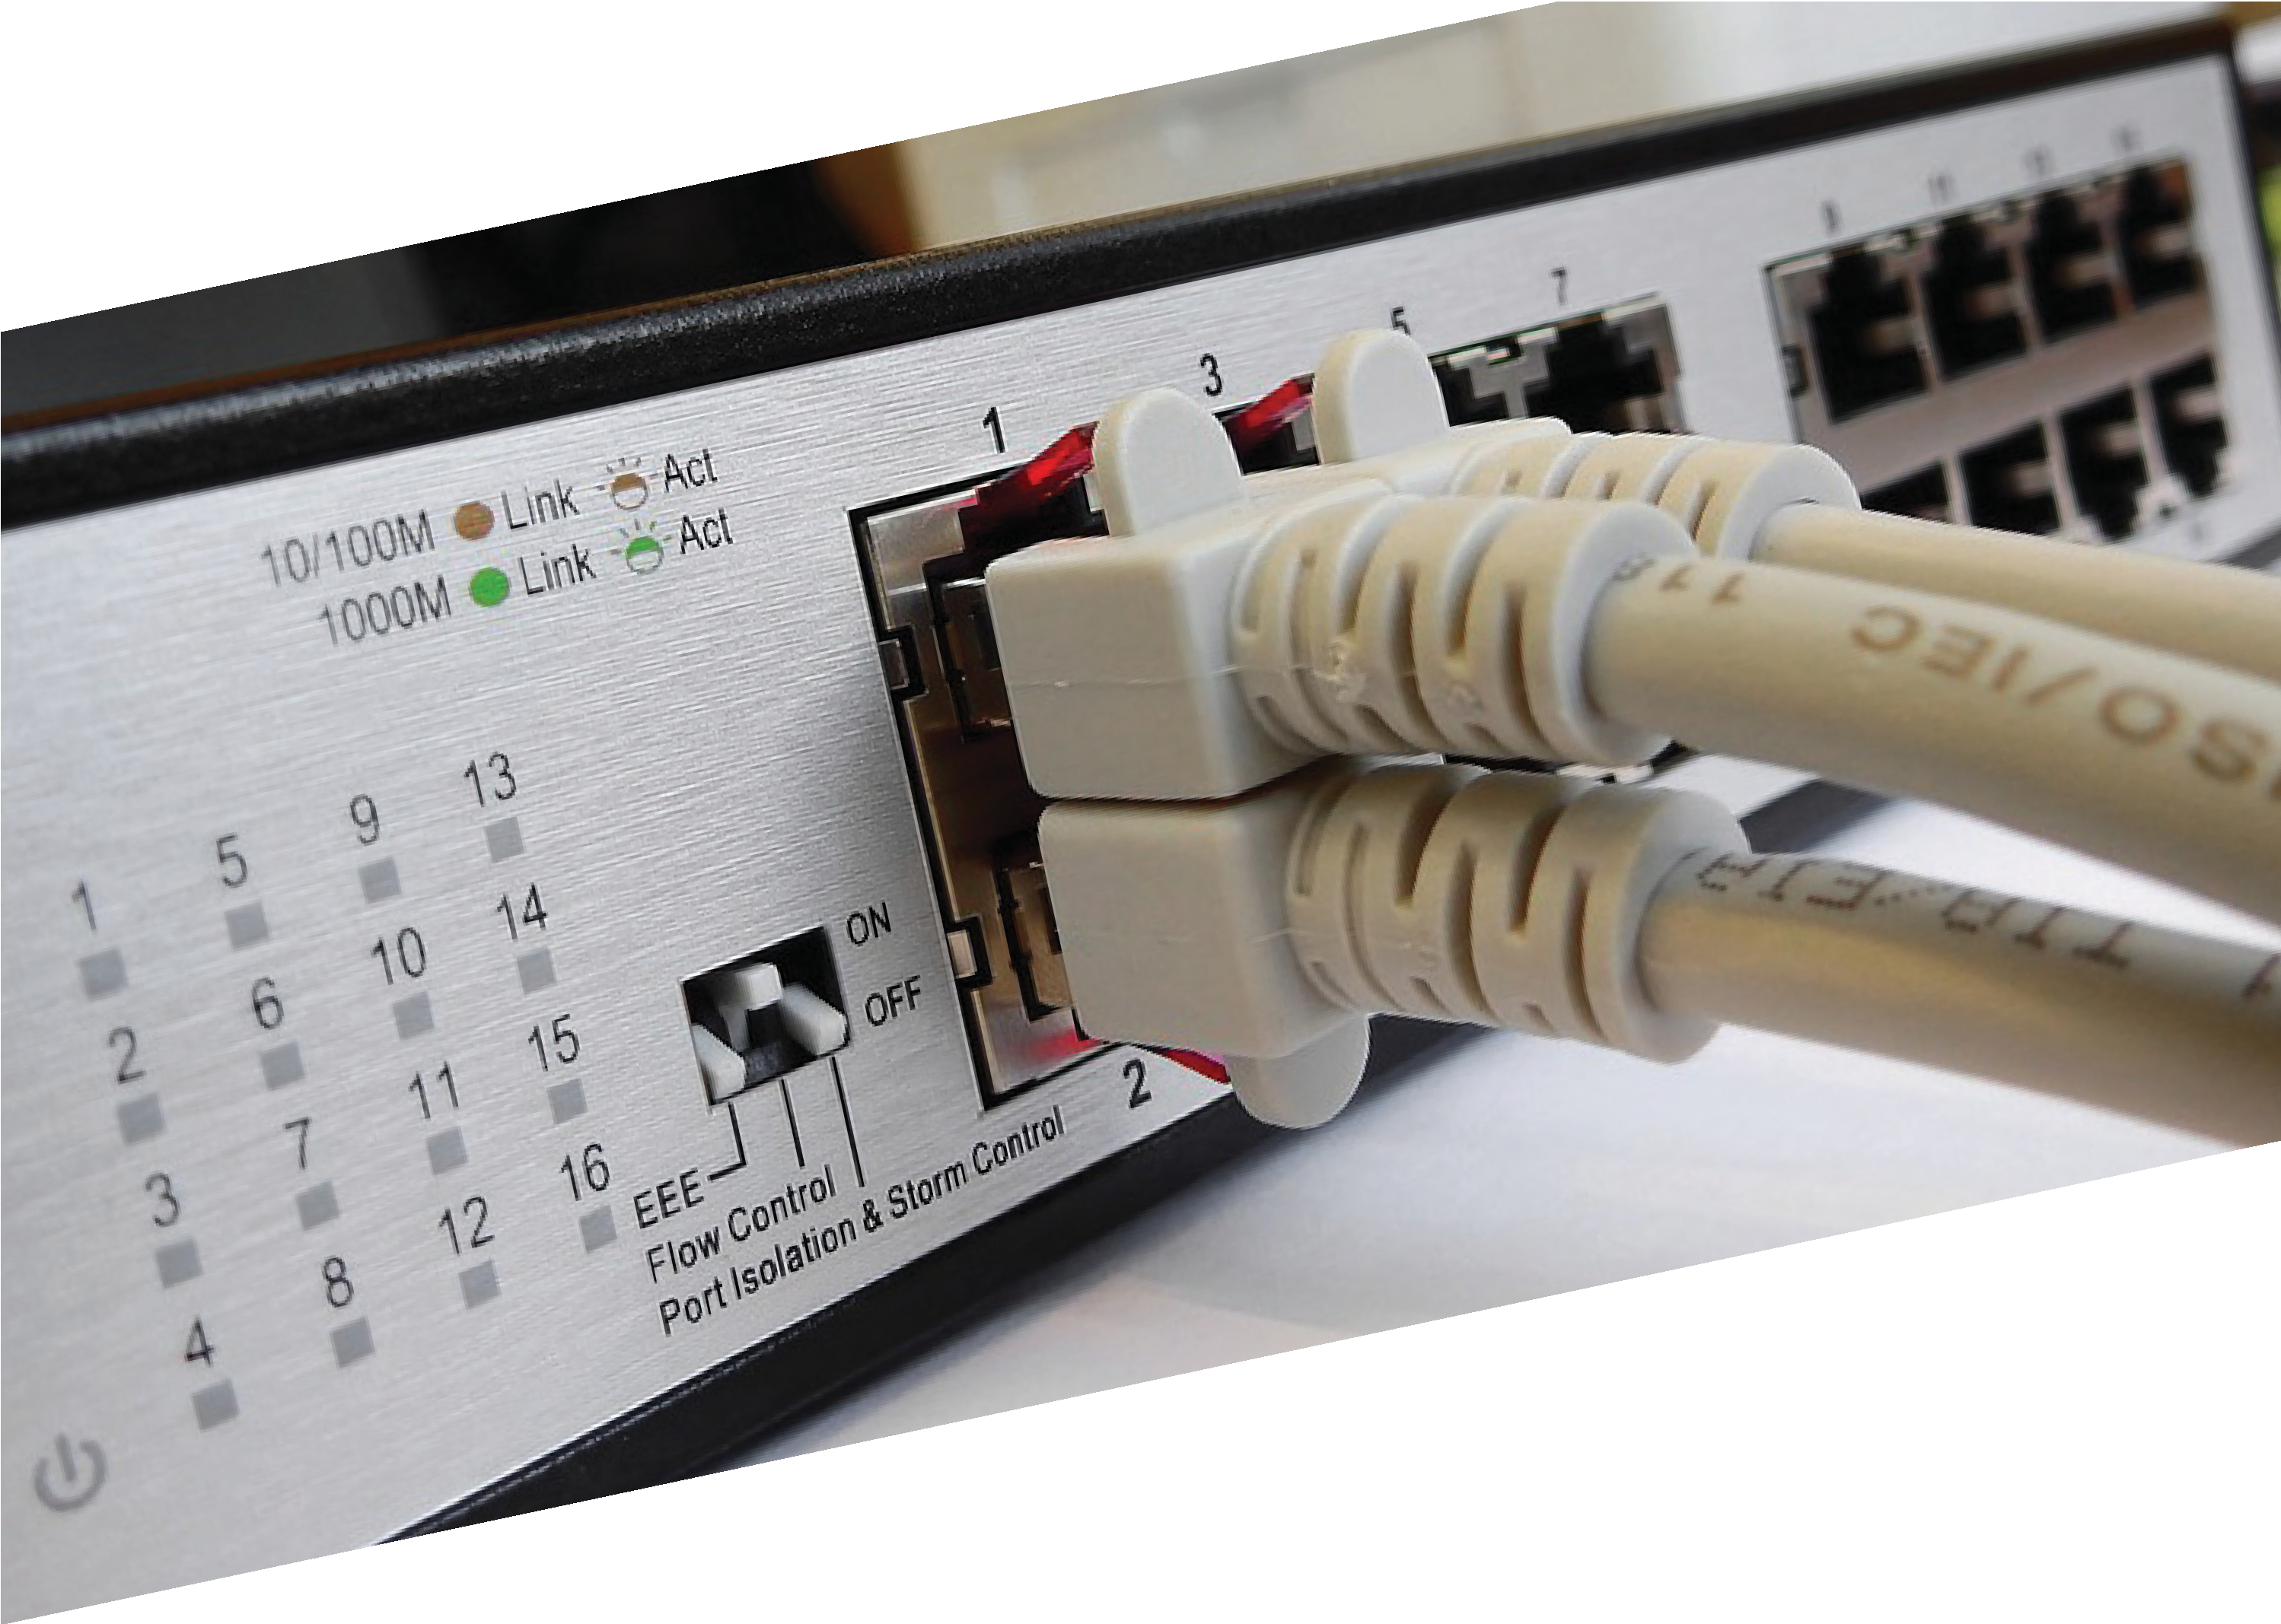1

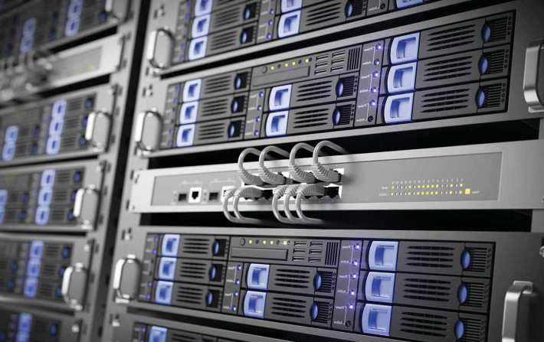

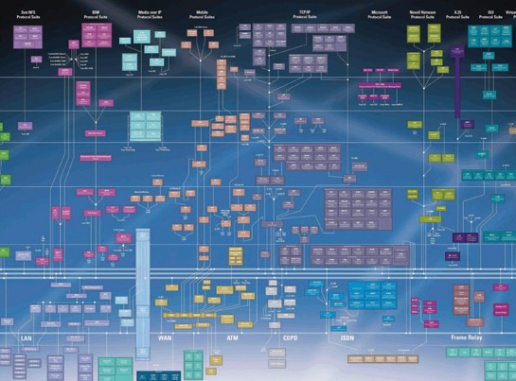
1 NetworK Devices and Equipment

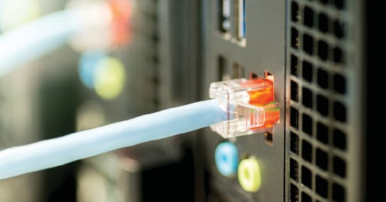
Do you know the answers to the following questions? Work in groups and try to answer as many as you can (you may use Greek language too). Then, read the text and come back to check or complement your answers.

group work

1. | What do network devices do? What are they used for?  ............................................................................................................................  ............................................................................................................................
2. | What does network equipment include? Name specific devices.  .............................................................................................................................  .............................................................................................................................
3. | What is the difference between wired and wireless  networks?  .............................................................................................................................  .............................................................................................................................
4. | Why are protocols regarded to be fundamental mechanisms for network communications?  What do they do?  ............................................................................................................................  .............................................................................................................................

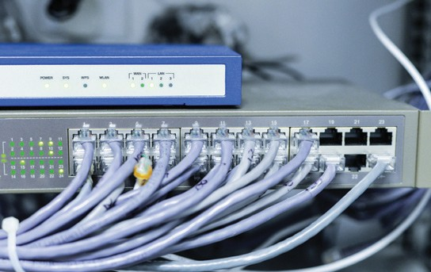
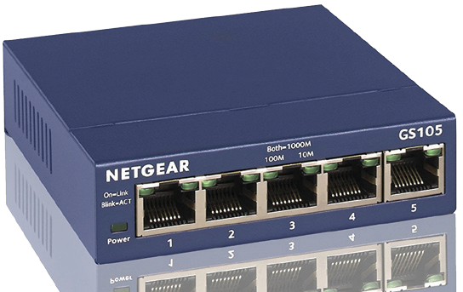
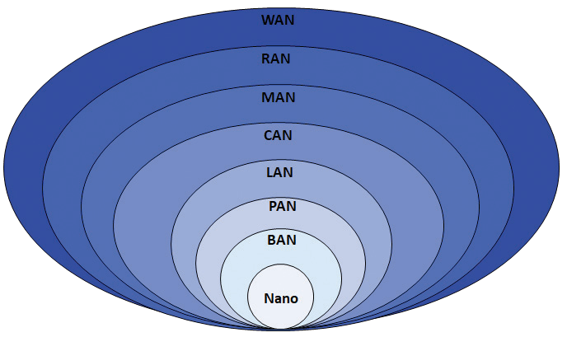

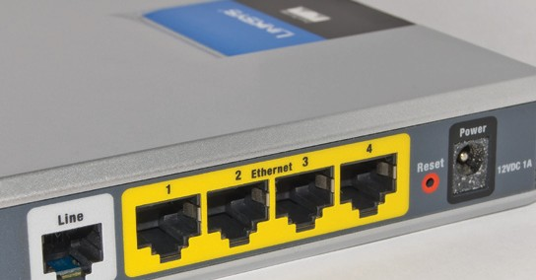
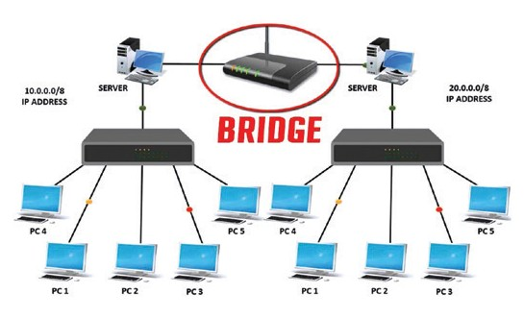


5. | What are the main kinds of area networks?  .............................................................................................................................  .............................................................................................................................
6. | What is a network hub used for? What are its drawbacks?  .............................................................................................................................  .............................................................................................................................
7. | What is a network switch used for? What is its advantage in comparison with a network hub?  .............................................................................................................................  .............................................................................................................................
8. | What does a modem do?  .............................................................................................................................  .............................................................................................................................
9. | What does a router do?  .............................................................................................................................  .............................................................................................................................
10. | What does a bridge do?  .............................................................................................................................  .............................................................................................................................
11. | What does a repeater do?  .............................................................................................................................  .............................................................................................................................

- Read the following text to get the information you need for the previous activity and then do the tasks below.
NetworK Devices and Equipment
1

ISSUE VOLUME YEAR

the best in current research

Network Devices and Equipment
Network equipment is used to combine, split, switch, boost or direct packets of information along a computer or telecommunications

  - Full Site Digital Library Advanced Search

packets may be called blocks, cells, frames or segments. Network protocols may also prescribe some or all of the operational characteristics of the network hardware on which they run.

network. This product area includes hubs, switches, routers, bridges, gateways, multiplexers, transceivers and firewalls. In addition to device type, network equipment is defined by protocol (e.g. Ethernet) and port or interface type.
Networking equipment interconnects devices so that data can be shared between them. The layout or topology of these connected devices describes the network's design or structure. Common topologies for computer networks include bus, ring, star, tree and mesh.
In wireless networks, devices communicate via radio waves and do not require physical connections whereas in wired networks, cables are used. These cables are equipped with connectors for a specific port or interface type.
Computer networks handle data according to protocols that are fundamental mechanisms for network communications. Network protocols specify the software attributes of data communications, including the structure of packets and the information contained therein. Depending upon the type of network,
Network equipment may be designed for local area networks (LAN), metropolitan area networks (MAN) or wide area networks (WAN).
If we take a look at the different devices, they work at different layers of the computer networks. These different layers are like different zones of a computer network with specified works, also called ‘network protocols’. For example, a LAN cable has got the purpose of connecting a computer to the local area network whereas a Wi-Fi router has got the purpose of sending and receiving data between you and your internet connection.

Types of Network Equipment
Net work Hub
This is a networking device used to connect multiple network hosts as well as to do data transfer. The data is transferred in terms of packets on a computer network. So when a host sends a data packet to a network hub, the hub copies the data packet to all of its ports

connected to. However, because of its working mechanism, a hub is not so secure and safe. Moreover, copying the data packets on all the interfaces or ports makes it slower and more congested, a fact which led to the use of network switch.

Net work Switch
Like a hub, a switch also works at the layer of LAN (Local Area Network). While hub just does the work of data forwarding, a switch does ‘filter and forwarding’ which is a more intelligent way of dealing with the data packets. So, when a packet is received at one of the interfaces of the switch, it filters the packet and sends it only to the interface of the intended receiver. For this purpose, a switch also maintains a CAM (Content Addressable Memory) table and has its own system configuration and memory.

Mode m
A modem, which stands for Modulator + Demodulator, is a hardware device that allows a computer to send and receive data over a telephone line or a cable or satellite connection. In the case of transmission over an analog telephone line, which was once the most popular way to access the internet, the modem converts data between analog and digital formats in real time for two-way network communication. In the case of the high-speed digital modems popular today, the signal is much simpler and doesn't require the analog- to-digital conversion.

Router
A router, which is a protocol-dependent device, is a physical layer networking device that joins multiple networks together. Typically routers are designed to make decisions about which path or interface to use for network traffic. Generally they perform very little filtering or policing, instead they are optimized for speed.

Bridge
They should be used to interconnect local or remote networks in order to centralise network administration. A bridge connects two subnetworks as a part of the same network. You can think of two different labs or two different floors connected by a bridge.

Re pe ater
A repeater is an electronic device that amplifies the signal it receives. When it receives a signal, it retransmits it at a higher level or higher power so that it can cover longer distances. Repeaters use regeneration and retiming to ensure then that signals are transmitted clearly through all network segments.

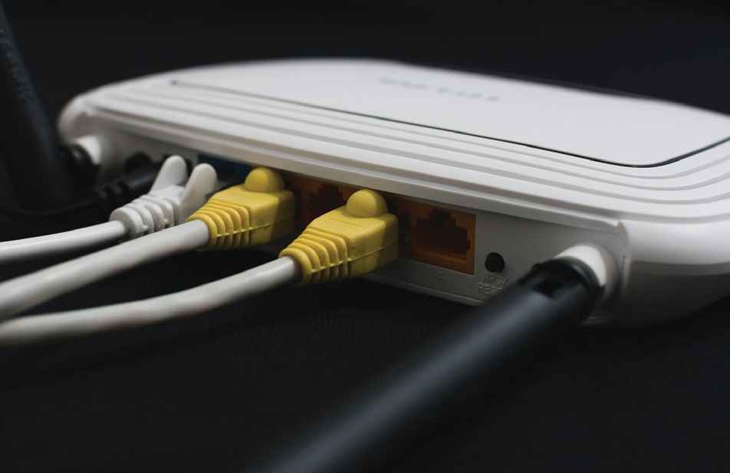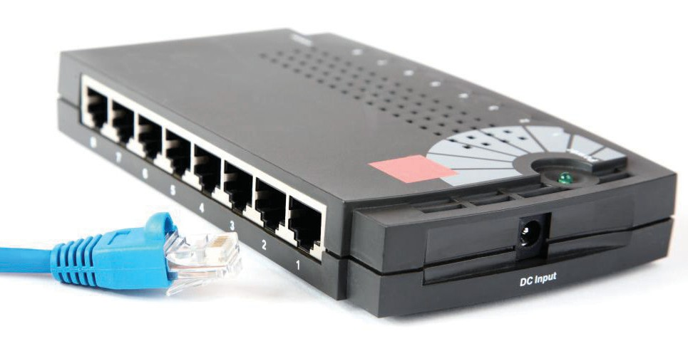
http://www.globalspec.com/learnmore/networking_communication_equipment/networking_equipment/networking_equipment
http://fossbytes.com/networking-devices-and-hardware-types/

- T rue or F alse ?
NetworK Devices and Equipment
1

Which of the following sentences is true (T ) or false (F ) according to the text?
 |  | True | False
1. | Blocks, cells, frames or segments are all packets of information or data.
2. | ‘Network protocols’ are layers of a computer network with specified purpose.
3. | A hub just connects network hosts without being able to transfer data.
4. | A switch maintains a Content Addressable Memory table and has its own system configuration and memory in order to be able to send packets to the intended receiver only.
5. | Transmission over an analog telephone line is nowadays the most popular way to access the internet.

- Read the text carefully and then choose the correct answers.

1. | What is the aim of the text?  - To list different products for purchase.  - To compare the function of different equipment.  - To provide knowledge about network devices and equipment.
2. | According to the article, why are network devices necessary?  - They facilitate the sharing of information and data.  - They distribute the layout of various interconnected devices.  - They forward information to a wide area network.
3. | Why is the network hub not preferable?  - Because it provides access to few computer networks.  - Because it transfers data to all active ports without filtering.  - Because it works at the layer of LAN (Local Area Network).



Match the words (1-10) with the definitions (A-J ).


pair work
1. Ethernet
6. configuration
2. protocol
7. cable
3. hub
8. router
4. switch
9. optimise
5. interface
10. gateway

A | Hardware device designed to receive, analyse and move incoming packets to another network.
B | A device or programme that enables a user to interact with a computer.
C | Wire(s) inside a protective covering used for transmitting electricity or telecommunication signals.
D | To achieve maximum efficiency / make the most effective use of a situation or  resource.
E | The point of access to computers outside your network.
F | Technology for connecting wired local area networks (LANs) enabling devices to communicate with each other via a protocol.
G | A set of technical rules governing the exchange or transmission of data between  devices.
H | A basic networking device that connects multiple computers or other network devices together.
I | A hardware device that connects computers in a network, filtering and forwarding  data packets.
J | The arrangement of functional units, i.e. the internal and external components, that make up a computer system.

- Choose the answer (a, b, or c) you find most appropriate.
NetworK Devices and Equipment
1

⬥ protocol
⬥ transceiver
⬥ interface
⬥ analog
⬥ attribute
⬥ repeater
⬥ LAN
⬥ networking
1
2

3

4

5
A user _______ is a point of interaction between a computer and humans.
A(n) _______ has networking equipment in close proximity to each other, capable of communicating, sharing resources and information.
_______ transmission is a transmission method of conveying information using a continuous signal of varying frequency as opposed to digital transmission.
Each _______ has its own rules that dictate how data is formatted, transmitted and received.
_______ is an electronic device that receives a signal and retransmits it; it extends transmissions so that the signal can cover longer distances or be received on the other side of an obstruction.

- Complete each blank in the following pairs of sentences with the correct word.

1. | device / equipment  - The newly-designed _______ will be displayed on this year’s annual technology exhibition.  - Thieves broke into the offices last night and stole €15,000's worth of computer  _______.
2. | router / hub  - A _______, which connects multiple computers or other network devices together, has no routing tables or intelligence so as to be able to traffic information.  - Within a LAN environment the _______ provides local address resolution services and may segment the network using a subnetwork structure.
3. | configuration / interface  - _______ refers to what kind of hardware is connected, and how those connections are set up.  - In computing, a(n) _______ is a shared boundary across which two or more separate components of a computer system exchange information.

- Word formation. Look at the following table showing how we form nouns from verbs adding a suffix.

Vocabulary building | forming nouns  from verbs | verb + suffix 🢣 noun
 | -tion | communicate | 🢣 | communication
 | -sion | admit | 🢣 | admission
 | -ment | equip | 🢣 | equipment
 |  | develop | 🢣 | development
 | -ence | prefer | 🢣 | preference
Adding affixes to existing words is a way to form  new words.  Suffixes usually change the class  of the word. | -ance | maintain | 🢣 | maintenance
 | -ant  -ent | assist  depend | 🢣  🢣 | assistant  dependent
 | -age | pack  waste | 🢣  🢣 | package  wastage
 | -er | drive | 🢣 | driver
 |  | compute | 🢣 | computer
 | -ery / -ory | rob | 🢣 | robbery
 | -ry | bake | 🢣 | bakery
 | -al | arrive | 🢣 | arrival

Complete the sentences using the correct noun from the verbs in parentheses.
This _______ (route) has been specially designed to improve its overheating
1

2

3

4

5

6
7

8
_______ (resist).
The networking equipment needs further _______ (improve) before launched in the market.
_______ (convert) is a term used to describe the ability of _______ (transfer) of a file or a segment of data from one format to another format.
Staying at a suspicious website in unsafe mode may lead to the loss of personal data and computer (break).
A _______ (use) may setup a _______ (serve) to control access to a network, send/receive e-mail, manage _______ (print) jobs, or host a website.
What is the _______ (differ) between a _______ (direct) and a (fold)?
A criminal _______ (hack) is any individual who illegally breaks into computer systems to damage or steal (inform).
A _______ (direct), which is found in a hierarchical file system, is a _______
(locate) for storing files on your computer.

17



Modal Verbs
NetworK Devices and Equipment
1

The following sentences appear in the text about network devices and equipment. Underline the modal verbs and match them with their functions below.
- When it receives a signal, it retransmits it at a higher level or higher power so that it can cover longer distances.
- Depending upon the type of network, packets may be called blocks, cells, frames or segments.
- They should be used to interconnect local or remote networks in order to centralise network administration.

1 obligation | 2 ability | 3 possibility | 4 permission | 5 advice



Modal Verbs
Modal verbs do not have all tense forms.
They are followed by bare infinitive (infinitive without to)
They do not take -s / -ing / -ed suffixes They form the interrogative and negative form without an auxiliary verb.

In the following table you can see the meanings and different uses of modal verbs.

Modal verbs | Use
 | ABILITY
can / be able to | ability in the present / future
could | ability in the past
was able to | ability on a specific occasion
can / may could / might | POSSIBI L ITY / PERMISSION  possibility in the present / future possibility on a specific occasion
 | PROBABILITY
should / ought + present infinitive | probability in the present / future
 | something was expected to happen
should / ought + perfect infinitive | but it did not happen
should / ought to | ADVIC E  general / strong advice
 | OBLIGATION / DUTY / NECESSITY
must | duty / strong obligation
mustn’t | prohibition
have to / had to | strong necessity / obligation
should / ought to | duty / weak obligation
 | ABS E NC E O F NECESSITY
don’t have to / don’t need to / needn’t | it is not necessary in the present / future
didn’t have to / didn’t need to | it was not necessary
needn’t + have + past participle | it was not necessary but it was done
 | DEDUCTION / LOGICAL ASSUMPTION
must + present / perfect infinitive | Almost certain that it is / was true
can’t / couldn’t | almost certain that it is / was impossible
may / might / could | possible that it is / was true

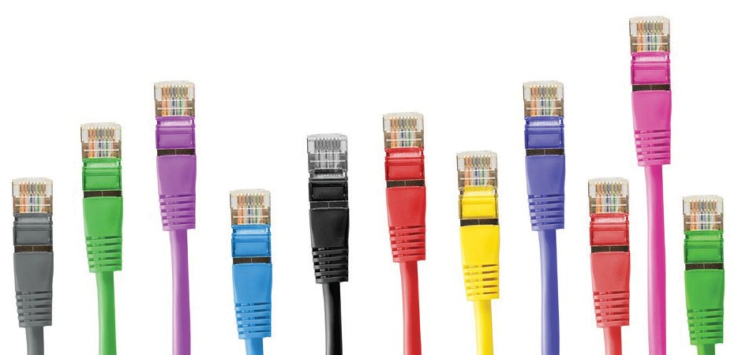

- Complete the sentences in the following router user guide choosing the correct item and providing justifications for your answers.
NetworK Devices and Equipment
1

1

2

3

4

5

6

7
8
When using this guide, please notice that features of the router may / must vary slightly depending on the model.
This guide aims at allowing you to use your router so that all of your connected devices will be able to / should take advantage of the service.
The product should not / may not be located where it will be exposed to mois- ture or excessive heat.
Place the router in a location where it can / might be connected to devices as well as to a power source.
In a domestic environment, this product needn't / may cause radio interference, in which case the user is required to take adequate measures.
You must have / should follow the instructions on the page to continue the configuration.
If the router works, you must / may have followed the right instructions. You don't need to / mustn't run the setup CD included with the router.

20

Complete the sentences in the following guide with the correct modal verb in the right form.

How to Build and Maintain the Best Home Network
With just a little time and effort, anyone (1)_______ set up a basic home computer network. Simple home networks, though, (2)_______ provide only a small fraction of the capability that an advanced network does. In order to get the most out of your home network you (3)_______ invest in better hardware and additional software. With the movement to cloud computing continuing, families (4)_______
use reliable, fast access to all of their online accounts and data. Most Internet providers nowadays (5)_______ offer a range of service plans at different prices. Subscribing to your provider’s basic plans (6) save a few euros
each month but you (7)_______ also consider time and convenience. Even small increases in
data rates (8)_______ shave valuable minutes off of long download. You (9)_______
upgrade your Internet service plan to the best available and (10) change
providers if necessary. Note that the best home Internet service (11)_______ not be provided by the one with the largest Mbps rating. If you still have problems with accessing all points at home, you (12)_______ followed the above instructions. You (13)_______ a computer expert to follow these rules.

Match the verbs in bold to their meanings.
NetworK Devices and Equipment
1
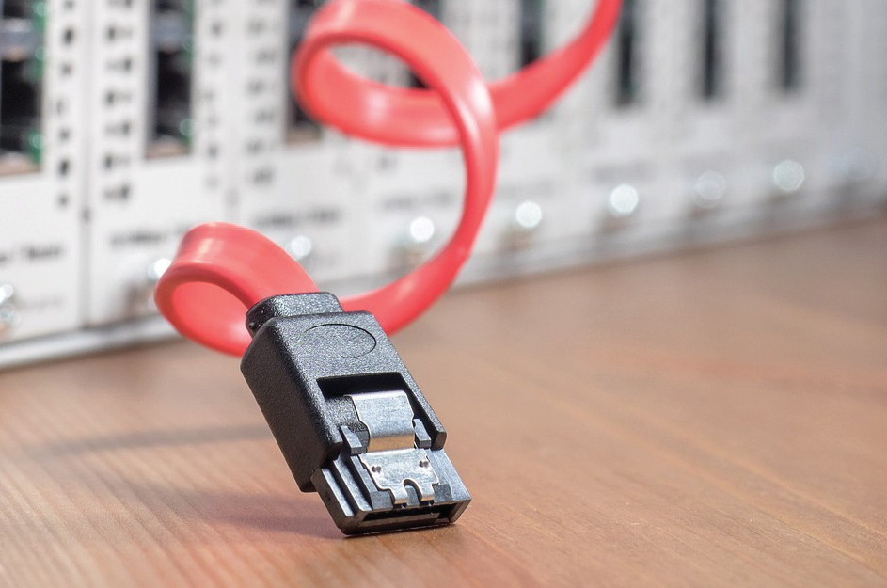
______ | 1. | You didn't need to buy a new router since  you didn’t wish to upgrade your home network.
______ | 2. | We had to unplug our router due to overheating.
______ | 3. | You can get the router IP address  from the manufacturer's documentation.
______ | 4. | You might as well buy a modem if you have an up-to-date router.
______ | 5. | You mustn't reset your router, if there are no problems.
______ | 6. | You can't use your neighbour’s IP address.
______ | 7. | Could I please use your laptop?

a | You are not allowed to...
b | It’s against the rules...
c | We were  obliged to...
d | Is it OK if...
e | It wasn’t  necessary...
f | It’s possible...
g | Perhaps  you can...


- You are going to hear a talk by a Tech enthusiast about technology innovations and the impact on our lives. Then do the following tasks.
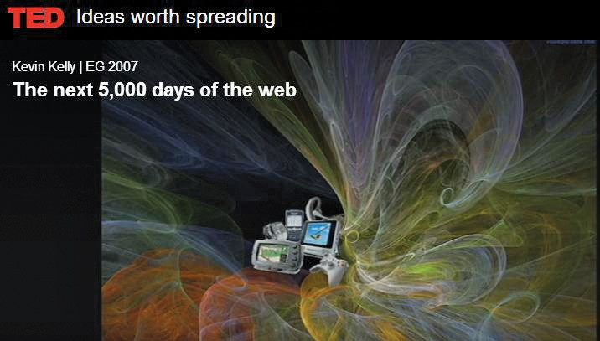

http://www.ted.com/talks/kevin_kelly_on_the_next_5_000_days_of_the_web

Choose the most appropriate title for the talk.
- What is technology about?
- Predicting the future of the World Wide Web.
- The impact of technology on our lives.

Listen again and complete the missing words in the following sentences.

1 | If I told you it was all _______, you would say, this is simply _ you're dreaming.
2 | One of the things that we're learning from this era, from this last decade, is that we have to get good at believing in the _.
3 | There’s almost no other machine that we've ever made that _______ of hours, the number of days.

NetworK Devices and Equipment
1

4 | But to a first _______, the size of this machine is the size _and its complexity, kind of_ to your brain.
5 | Thirdly, we're going to become completely _______ upon it.
6 | The cloudbook doesn't have any storage. It’s _______. It's always connected.
7 | All the cameras, and the microphones, and the _______ in cars and everything is connected to this machine.
8 | Every item, every artifact that we make, will have _______ in it some little sliver of Webness and connection.

- Work in groups to answer the following questions:

group work
- Name some things mentioned in the talk that were thought impossible 10 years ago. What other things we have today were thought impossible?
- Kevin Kelly asks: “How can we predict what's coming in the next 5,000 days?” What do you think is coming?


http://www.ted.com/talks/kevin_kelly_on_the_next_5_000_days_of_the_web#t-98088



Brainstorm reasons why you should upgrade your home computer network and decide which devices and equipment to use. Write them down in the following table.

group work

Reasons
Devices

•
•

•
•

•
•

•
•

•
•

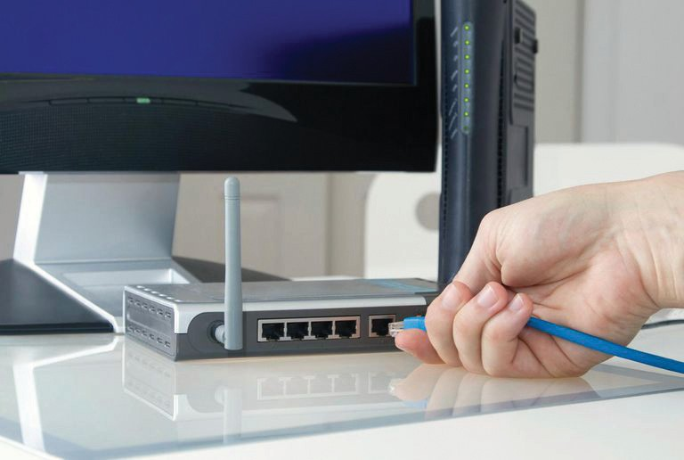What are the similarities and differences among routers, switches and hubs? Work in groups to
prepare a presentation about the key characteristics of each of the devices.
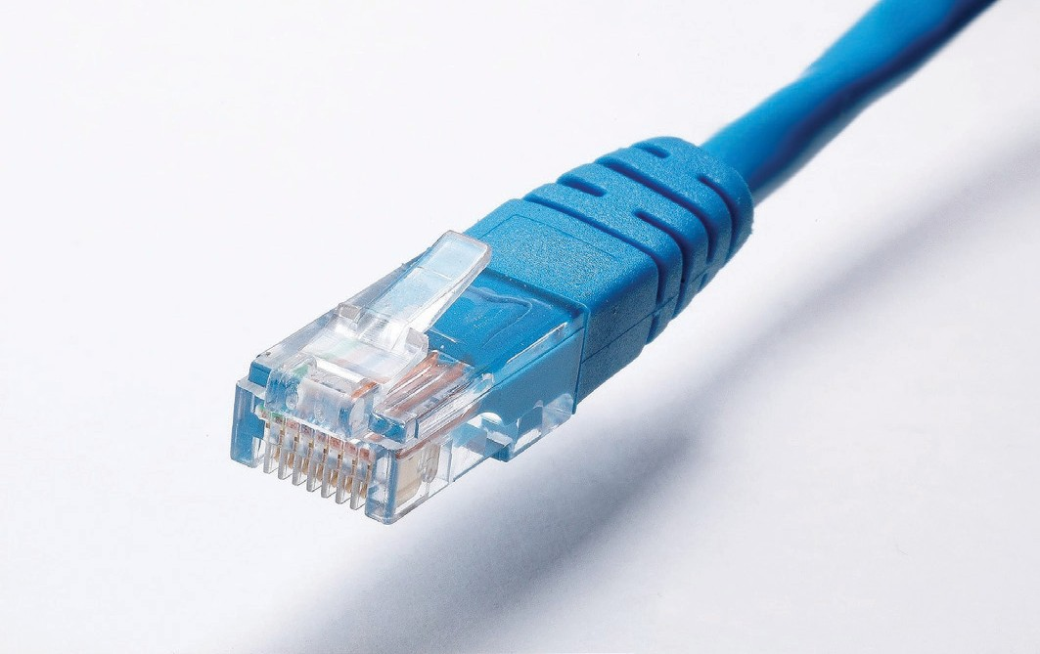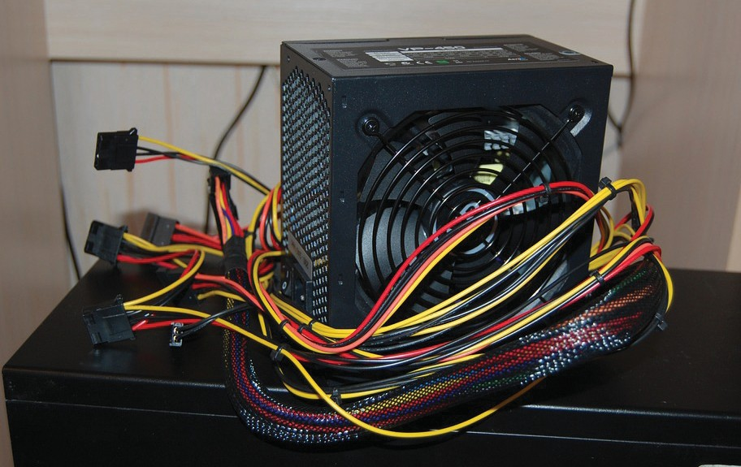

Your school's principal has asked you to improve the school's computer network. Discuss the importance of the following or other needs and decide on the priority of works to be undertaken.

class
discussion
SETTING UP A NETWORK
use a bridge
to expand your LAN
hardware required to build a network
wired Ethernet networks
wireless access points
how to troubleshoot connection problems
NetworK Devices and Equipment
1

- a. How do network devices and equipment contribute to interaction and communication?
b. How does a computer network facilitate the operation of a school / office / business?
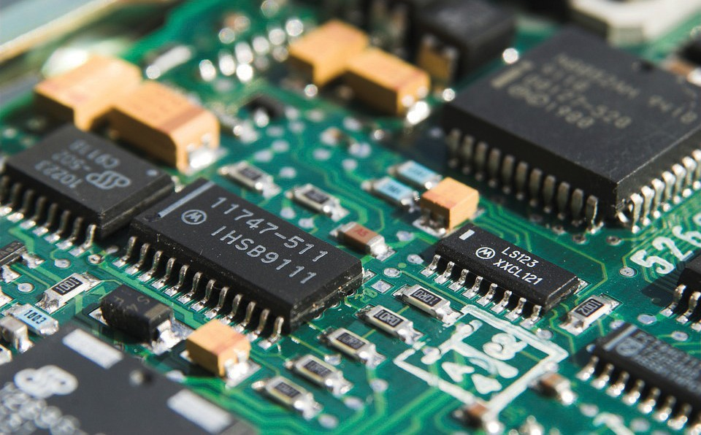



Write instructions, in steps, about how to improve and upgrade the reliability of a home computer network. The instructions will be uploaded in the Tech-how-to website (100- 140 words). There are some points below to help you:

Tech How-To Guides & Tutorials
  - Use broadband routers
  - Add Wireless Capability to Home Networks
  - Improve the Performance of a Home Network
  - Expand the Size of a Home Network
  - Add More Features to a Home Network
  - Increase Home Network Security
  - Add any other features you consider necessary

.................................................................................................................................................................................................

.................................................................................................................................................................................................

.................................................................................................................................................................................................

.................................................................................................................................................................................................

.................................................................................................................................................................................................

.................................................................................................................................................................................................

.................................................................................................................................................................................................

.................................................................................................................................................................................................

1 NetworK Devices and Equipment

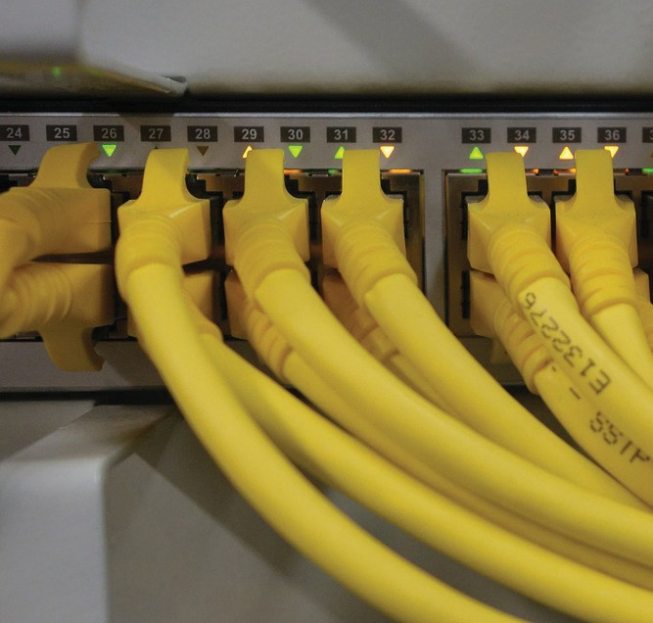

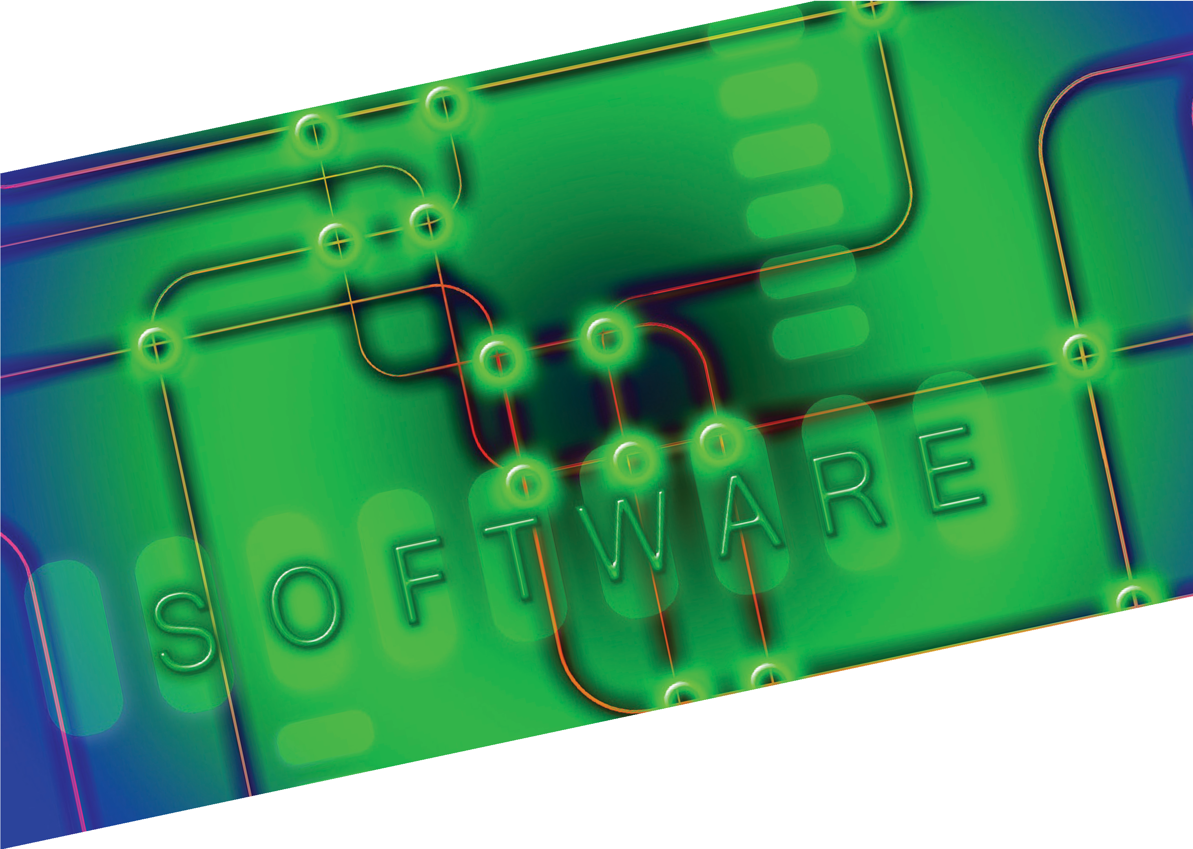2

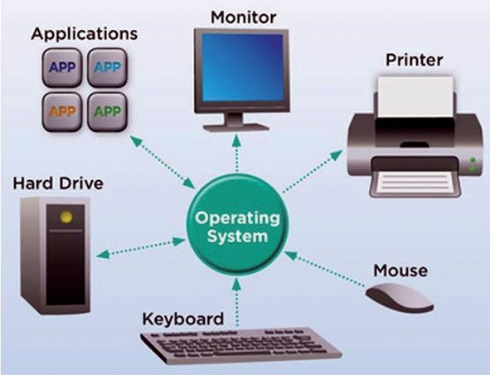2 Operating Systems

How many operating systems do you know?
  - Which are the most common operating systems nowadays?

pair work


1. Read the text and, in pairs, fill in the blanks choosing the correct words from the list below. Some words are written in bold to help you choose.

⬥ hardware ⬥ input ⬥ data ⬥ guest ⬥ processes
⬥ operating ⬥ friendly ⬥ users ⬥ consoles
⬥ intermediary ⬥ phones ⬥ networked

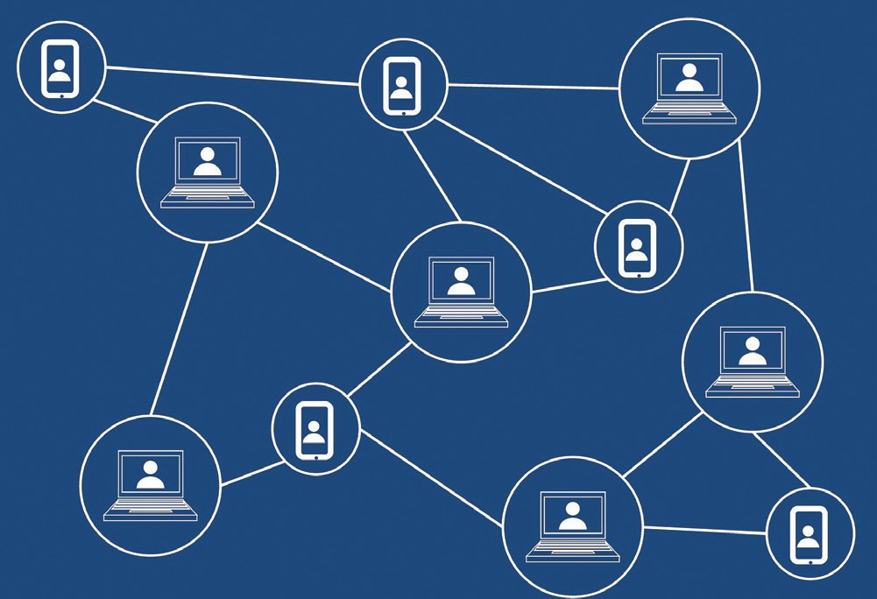Information
Technology Sector

Operating Systems

Objectives Functions

An operating system (OS) is system software that manages computer hardware and software resources, providing common services for computer programmes.
For hardware functions such as (1) ___________
and output and memory allocation, the operating system acts as an (2) ___________
between programmes and the computer
(3) _. The application code, however,
is usually executed directly by the hardware and makes system calls to an OS function or is interrupted by it. Operating systems are found on many devices that contain a computer
– from cellular (4) ___________ and video game (5) ___________ to web servers and supercomputers.

The objectives of an Operating System are to provide:
- Convenience: an OS makes a computer more
suitable to use, so it becomes user (6) _.
- Efficiency: an OS allows the computer system resources to be used in a well-organized manner.
- Ability to evolve: an OS should be constructed in a way that permits effective development, testing and introduction of new functions.

Types of operating systems Single- and multi-tasking
A single-tasking system can only run one programme at a time, while a multi-tasking system allows more than one programmes to be
running at the same time. This is achieved by time-sharing, where the available processor time is divided between multiple (7)
___________.

Single- and multi-user
Single-user operating systems have no facilities to distinguish (8) , but may
allow multiple programmes to run alongside. A multi-user operating system extends the basic concept of multi-tasking with facilities that identify processes and resources, such as disk space, permits multiple users to interact with the system at the same time.

Distributed
A distributed operating system manages a group of distinct computers and makes them appear to be a single computer. The development of
(9) ___________ computers that could be linked and communicate with each other gave rise to distributed computing. Distributed computations are carried out on more than one machine. When computers in a group work in cooperation, they form a distributed system.

Operating Systems
2

Templated
In a distributed and cloud computing context, templating refers to creating a single virtual machine image as a (10) ___________
operating system, then saving it as a tool for multiple running virtual machines. The technique is used both in virtualization and cloud computing management, and is common in large server warehouses.

Embedded
Embedded operating systems are designed to be used in embedded computer systems. They are designed to operate on small machines like PDAs with less autonomy. They are able to operate with a limited number of resources. They are very compact and extremely efficient by design.

Real-time
A real-time operating system is a time bound system which has well-defined fixed-time

constraints. It serves real-time applications that process (11) ___________ data as it comes in, typically without buffer delays. A real-time operating system may be single- or multi- tasking.

Library
In a library (12) ___________ system, services such as networking are provided in the form of libraries. They are composed with the application and configuration code to construct a uni-kernel: a specialised, single address space (SAS), machine image that can be used in cloud or embedded environments.


http://en.wikipedia.org/wiki/Operating_system

- T rue or F alse ?

Are the following sentences true (T) or false (F) according to the text?
 |  | True | False
1. | An operating system is system software for personal computers only.
2. | Multi-tasking operation is achieved by time-sharing.
3. | With single-user operating systems you cannot have multiple programmes runnning in parallel.
4. | If you want a number of computers to work in a network you need to have a distributed operating system.
5. | Embedded operating systems are compact and efficient but they operate with a limited number of resources.

- Read the text carefully and then choose the correct answers.
Operating Systems
2

1. | What does an operating system do?  _________________________________________________________________________
2. | What kind of devices does an operating system need to work?  _________________________________________________________________________
3. | How is multi-tasking operation achieved?  _________________________________________________________________________
4. | What is the difference between multi-tasking and multi-user operating systems?  _________________________________________________________________________
5. | What does a distributed operating system do?  _________________________________________________________________________
6. | What does "templating" mean?  _________________________________________________________________________
7. | What are the characteristics of embedded operating systems?  _________________________________________________________________________
8. | What is the basic characteristic of real-time operating systems?  _________________________________________________________________________
9. | What is a library operating system?  _________________________________________________________________________
10. | What is a uni-kernel?  _________________________________________________________________________

Make a list with the kinds, functions and objectives of operating systems using information from the text or from the internet.

group work

Then, in groups, make a poster or use a diagram like the one on the left to present the various operating systems in class.

Kinds | Functions | Objectives
■ | ■ | ■
■ | ■ | ■
■ | ■ | ■
■ | ■ | ■

Do you know the meaning of the following words?
Operating Systems
2
In pairs, match the words (1-10) with the definitions (A-J ).


pair work
1. _____ system resource
6. retrieve
2. booting
7. _____ cloud computing
3. interface
8. vulnerability
4. _____ device driver
9. _____ attack vector
5. directory
10. _____ source code

A | a location/folder for storing files on a computer
B | security weakness in a software programme putting the programme or computer at risk of malicious attacks
C | get stored information from a computer
D | starting up a computer
E | the code used by the programmer to create a software programme
F | technique or means for gaining access to a network server or a computer
G | a programme that enables one or more devices to communicate with the computer's operating system
H | any device/ component connected to a computer system
I | using a network of remote servers to store, manage and process data
J | a connection between two or more components of a computer system exchange (software, hardware, devices, humans).

Complete the sentences with the correct word from the following word list. There is one extra option you do not need.

⬥ storage devices ⬥ boot sector ⬥ malware ⬥ vulnerability
⬥ interface ⬥ source code ⬥ corrupting ⬥ device drivers ⬥ directories

1 | A new type of computer _________ is to enable blind people to feel and hear 3D graphic environments.
2 | A _________ is a physical section on a hard drive that includes information about how to start the boot process in order to load an operating system.
3 | _________ scanning tools are computer programmes used to gather information that may be used by an attacker to gain illegal or unauthorized access to a network.
4 | In a GUI such as Microsoft Windows, _________ are referred to as folders, there- fore being synonymous.
5 | Without _________ the computer would not be able to send and receive data correctly to hardware devices, such as a printer.
6 | A boot sector exists on an internal hard drive where an operating system is installed, as well on _________, like an external hard drive, floppy disk, or other USB device.
7 | The 5 most common _________ types are viruses, worms, Trojan Horses, spyware, and ransomware.
8 | Viruses are designed to damage their target computer by data,  reformatting your hard disk, or completely shutting down your system

- Complete each blank in the following pairs of sentences with the correct word.
Operating Systems
2

 | 1. | security / vulnerability  - An Internet browser could have a _______  that crashes the browser or allows someone to read or copy files on your computer when you visit a web page with malicious code.  - Data , which does not always guarantee  that data cannot be compromised, is a system that protects data from unauthorized access and corruption.
 | 2. | encryption / encoding  - ______________ transforms sensitive data (such as emails, files, folders and entire drives) into another format to make it more secure and less likely to be intercepted by those unauthorized to view it. It is for maintaining data confidentiality and requires the use of a key (kept secret) in order to return to plaintext.  - ___________ transforms data into another format using a scheme that is publicly available so that it can easily be reversed. It does not require a key. It is for maintaining data usability and integrity and can be reversed by employing the same algorithm used.
 | 3. | proprietary / open source  - A(n) programme can be freely modified  by anyone, allowing users or organizations to adjust the programme's functionality to their needs.  - Commercial _______ software is targeted to narrower market of end users and its source code is usually a closely guarded secret.


Comparisons

Study the words in bold below. What is the function of each language form?
  - Convenience: an OS makes a computer more suitable to use, so it becomes user friendly.
  - Windows is one of the easiest desktop operating systems to use.
  - ...... as the operating system with the largest user base, ...... it is the primary target for malicious coders.

Study the following tables about the formation of comparative and superlative and fill in the blanks.

Comparison of Adjectives - Adverbs
Comparative Superlative
Positive -er than the -est in/of more ... than the most ... in/of
We use comparative form to compare one person / thing with another. | fast long | fast longer | the fastest  long
 | nice safe | nicer safer | the nicest the safest
We use superlative form to compare one person  / thing with others in the same group. | thin fat | thin fatter | the thinnest the fattest
 | early happy | earlier happier | earl the happiest
 | realistic comfortable | realistic more comfortable | the most realistic  comfortable


Operating Systems
2

 | Irregular forms
positive | comparative | superlative
good / well | _______________ | the best
bad / badly | worse | the ________
much / many | more | the most
little | less | the ______
far | farther / ________ | farthest / _________

Other comparative structures
as positive as  not as / so positive as  (to show that two persons / things are similar / different in some way) | e. g. | Safety rules in the previous decade were  not so/as strict as the ones in force now.
comparative and comparative  (to show that something is gradually increasing / decreasing) | e. g. | Finding a job seems to be more and more difficult nowadays.
the comparative ..., the comparative  (to show successive comparison) | e. g. | The faster the machine cycle, the faster  your computer processes data.
by far the superlative  (to emphasise an adjective / adverb) | e. g. | This is by far the greenest area in our city.

- Complete the sentences using the correct form of the adjectives/adverbs in brackets. Add any other words necessary.

1 | Microsoft Windows was released ______________ (early) the Linux OS.
2 | Linux is one of ______________ (much) used operating systems in the world.
3 | Microsoft Windows is regarded to be as ______________ (reliable) Linux.
4 | When choosing a computer, speed is definitely one (important)  features.
5 | The main aim of developers is to ensure that the user gets ______________  (good) out of the possibilities of each operating system.
6 | When an operating system does not need an antivirus software programme, it is as a result (economical).
7 | Windows commands a ______________ (high) number of desktop users, and therefore it offers a ______________ (large) selection of commercial software.
8 | Some people think that when an operating system is used by ______________  (few) users, it is (secure).
9 | Gamers usually choose operating systems which do not run well on _________  (old) hardware.
10 | ______________ (high) the protection it offers, ______________ (expensive) a secure operating system can be.

Complete the sentences choosing the right item.

1 | The Mac vs PC debate is one of the more / the most controversial topics when it comes to computers.
2 | Users, who are interested in buying a new computer, always have a dilemma about which brand is better / the best.
3 | Undoubtedly, the operating system he chose is by far the safest / safer one.
4 | While newer versions of this operating system have made significant improvements in security, they are still not as secure as / than others.
5 | Farther / further measures need to be taken for a safer / safest internet.

- Compare the operating systems shown below, using the words in the table.
Operating Systems
2


pair work
secure | vulnerable
highly customisable | limited customisation
fast | slow
pricey | free
easy to use | complicated





Listen to the dialogue between a man and a woman talking
about computer problems, and answer the following questions:
http://www.oxfordonlineenglish.com/computer-problems


1. | What exactly is the problem with the woman's computer?  ________________________________________________________________________
2. | Does she use the antivirus programme regularly?  ________________________________________________________________________
3. | What did she find annoying?  ________________________________________________________________________
4. | What does the technician intend to do about the problem?  ________________________________________________________________________
5. | How much will it cost to fix the problem?  ________________________________________________________________________
6. | What do you think the expression "that's a good racket" means? Does it have a positive or a negative meaning?  ________________________________________________________________________
7. | How long will the technician take to fix the computer?  ________________________________________________________________________

Listen to the dialogue again and complete the missing words in the following sentences
Operating Systems
2

1 | What exactly is ___________ with it?
2 | Do you have antivirus and ___________ programmes installed?
3 | Warnings kept ___________ when I was surfing the Internet.
4 | If your computer’s been ___________ with something, we can try to get rid of it.
5 | Others are more difficult - we might have to ___________ your hard drive.
6 | $200 if we have to reformat and ___________ your operating system.
7 | Would you like to ___________ it ?
8 | No, no, I need it fixed. When can I ?



- A local organisation is willing to donate money to your school so that you can purchase new computers and upgrade the IT laboratory. Your school's principal has asked for your opinion on the issue. Form groups and discuss about the characteristics of each operating system in terms of reliability, security, ease of use etc commending on their advantages and disadvantages.

FURTHER PRACTICE

group work

OPERATING SYSTEMS
Linux
Mac OS X
Microsoft Windows


- Imagine that you are employed by a medium-sized business and the business manager has asked you to write a report (140-180 words) about the Operating System in use. Illustrate the major advantages and disadvantages and recommend a different one, if you like.
Operating Systems
2

H-NEWS PROJECT REPORT
TEC
To:
Fro Subj
D
...........................................................................................................
m: ......................................................................................................
ect: ................................................................................................
ate: ..............................................................................................

The purpose of this report is to ......................................................................................................................

.................................................................................................................................................................................................

.................................................................................................................................................................................................

.................................................................................................................................................................................................

.................................................................................................................................................................................................

.................................................................................................................................................................................................

- a. Why do operating systems have to progress and develop constantly?

class
discussion
b. What are the consequences of this progress?


2 Operating Systems



Βάσει του ν. 3966/2011 τα διδακτικά βιβλία του Δημοτικού, του Γυμνασίου, του Λυκείου, των ΕΠΑ.Λ. και των ΕΠΑ.Σ. τυπώνονται από το ΙΤΥΕ - ΔΙΟΦΑΝΤΟΣ και διανέμονται δωρεάν στα Δημόσια Σχολεία. Τα βιβλία μπορεί να διατίθενται προς πώληση, όταν φέρουν στη δεξιά κάτω γωνία του εμπροσθόφυλλου ένδειξη «ΔIΑΤΙΘΕΤΑΙ ΜΕ ΤΙΜΗ ΠΩΛΗΣΗΣ». Κάθε αντίτυπο που διατίθεται προς πώληση και δεν φέρει την παραπάνω ένδειξη θεωρείται κλεψίτυπο και ο παραβάτης διώκεται σύμφωνα με τις διατάξεις του άρθρου 7 του νόμου 1129 της 15/21 Μαρτίου 1946 (ΦΕΚ 1946,108, Α').

Απαγορεύεται η αναπαραγωγή οποιουδήποτε τμήματος αυτού του βιβλίου, που καλύπτεται από δικαιώματα (copyright), ή η χρήση του σε οποιαδήποτε μορφή, χωρίς τη γραπτή άδεια του Υπουργείου Παιδείας, Έρευνας και Θρησκευμάτων / IΤΥΕ - ΔΙΟΦΑΝΤΟΣ.

