ΔΙΑΓΩΝΙΣΜΑ Α ΤΕΤΡΑΜΗΝΟΥ ΣΤΑ ΑΓΓΛΙΚΑ ΤΟΜΕΑ

ΟΝΟΜΑ:

ΤΑΞΗ:

ΗΜΕΡΟΜΗΝΙΑ:

ΒΑΘΜΟΣ:

PART A: READING COMPREHENSION

TASK 1: Read the text and answer the questions /30points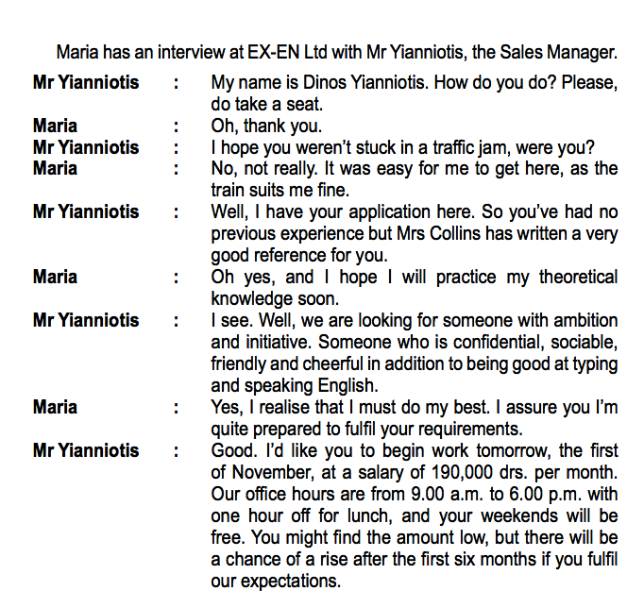

1. The text above is a) an article b) a job interview c) a TV debate
2. Mr Yianniotis is a) the employer b) the interviewee c) the interviewer
3. Was it easy for Maria to reach the location? a) No, there was heavy traffic b)Yes, she took the train c) Not clear
4. The interviewer is drawing information from a) the interviewee’s application b) her CV c) her letter
5. Maria has had a) no previous experience b) some previous experience c) important previous experience
6. Mrs Collins has written a favorable a) review b) poem c) reference
7. Which of the following skills is not required for the job? a) fluency in english b) computer skills c) typing
8. During the working hours there is a break for a) lunch b) work out c) shopping
9. Maria doesn’t have to work at weekends a) Not clear b) True c) False
10. There is a prospect for pay rise after a) one year b) a decade c) six months

PART B: VOCABULARY & USE OF ENGLISH

TASK 2: Fill in the blanks with the words on the left. /20 points

|  |  |
| --- | --- |
| fulfil  justify  theoretical  endeavor  salary  initiative  offer  ambition  confidential  grateful | 1. A ……………..of 600E is rather low but common nowadays |
| 2. She promised to ………………..the company’s requirements if she got the job. |
| 3. A ………………….person is someone we can trust. |
| 4. ……………….knowledge is as important as experience at work. |
| 5. That’s sounds like a good ………….to me! I’ll take it! |
| 6. We should be ………………to people who have helped us. |
| 7. …………………..: Try very hard to achieve something |
| 8. He tried to ……………….his rudeness by saying he’s been tired. |
| 9. Ken was the only one with the ……………….and power to solve the problem. |
| 10. It was his personal ………………..to conquer Everest. |

TASK 3: Choose the correct word to correct the sentence. There is an extra word you do not need to use /20points

|  |  |  |  |  |  |  |  |
| --- | --- | --- | --- | --- | --- | --- | --- |
| rays | seat | sociable | raise | quiet | suits | here | low |

1. The interviewer asked me to take a sit.
2. The new schedule shoots me fine.
3. The salary is slow but there will be a raze soon.
4. I Hope he doesn’t stay hear.
5. They are looking for a social and quite employee.

PART C: WRITING

TASK 4: Send an email to Mr. Yianniotis , to provide good reference for a former employee of yours who is a candidate for a post as a secretary in the Sales Department of his company. (80-120 words)